**Fiber Distribution Box (FDB)**

* **Definition**: An FDB is a passive device used to manage, organize, and distribute fiber optic cables within a network.
* **Primary Function**: Provides a centralized point for splicing, connecting, and distributing fiber optic cables. It helps in organizing and protecting the cables, making it easier to maintain and expand the network.
* **Components**:
  + **Splice Trays**: Used for organizing and protecting splices.
  + **Patch Panels**: Provide a structured way to connect and manage fiber optic cables using connectors.
  + **Splitters**: Passive devices that divide a single optical signal into multiple signals.
  + **Cable Management Systems**: Help in organizing and routing cables within the box.
* **Location**: Can be installed indoors or outdoors, depending on the network design. Outdoor FDBs are designed to be weather-resistant and suitable for harsh environmental conditions.
* **Use Cases**:
  + **FTTH Networks**: Used to distribute optical signals to individual homes and businesses.
  + **Data Centers**: Helps in managing and organizing fiber optic cables within data centers.
  + **Telecommunication Networks**: Used in various telecommunication applications to manage and distribute fiber optic cables.
* **Advantages**:
  + **Improved Organization**: Makes it easier to manage and maintain the fiber optic network.
  + **Scalability**: Allows for easy expansion of the network by adding more cables and connections.
  + **Reliability**: Enhances the reliability of the network by providing a secure and organized environment for fiber optic cables.
  + **Cost-Effective**: Reduces the need for frequent maintenance and repairs, saving time and money.

**Fiber Access Terminal (FAT)**

* **Definition**: A FAT is a terminal point where fiber optic cables are connected and managed. It serves as an interconnection point between the distribution and access networks.
* **Primary Function**: Acts as a connection point between the main fiber optic distribution network and the access network that serves end-users. It helps in managing and organizing the fiber optic cables at this interconnection point.
* **Components**:
  + **Connectors and Adapters**: Used to connect and manage fiber optic cables.
  + **Patch Panels**: Provide a structured way to connect and manage fiber optic cables.
  + **Cable Management Systems**: Help in organizing and routing cables within the terminal.
* **Location**: Typically located at the boundary between the distribution and access networks. It can be found in various locations such as telecommunication rooms, outdoor cabinets, or on poles.
* **Use Cases**:
  + **FTTH Networks**: Used to manage the interconnection between the main distribution network and the access network serving individual homes and businesses.
  + **Telecommunication Networks**: Used in various telecommunication applications to manage the interconnection between different segments of the fiber optic network.
* **Advantages**:
  + **Improved Connectivity**: Ensures a reliable and organized interconnection between the distribution and access networks.
  + **Easy Maintenance**: Provides a structured environment for managing and maintaining fiber optic cables.
  + **Scalability**: Allows for easy expansion of the network by adding more connections and cables.

**Summary**

* **FDB (Fiber Distribution Box)**: A comprehensive device used to manage, organize, and distribute fiber optic cables within a network. It includes components like splice trays, patch panels, splitters, and cable management systems.
* **FAT (Fiber Access Terminal)**: A terminal point that serves as an interconnection between the distribution and access networks. It includes components like connectors, adapters, patch panels, and cable management systems.

Both FDB and FAT play crucial roles in the deployment and management of fiber optic networks, ensuring efficient and organized cable management and distribution.

Connecting to the internet via a fiber optic connection involves several steps and components that work together to ensure you have a stable and secure connection. Here's a detailed explanation of how your Internet Service Provider (ISP) helps you connect to the internet, identifies your connection, and assigns you a public IP address:

**1. Fiber Optic Connection**

* **Fiber to the Home (FTTH)**: The fiber optic cable runs from the ISP's central office to your home. This cable carries data in the form of light signals, which are faster and more reliable than traditional copper cables.
* **Optical Network Terminal (ONT)**: The fiber optic cable connects to an ONT installed at your home. The ONT converts the optical signals into electrical signals that your wireless router can understand.

**2. Wireless Router**

* **Connection to ONT**: Your wireless router is connected to the ONT via an Ethernet cable. The ONT acts as a modem, converting the fiber optic signals into a format that the router can use.
* **Wi-Fi and Ethernet**: The wireless router broadcasts a Wi-Fi signal, allowing your devices to connect wirelessly. It also provides Ethernet ports for wired connections.

**3. Authentication and Identification**

* **MAC Address**: Your ONT and router have unique Media Access Control (MAC) addresses. These addresses are used by the ISP to identify your devices on the network.
* **PPPoE (Point-to-Point Protocol over Ethernet)**: Many ISPs use PPPoE for authentication. When you connect to the ISP, your router sends a PPPoE request with your username and password. The ISP verifies these credentials and establishes a session.
* **DHCP (Dynamic Host Configuration Protocol)**: Once authenticated, your router requests an IP address from the ISP's DHCP server. The DHCP server assigns a public IP address to your router, which is used to identify your connection on the internet.

**4. Public IP Address Assignment**

* **Public IP Address**: The ISP assigns a public IP address to your router. This IP address is unique and allows your devices to communicate with the internet.
* **Dynamic vs. Static IP**: Most residential connections use dynamic IP addresses, which can change over time. Static IP addresses, which do not change, are typically used for business connections or specific services that require a consistent IP address.

**5. Data Transmission**

* **Upstream and Downstream**: Data is transmitted between your devices and the internet through the fiber optic cable. Upstream data is sent from your devices to the ISP, while downstream data is sent from the ISP to your devices.
* **Bandwidth**: The fiber optic connection provides high bandwidth, allowing for fast data transfer rates. The ISP manages the bandwidth to ensure that all customers receive the promised speeds.

**6. ISP Infrastructure**

* **Central Office**: The fiber optic cable from your home connects to the ISP's central office. The central office houses the equipment that manages the fiber optic network, including optical line terminals (OLTs) and routers.
* **Core Network**: The central office connects to the ISP's core network, which consists of high-capacity routers and switches that handle data traffic between the ISP and the internet.
* **Peering and Transit**: The ISP's core network connects to other networks and the internet backbone through peering and transit agreements. These connections allow data to travel between different networks and reach its destination.

**7. Internet Access**

* **DNS (Domain Name System)**: When you enter a website URL in your browser, your router sends a DNS request to the ISP's DNS server. The DNS server translates the URL into an IP address, allowing your browser to connect to the website.
* **Routing**: The ISP's routers use routing protocols to determine the best path for data packets to travel between your devices and the internet. This ensures efficient and reliable data transmission.

**8. Security and Management**

* **Firewall**: The ISP and your router use firewalls to protect your network from unauthorized access and attacks. The firewall filters incoming and outgoing traffic based on security rules.
* **Quality of Service (QoS)**: The ISP manages the quality of service to ensure that all customers receive consistent and reliable internet access. This includes prioritizing certain types of traffic, such as video streaming or online gaming, to reduce latency and improve performance.

**Summary**

1. **Fiber Optic Connection**: The fiber optic cable connects your home to the ISP's central office, providing high-speed data transmission.
2. **ONT and Router**: The ONT converts optical signals into electrical signals, which are then used by your wireless router to provide internet access to your devices.
3. **Authentication**: The ISP uses PPPoE and DHCP to authenticate your connection and assign a public IP address to your router.
4. **Data Transmission**: Data is transmitted between your devices and the internet through the fiber optic cable, managed by the ISP's core network and routing protocols.
5. **Security**: The ISP and your router use firewalls and other security measures to protect your network from unauthorized access and attacks.

By following these steps, the ISP ensures that you have a secure and reliable internet connection, identifies your connection using unique MAC addresses and authentication protocols, and assigns a public IP address to your router for internet access.

# 📡 WiFi Standards: A Complete Guide

WiFi (Wireless Fidelity) is based on the **IEEE 802.11** standard and allows wireless communication between devices. Over the years, multiple WiFi versions have been developed, each improving **speed, range, and efficiency**.

**📌 1️⃣ What is IEEE 802.11?**

IEEE 802.11 is the set of standards that define **wireless local area networks (WLANs)**. Each version of WiFi operates on different **frequencies**, supports different **maximum speeds**, and has varying levels of **coverage**.

**🔹 Frequency Bands**

* **2.4 GHz** → Wider coverage, but slower speed and more interference
* **5 GHz** → Faster speed, but shorter range
* **6 GHz** → Very fast with low interference (WiFi 6E and beyond)

**📌 2️⃣ WiFi Standards Over the Years**

| **WiFi Standard** | **Frequency** | **Max Speed** | **Year Introduced** | **Common Name** |
| --- | --- | --- | --- | --- |
| **802.11** | 2.4 GHz | 2 Mbps | 1997 | Legacy WiFi |
| **802.11a** | 5 GHz | 54 Mbps | 1999 | Faster, but short range |
| **802.11b** | 2.4 GHz | 11 Mbps | 1999 | Slower, but longer range |
| **802.11g** | 2.4 GHz | 54 Mbps | 2003 | Faster than 802.11b |
| **802.11n** | 2.4 GHz / 5 GHz | 600 Mbps | 2009 | First dual-band WiFi |
| **802.11ac** | 5 GHz | 1.3 Gbps | 2014 | Faster with MU-MIMO |
| **802.11ax** | 2.4 GHz / 5 GHz / 6 GHz | 9.6 Gbps | 2019 | WiFi 6, better efficiency |
| **802.11be** | 6 GHz | 40 Gbps | 2024+ | WiFi 7, ultra-fast |

**📌 3️⃣ Understanding WiFi Generations (WiFi 4, 5, 6, 7)**

🔹 **WiFi 4 (802.11n)** → First standard with **MIMO (Multiple-Input, Multiple-Output)** for better performance.  
🔹 **WiFi 5 (802.11ac)** → Faster speeds and **beamforming** for focused signals.  
🔹 **WiFi 6 (802.11ax)** → Uses **OFDMA (Orthogonal Frequency Division Multiple Access)** for handling multiple devices efficiently.  
🔹 **WiFi 6E (Extended WiFi 6)** → Adds support for the **6 GHz** band for ultra-fast performance.  
🔹 **WiFi 7 (802.11be)** → **Higher speeds (40 Gbps)** and **lower latency** for advanced applications like **AR/VR** and cloud gaming.

**📌 4️⃣ How to Choose the Best WiFi Standard for You?**

✅ **Home Use (Streaming, Browsing, Smart Devices)** → WiFi 5 or WiFi 6  
✅ **Gaming & High-Speed Internet** → WiFi 6E or WiFi 7  
✅ **Business & Office Networks** → WiFi 6 for better device management  
✅ **Industrial & IoT Applications** → WiFi 6E for low interference

**📌 5️⃣ Key Technologies in WiFi Standards**

✔️ **MIMO (Multiple-Input, Multiple-Output)** → Uses multiple antennas for better performance  
✔️ **Beamforming** → Directs WiFi signals toward connected devices for better speed  
✔️ **OFDMA (Orthogonal Frequency Division Multiple Access)** → Allows multiple users to share a single WiFi channel efficiently  
✔️ **MU-MIMO (Multi-User MIMO)** → Supports multiple devices at the same time  
✔️ **BSS Coloring** → Reduces interference in crowded environments

**📌 6️⃣ Future of WiFi (WiFi 7 and Beyond 🚀)**

* **WiFi 7 (802.11be)** → Expected speeds up to **40 Gbps** ⚡
* **Lower latency** for real-time applications like gaming and VR 🎮
* **More reliable connections** in high-density areas 🌎

**📌 7️⃣ Conclusion**

WiFi has evolved significantly over the years, improving speed, range, and efficiency. Choosing the right WiFi standard depends on your **use case** and **network requirements**.

To check your Wi-Fi standard on a Windows system, open the Command Prompt and type the command "netsh wlan show drivers"; look for the "Radio types supported" section to see the supported Wi-Fi standards like 802.11ac (for Wi-Fi 5) or 802.11ax (for Wi-Fi 6).

# 1. What Are Port Numbers?

A **port number** is a **16-bit** number (ranging from **0 to 65535**) used to identify different types of network communication.

* When you access a website, send an email, or play an online game, your device communicates using **IP addresses and port numbers**.
* The **IP address** identifies the device, while the **port number** identifies the specific service or application.

**2. Port Number Categories**

Port numbers are divided into **three ranges**:

| **Port Range** | **Type** | **Usage** |
| --- | --- | --- |
| **0 – 1023** | **Well-Known Ports** | Reserved for common services (HTTP, HTTPS, FTP, DNS) |
| **1024 – 49151** | **Registered Ports** | Assigned for specific applications (games, VoIP, messaging apps) |
| **49152 – 65535** | **Dynamic/Private Ports** | Used for temporary connections (randomly assigned) |

**3. Commonly Used Port Numbers**

Here are some of the most frequently used port numbers:

**A. Web Services**

| **Port** | **Protocol** | **Usage** |
| --- | --- | --- |
| 80 | HTTP | Standard web browsing (unsecured) |
| 443 | HTTPS | Secure web browsing (SSL/TLS) |

**B. Email Services**

| **Port** | **Protocol** | **Usage** |
| --- | --- | --- |
| 25 | SMTP | Sending emails |
| 110 | POP3 | Retrieving emails |
| 143 | IMAP | Email synchronization |

**C. File Transfer Services**

| **Port** | **Protocol** | **Usage** |
| --- | --- | --- |
| 20, 21 | FTP | File Transfer Protocol |
| 22 | SFTP (over SSH) | Secure file transfer |
| 69 | TFTP | Simple file transfer (without authentication) |

**D. Remote Access Services**

| **Port** | **Protocol** | **Usage** |
| --- | --- | --- |
| 22 | SSH | Secure remote login |
| 23 | Telnet | Remote login (insecure) |
| 3389 | RDP | Remote Desktop Protocol (Windows) |

**E. Network and DNS Services**

| **Port** | **Protocol** | **Usage** |
| --- | --- | --- |
| 53 | DNS | Resolving domain names |
| 67, 68 | DHCP | Assigning IP addresses |
| 161 | SNMP | Network device monitoring |

**F. Gaming & Streaming**

| **Port** | **Protocol** | **Usage** |
| --- | --- | --- |
| 1935 | RTMP | Video streaming (YouTube, Twitch) |
| 3478-3480 | STUN/TURN | NAT traversal for voice/video calls |
| 25565 | Minecraft | Minecraft game server |

**4. How Port Numbers Work in Communication**

When a device sends or receives data, it uses a **combination of an IP address and port number**. This is called a **socket**.

For example:

* When you visit https://www.google.com, your computer:
  + Contacts **Google’s IP address (e.g., 142.250.190.14)**
  + Uses **port 443** (HTTPS)
  + Your computer assigns a **random high-numbered port** (e.g., **50567**) for the response.

**Example: Web Browsing (Client-Server Communication)**

| **Device** | **IP Address** | **Port Number** |
| --- | --- | --- |
| Your Computer (Client) | 192.168.1.100 | **50567 (random)** |
| Google Web Server | 142.250.190.14 | **443 (HTTPS)** |

* The request is sent from **192.168.1.100:50567 → 142.250.190.14:443**.
* The response comes back from **142.250.190.14:443 → 192.168.1.100:50567**.

**5. Checking Open Ports on Your Device**

You can check open ports using **command-line tools**:

**On Windows (Command Prompt)**

**netstat -an**

* Shows active connections and listening ports.

**On Linux/Mac (Terminal)**

**netstat -tulnp**

* Displays open ports and active services.

**6. Importance of Port Numbers in Security**

* **Firewalls** block or allow traffic based on port numbers.
* **Hackers** target vulnerable ports (e.g., **Telnet on port 23**).
* **Network administrators** use **port filtering** to secure networks.

**Conclusion**

* **Port numbers** help computers manage multiple applications over a network.
* Different services have **standard ports** (e.g., **80 for HTTP, 443 for HTTPS**).
* Ports can be **filtered or blocked** for security.
* Understanding ports is essential for **networking, cybersecurity, and troubleshooting**.
* **ICANN** Organization assigns port numbers

# UDP vs. TCP: Understanding the Key Differences

UDP (User Datagram Protocol) and TCP (Transmission Control Protocol) are two major transport layer protocols used for data transmission over networks. Both operate on **Layer 4 (Transport Layer)** of the OSI model but have key differences in how they handle communication.

**1. Transmission Control Protocol (TCP)**

TCP is a **connection-oriented** protocol, meaning it establishes a **reliable** connection before transmitting data.

**Key Features of TCP:**

✅ **Reliable:** Ensures all data reaches the destination correctly.  
✅ **Connection-Oriented:** Uses a **three-way handshake** to establish a connection.  
✅ **Error Checking & Recovery:** Uses acknowledgments (ACKs) and retransmissions.  
✅ **Ordered Delivery:** Data packets arrive in the correct order.  
✅ **Flow Control:** Uses a mechanism called **windowing** to control data transmission speed.

**TCP Communication Process (Three-Way Handshake)**

1. **SYN** → The client sends a synchronization request to the server.
2. **SYN-ACK** → The server acknowledges and responds with SYN-ACK.
3. **ACK** → The client acknowledges the connection, and data transfer begins.

**Use Cases of TCP:**

* Web Browsing (HTTP/HTTPS) 🌍
* File Transfers (FTP) 📂
* Email (SMTP, IMAP, POP3) 📧
* Secure Shell (SSH) 🔒

**2. User Datagram Protocol (UDP)**

UDP is a **connectionless** protocol, meaning it does not establish a session before sending data. It is **faster but unreliable** compared to TCP.

**Key Features of UDP:**

✅ **Fast and Lightweight:** No need for handshaking before data transmission.  
✅ **Connectionless:** Data is sent without setting up a session.  
✅ **No Error Checking or Retransmissions:** If data is lost, it is not resent.  
✅ **No Order Guarantee:** Packets may arrive **out of order or be dropped**.

**Use Cases of UDP:**

* **Live Streaming (YouTube, Netflix, Twitch) 📺**
* **VoIP (Voice over IP) Calls ☎️**
* **Online Gaming 🎮**
* **DNS Queries (Domain Name System) 🌐**
* **DHCP (Dynamic Host Configuration Protocol) 🔌**

**Comparison Table: TCP vs. UDP**

| **Feature** | **TCP** | **UDP** |
| --- | --- | --- |
| **Type** | Connection-Oriented | Connectionless |
| **Reliability** | Reliable (Retransmits lost packets) | Unreliable (No retransmissions) |
| **Speed** | Slower due to error checking | Faster due to no overhead |
| **Packet Ordering** | Ensures order | No guarantee of order |
| **Error Checking** | Yes (ACKs & retransmissions) | Minimal (Checksums only) |
| **Use Cases** | Web browsing, file transfers, emails | Streaming, gaming, VoIP |

**Conclusion**

* Use **TCP** when reliability and data integrity matter.
* Use **UDP** when **speed is more important than reliability** (e.g., streaming & gaming).

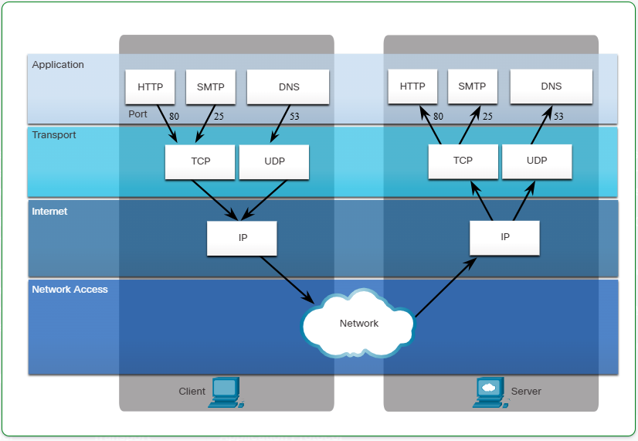

# Routing Between Networks – Explained

**1️⃣ What is Routing?**

**Routing** is the process of forwarding data packets from one network to another using a **router**. It ensures that data travels efficiently across interconnected networks, like from a home network to the internet.

🔹 **Why is Routing Important?**  
✅ Allows devices from different networks to communicate.  
✅ Helps in managing large-scale networks like the internet.  
✅ Enables efficient data delivery by choosing the best path.

**2️⃣ How Routing Works (Step-by-Step)**

📌 **Example Scenario:**

* **Network A**: 192.168.1.0/24 (PC A: 192.168.1.10)
* **Network B**: 192.168.2.0/24 (PC B: 192.168.2.10)
* A **router** connects both networks and routes traffic between them.

1️⃣ **PC A (192.168.1.10) wants to send data to PC B (192.168.2.10).**  
2️⃣ It checks if the destination IP belongs to its own subnet.  
3️⃣ If not, it sends the packet to its **default gateway** (router).  
4️⃣ The **router checks its routing table** to find the next hop.  
5️⃣ The router forwards the packet to Network B.  
6️⃣ PC B receives the data and responds similarly.

**3️⃣ Types of Routing**

**🔹 1. Static Routing**

* Manually configured by a network administrator.
* Used in small networks with **fixed paths**.
* Example Command (Cisco Router):

ip route 192.168.2.0 255.255.255.0 192.168.1.1

✅ **Advantages:**  
✔ Simple and secure  
✔ No extra CPU/memory usage

❌ **Disadvantages:**  
✖ Does not adapt to network changes  
✖ Difficult to manage in large networks

**🔹 2. Dynamic Routing**

* Uses **routing protocols** to automatically update routes.
* Best for **large, complex networks**.

✅ **Advantages:**  
✔ Automatically finds the best path  
✔ Adapts to network changes

❌ **Disadvantages:**  
✖ Requires CPU/memory resources  
✖ More complex than static routing

🔹 **Common Dynamic Routing Protocols:**

| **Protocol** | **Type** | **Best for...** |
| --- | --- | --- |
| RIP | Distance Vector | Small networks |
| OSPF | Link State | Medium to large networks |
| EIGRP | Hybrid | Cisco networks |
| BGP | Path Vector | Internet routing |

**4️⃣ Default Gateway and Inter-VLAN Routing**

📌 **Default Gateway:**

* A **default gateway** is a router that forwards traffic **outside a local network**.
* Each device in a network is configured with a **default gateway IP** (usually the router’s IP).

📌 **Inter-VLAN Routing:**

* In a VLAN-based network, **a Layer 3 device (router or L3 switch)** is required for communication between VLANs.
* **Router-on-a-Stick** is a method using a single router interface with subinterfaces for multiple VLANs.

🔹 **Example Inter-VLAN Configuration on a Router:**

interface GigabitEthernet0/0.10

encapsulation dot1Q 10

ip address 192.168.10.1 255.255.255.0

**5️⃣ Routing Tables and Commands**

📌 **Checking the Routing Table:**  
✅ **Windows:**

route print

✅ **Linux/macOS:**

ip route show

✅ **Cisco Router:**

**show ip route**

📌 **Adding a Static Route in Windows:**

route add 192.168.2.0 mask 255.255.255.0 192.168.1.1 -p

**6️⃣ Routing Troubleshooting Tips**

✅ Check if the device has the correct **default gateway**.  
✅ Verify routes using traceroute (tracert on Windows).  
✅ Use ping to test connectivity.  
✅ On routers, check the routing table using show ip route.

**Routing Tables & How Routers Forward Packets**

1. **Routers use routing tables** to determine the best path for forwarding packets.
2. **Routing tables contain network addresses**, not individual host addresses.
3. **Routing information can be added in two ways**:
   * **Dynamically**: Learned from other routers using routing protocols (e.g., RIP, OSPF, BGP).
   * **Manually**: Configured by a network administrator (static routes).

**Default Route & Dropped Packets**

* If a router **cannot find a matching route**, it **drops the packet**.
* To avoid this, a **default route** (also called the ***gateway of last resort***) is configured.
* This default route sends packets to another router that **knows how to reach the destination**.

**Example of a Default Route on a Cisco Router:**

ip route 0.0.0.0 0.0.0.0 192.168.1.1

This command tells the router to **send all unknown traffic** to 192.168.1.1, which is likely another router.

# Address Resolution Protocol (ARP) – Explained

**1️⃣ What is ARP?**

**Address Resolution Protocol (ARP)** is a network protocol used to map an **IP address** to a **MAC (Media Access Control) address** in a local network. It enables communication between devices in an Ethernet or Wi-Fi network by ensuring that data packets reach the correct destination.

🔹 **Why is ARP important?**  
✅ Devices use **IP addresses** to communicate, but data packets are sent using **MAC addresses**.  
✅ ARP helps find the **MAC address** of a device given its **IP address**.

**2️⃣ How ARP Works (Step-by-Step)**

📌 **Scenario:** Device A (192.168.1.10) wants to send data to Device B (192.168.1.20).

1️⃣ Device A **checks** if it already knows the MAC address of 192.168.1.20 in its ARP table.  
2️⃣ If not, it sends an **ARP Request** (***broadcast***) to all devices in the network.  
3️⃣ Device B, which has the IP 192.168.1.20, replies with an **ARP Reply** (***unicast***) containing its MAC address.  
4️⃣ Device A stores the **MAC address of Device B** in its ARP table and sends the data.

📌 **Example of ARP Table**

| **IP Address** | **MAC Address** | **Interface** |
| --- | --- | --- |
| 192.168.1.1 | 00:A1:B2:C3:D4:E5 | eth0 |
| 192.168.1.10 | 00:F1:E2:D3:C4:B5 | eth0 |

**3️⃣ Types of ARP**

**🔹 1. Regular ARP (Request & Reply)**

* Used when a device **does not know** the MAC address of another device.

**🔹 2. Gratuitous ARP**

* Sent by a device to **announce its MAC address** to the entire network.
* Used when a device gets a **new IP address** or to detect **duplicate IPs**.

**🔹 3. Proxy ARP**

* A router responds to ARP requests on behalf of another device **in a different network**.
* Allows communication between two subnets **without a gateway**.

**🔹 4. Reverse ARP (RARP)**

* Resolves an **IP address** when only the **MAC address** is known.
* Used in diskless systems to obtain an IP from a central server.

**4️⃣ Viewing and Managing ARP Table**

📌 **Commands to check ARP table**

✅ **Windows:**

**arp -a**

✅ **Linux/macOS:**

**arp -n**

✅ **Cisco Router:**

show ip arp

📌 **Clearing ARP Cache**  
✅ **Windows:**

arp -d *

✅ **Linux/macOS:**

sudo ip -s -s neigh flush all

**5️⃣ ARP Spoofing (Security Concern)**

⚠ **Attackers can manipulate ARP tables to intercept or redirect network traffic.**  
✅ **Mitigation Measures:**  
✔ Use **static ARP entries** for critical devices  
✔ Enable **Dynamic ARP Inspection (DAI)** on switches  
✔ Use **firewalls and security software**

# Network Address Translation (NAT) – Explained

**1️⃣ What is NAT?**

**Network Address Translation (NAT)** is a technique used in networking to allow multiple devices on a private network to access the Internet using a single **public IP address**. It modifies the source or destination IP addresses of packets as they pass through a router or firewall.

🔹 **Why is NAT Important?**  
✅ Reduces the number of **public IP addresses** needed.  
✅ Enhances **security** by hiding internal IP addresses.  
✅ Enables devices with **private IPs** (192.168.x.x, 10.x.x.x) to communicate over the Internet.

**2️⃣ Types of NAT**

There are **three main types** of NAT:

**🔹 1. Static NAT (1:1 Mapping)**

* Maps **one private IP** to **one public IP** permanently.
* Useful for hosting **web servers** and **email servers** that require a fixed public IP.

📌 **Example:**

nginx

Private IP → Public IP

192.168.1.10 → 203.0.113.10

✅ Good for **dedicated servers**  
❌ Limited scalability

**🔹 2. Dynamic NAT (Many-to-Many Mapping)**

* Assigns **a public IP from a pool** to internal devices when they need access to the Internet.
* **No guarantee** that a specific device gets the same public IP every time.

📌 **Example:**

nginx

Pool of Public IPs: 203.0.113.10 - 203.0.113.20

✅ Works for **multiple devices**  
❌ Requires **a pool of public IPs**

**🔹 3. Port Address Translation (PAT) / NAT Overload (Many-to-One Mapping)**

* **Most common NAT type** used in home and business networks.
* Multiple private IPs share **a single public IP** but use different **port numbers**.

📌 **Example:**

192.168.1.10 → 203.0.113.5:1025

192.168.1.11 → 203.0.113.5:1026

✅ Saves **public IPs**  
✅ Ideal for **home and office networks**  
✅ Uses **port numbers** to distinguish devices

**3️⃣ How NAT Works (Step-by-Step)**

🛠 **Scenario: A private device accessing the Internet**

1️⃣ A device (**192.168.1.10**) wants to visit www.google.com.  
2️⃣ The router changes the **source IP** from 192.168.1.10 → 203.0.113.5.  
3️⃣ The request reaches Google, and the response is sent back to 203.0.113.5.  
4️⃣ The router translates 203.0.113.5 back to 192.168.1.10 and delivers the response.

📌 **Example of NAT Table (PAT Example)**

| **Private IP** | **Private Port** | **Public IP** | **Public Port** | **Destination IP** |
| --- | --- | --- | --- | --- |
| 192.168.1.10 | 1025 | 203.0.113.5 | 50000 | 142.250.180.78 (Google) |
| 192.168.1.11 | 1026 | 203.0.113.5 | 50001 | 142.250.180.78 (Google) |

**4️⃣ Configuring NAT on a Router (Cisco CLI Example)**

**🔹 Configuring Static NAT**

configure terminal

ip nat inside source static 192.168.1.10 203.0.113.10

exit

**🔹 Configuring Dynamic NAT**

configure terminal

ip nat pool MYPOOL 203.0.113.10 203.0.113.20 netmask 255.255.255.0

access-list 1 permit 192.168.1.0 0.0.0.255

ip nat inside source list 1 pool MYPOOL

exit

**🔹 Configuring PAT (NAT Overload)**

configure terminal

ip nat inside source list 1 interface GigabitEthernet0/1 overload

exit

**5️⃣ NAT Advantages & Disadvantages**

✅ **Pros:**  
✔ Saves **IPv4 addresses**  
✔ Provides **security** by hiding private IPs  
✔ Enables **multiple devices** to share a public IP

❌ **Cons:**  
✖ Can cause **latency** due to translation  
✖ Some applications (VoIP, gaming) may not work without **NAT traversal**  
✖ NAT breaks **end-to-end connectivity** (not needed in IPv6)

**6️⃣ NAT vs. IPv6**

* **NAT is mainly needed for IPv4** because of the limited address space.
* **IPv6 does not require NAT** as it provides a vast number of unique IP addresses.

# Gateways in Networking

**What is a Gateway?**

A **gateway** is a network device that acts as a bridge between different networks, allowing communication between systems that use different protocols, architectures, or data formats. It serves as an entry and exit point for data traveling between networks.

**Functions of a Gateway**

1. **Protocol Conversion** – Translates data between different network protocols (e.g., IPv4 to IPv6, TCP/IP to OSI).
2. **Data Translation** – Converts data formats so that devices using different standards can communicate.
3. **Traffic Management** – Routes data between networks, often used in enterprise and ISP-level networking.
4. **Security Enforcement** – Can act as a firewall or proxy server to monitor and control data flow.
5. **Email and VoIP Processing** – Used in email systems (SMTP gateways) and voice-over-IP (VoIP) networks.

**Types of Gateways**

1. **Network Gateway** – Connects two different networks, such as an internal LAN and the internet.
2. **Protocol Gateway** – Converts one protocol into another (e.g., SIP-to-H.323 for VoIP calls).
3. **Cloud Gateway** – Bridges local enterprise networks with cloud services.
4. **IoT Gateway** – Facilitates communication between IoT devices and the internet.
5. **Firewall Gateway** – A security gateway that filters and protects data traffic.

**Examples of Gateways**

* **Home Routers** – Act as gateways between home networks and ISPs.
* **VoIP Gateways** – Convert traditional phone signals to digital VoIP.
* **Industrial Gateways** – Enable communication between industrial protocols like Modbus and Ethernet/IP.

**Example Use Case: Gateway in a Corporate Network**

**Scenario:**

A multinational company has two offices—one in **London** and another in **New York**—each using different networking protocols. The **London office** uses an **IPv4-based** network, while the **New York office** uses an **IPv6-based** network.

**Problem:**

Since these two offices use different IP versions, they **cannot communicate directly** over a standard router.

**Solution: Implementing an IP Gateway**

The company installs an **IP protocol gateway** between the two offices. This gateway **translates IPv4 packets into IPv6** and vice versa.

🔹 **Step-by-Step Process:**

1. A computer in the **London office** (IPv4 network) sends a request to access a server in **New York** (IPv6 network).
2. The request reaches the **IP gateway**, which **translates the IPv4 packet into an IPv6 format**.
3. The translated packet is sent to the New York server, which processes it and generates a response.
4. The **gateway translates the IPv6 response back into IPv4** before sending it back to the London computer.

**Why This Matters?**

* Ensures **seamless communication** between devices using different IP protocols.
* Reduces **the cost of upgrading entire network infrastructure** at once.
* Enhances **network interoperability** across multiple locations.

**Real-World Example:**

* Many ISPs use **dual-stack gateways** to allow IPv4 and IPv6 users to access the same online services.
* Large corporations deploy **cloud gateways** to enable communication between **on-premises** servers and cloud-based applications (AWS, Azure, Google Cloud).

# 7. Routers as Default Gateways

**What is a Default Gateway?**

A **default gateway** is a network device, typically a **router**, that serves as an access point to send data from one network to another. It allows devices in a local network (LAN) to communicate with external networks, such as the **internet** or other LANs.

**Role of a Router as a Default Gateway**

When a computer or device wants to communicate with another device **outside its local network**, it forwards the request to the **default gateway** (usually the router). The router then determines the best path for the data and forwards it accordingly.

🔹 **Example:**

* A laptop in a home network (192.168.1.10) wants to access [**www.google.com**](http://www.google.com) (which is on the internet).
* Since **Google’s IP address is outside the local network**, the laptop sends the request to the **default gateway** (e.g., 192.168.1.1).
* The router forwards the request to the **internet** via the ISP.
* The response from Google is sent back to the router, which **routes it back to the laptop**.

**How a Router Learns and Uses the Default Gateway?**

1. **Static Configuration** – The network administrator manually assigns a default gateway address to devices.
2. **Dynamic Configuration (DHCP)** – The router assigns itself as the default gateway when devices connect via **Dynamic Host Configuration Protocol (DHCP)**.
3. **Routing Table Lookup** – If a packet’s destination is unknown, the router checks its **routing table** and forwards the packet via the default gateway.

**Default Gateway in Enterprise Networks**

* **Home Networks:** The ISP’s router (e.g., 192.168.1.1) serves as the default gateway.
* **Corporate Networks:** Large organizations use **multiple routers** as default gateways for different network segments.
* **Cloud Networks:** In virtualized environments, cloud providers like AWS use **Virtual Private Gateways (VGWs)** to connect on-premise networks to the cloud.

**Troubleshooting Default Gateway Issues**

If devices **cannot access the internet**, the issue may be:  
✅ Incorrect default gateway configuration.  
✅ Router is down or misconfigured.  
✅ Network adapter issues (e.g., wrong IP settings).

**Configuring a Default Gateway in Windows & Linux**

**1️⃣ Windows (Using Command Prompt & GUI)**

**Method 1: Using Command Prompt**

1️⃣ Open **Command Prompt** (Win + R, type cmd, and press Enter).  
2️⃣ Type the following command to check the current default gateway:

ipconfig

* Look for the **Default Gateway** under your active network connection.  
  3️⃣ To manually set a default gateway, type:

netsh interface ip set address "Ethernet" static 192.168.1.1 255.255.255.0 192.168.1.1

* Replace **"Ethernet"** with your network interface name.
* **192.168.1.1** is the gateway IP (router’s address).
* **255.255.255.0** is the subnet mask.

**Method 2: Using GUI (Network Settings)**

1️⃣ Open **Control Panel** → **Network and Sharing Center**.  
2️⃣ Click **Change adapter settings** on the left panel.  
3️⃣ Right-click your active network (e.g., **Ethernet** or **Wi-Fi**) → Click **Properties**.  
4️⃣ Select **Internet Protocol Version 4 (TCP/IPv4)** → Click **Properties**.  
5️⃣ Select **Use the following IP address**, then enter:

* **IP Address:** 192.168.1.100 (Example)
* **Subnet Mask:** 255.255.255.0
* **Default Gateway:** 192.168.1.1 (Router’s IP)  
  6️⃣ Click **OK** → Restart your network connection.

**2️⃣ Linux (Using Terminal)**

**Method 1: Temporary Gateway Configuration**

1️⃣ Open **Terminal** (Ctrl + Alt + T).  
2️⃣ Check the current gateway:

ip route show

3️⃣ To add a new default gateway:

sudo route add default gw 192.168.1.1

4️⃣ To verify the change:

ip route show

**Method 2: Permanent Gateway Configuration (Ubuntu/Debian)**

1️⃣ Open the network configuration file:

sudo nano /etc/network/interfaces

2️⃣ Add or edit the gateway settings:

iface eth0 inet static

address 192.168.1.100

netmask 255.255.255.0

gateway 192.168.1.1

3️⃣ Save the file (Ctrl + X, then Y and Enter).  
4️⃣ Restart the network service:

sudo systemctl restart networking

# Dynamic Host Configuration Protocol (DHCP) 📡

The **Dynamic Host Configuration Protocol (DHCP)** is a network protocol used to **automate the assignment of IP addresses** and other network configuration settings to devices in a network. It helps **reduce manual configuration** and ensures devices can easily connect to a network.

As the figure shows, various types of devices can be DHCP servers. The DHCP server in most medium-to-large networks is usually a local, dedicated PC-based server. With home networks, the DHCP server is usually located on the local router that connects the home network to the ISP.

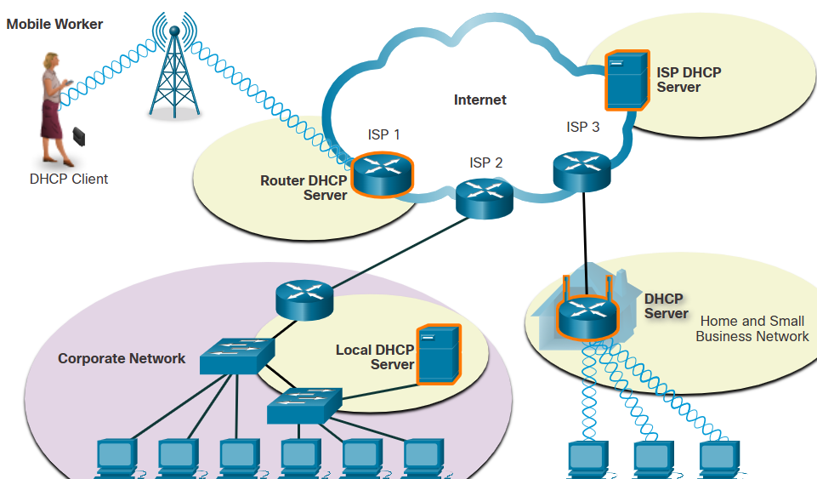

DHCP for IPv6 (DHCPv6) provides similar services for IPv6 clients. One important difference is that DHCPv6 **does not provide a default gateway address**. This can only be obtained dynamically from the Router Advertisement message of the router.

**🔹 Why is DHCP Needed?**

✔ In a large network, manually assigning IP addresses is **time-consuming and error-prone**.  
✔ Without DHCP, administrators would have to **manually configure** each device with an IP address, subnet mask, gateway, and DNS server.  
✔ DHCP **automates** this process, reducing errors and improving network efficiency.

**🔹 How DHCP Works (Process)**

When a device (client) connects to a network, it follows the **DORA process** to obtain an IP address from the DHCP server:

1️⃣ **D**iscover → The client sends a **DHCP Discover message** to find a DHCP server.  
2️⃣ **O**ffer → The DHCP server responds with an **IP address offer.**3️⃣ **R**equest → The client **requests the offered IP address**.  
4️⃣ **A**cknowledge → The DHCP server **confirms and assigns the IP address.**

📌 **Example:**

* A laptop connects to a Wi-Fi network.
* It sends a **DHCP Discover** message to find a DHCP server.
* The DHCP server responds with an **IP Offer** (e.g., 192.168.1.10).
* The laptop requests the IP (**DHCP Request).**
* The DHCP server **confirms** (**DHCP Acknowledge**), and the laptop is now online!

As shown in the figure, when an IPv4, DHCP-configured device boots up or connects to the network, the client broadcasts a **DHCP discover (DHCPDISCOVER)** message to identify any available DHCP servers on the network. A DHCP server replies with a **DHCP offer (DHCPOFFER)** message, which offers a lease to the client. The offer message contains the IPv4 address and subnet mask to be assigned, the IPv4 address of the DNS server, and the IPv4 address of the default gateway. The lease offer also includes the duration of the lease.

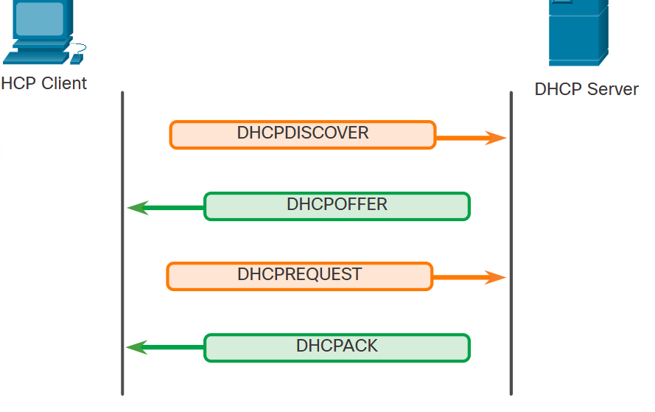

The client may receive multiple DHCPOFFER messages if there is more than one DHCP server on the local network. Therefore, it must choose between them, and sends a DHCP request (broadcast DHCPREQUEST) message that identifies the explicit server and lease offer that the client is accepting. A client may also choose to request an address that it had previously been allocated by the server.

Assuming that the IPv4 address requested by the client, or offered by the server, is still available, the server returns a DHCP acknowledgment (DHCPACK) message that acknowledges to the client that the lease has been finalized. If the offer is no longer valid, then the selected server responds with a DHCP negative acknowledgment (DHCPNAK) message. If a DHCPNAK message is returned, then the selection process must begin again with a new DHCPDISCOVER message being transmitted. After the client has the lease, it must be renewed prior to the lease expiration through another DHCPREQUEST message.

The DHCP server ensures that all IP addresses are unique (the same IP address cannot be assigned to two different network devices simultaneously). Most ISPs use DHCP to allocate addresses to their customers.

DHCPv6 has a set of messages that is similar to those for DHCPv4. The DHCPv6 messages are SOLICIT, ADVERTISE, INFORMATION REQUEST, and REPLY.

**🔹 Components of DHCP**

🔹 **DHCP Client** → The device requesting an IP (e.g., laptop, phone).  
🔹 **DHCP Server** → The server assigning IPs (e.g., router, dedicated server).  
🔹 **DHCP Lease** → The period an IP is assigned before renewal is needed.  
🔹 **DHCP Scope** → The range of IP addresses a server can assign (e.g., 192.168.1.10 - 192.168.1.100).

**🔹 DHCP Address Allocation Methods**

DHCP can assign IPs in **three ways**:

1️⃣ **Dynamic Allocation**

* The DHCP server assigns an **IP address for a limited time (lease)**.
* The device must **renew** the lease before it expires.
* Used in most networks (e.g., home Wi-Fi, office networks).

2️⃣ **Automatic Allocation**

* The DHCP server **permanently assigns** an IP to a device.
* Once assigned, the same device will **always get the same IP**.

3️⃣ **Static (Manual) Allocation**

* The network administrator **manually assigns** an IP to a device.
* Used for **printers, servers, and network devices** that need fixed IPs.

**🔹 DHCPv4 vs. DHCPv6**

| **Feature** | **DHCPv4** | **DHCPv6** |
| --- | --- | --- |
| Address Type | IPv4 (32-bit) | IPv6 (128-bit) |
| Address Assignment | Uses lease time | Uses IA (Identity Association) |
| Broadcast Support | Uses Broadcast | Uses Multicast |
| Auto-Configuration | No built-in support | Supports **SLAAC** (Stateless Address Auto-Configuration) |

**🔹 Advantages of DHCP**

✅ **Reduces manual work** → No need to configure IPs manually.  
✅ **Avoids IP conflicts** → DHCP ensures unique IP assignments.  
✅ **Centralized management** → Admins can control IP distribution from one place.  
✅ **Efficient IP usage** → Unused IPs are returned to the pool.

**🔹 Disadvantages of DHCP**

❌ **Security risks** → An attacker can set up a rogue DHCP server.  
❌ **Device dependency** → If the DHCP server fails, clients cannot get IPs.  
❌ **Short-term leases** → Can cause network disruptions if not renewed properly.

**🔎 Summary**

✔ DHCP **automates** IP address assignment using the **DORA process**.  
✔ It supports **Dynamic, Automatic, and Static allocation**.  
✔ **Reduces IP conflicts** and **simplifies network management**.  
✔ Works for both **IPv4 (DHCPv4) and IPv6 (DHCPv6)**.

**Configuring a Router as a DHCP Server**

A **DHCP (Dynamic Host Configuration Protocol) Server** automatically assigns **IP addresses**, **subnet masks**, **default gateways**, and other network configurations to devices.

**🖥️ Commands to Configure a Router as a DHCP Server**

**1️⃣ Cisco Router (Cisco IOS)**

👉 Used in **enterprise networks** and **CCNA/CCNP labs**.

🔹 **Step 1: Enter Global Configuration Mode**

configure terminal

🔹 **Step 2: Exclude IP Addresses (Optional)**

ip dhcp excluded-address 192.168.1.1 192.168.1.10

* Prevents DHCP from assigning addresses **1-10** (reserved for routers, servers, or static devices).

🔹 **Step 3: Create a DHCP Pool**

ip dhcp pool MY_POOL

* MY_POOL is the name of the DHCP pool.

🔹 **Step 4: Define the Network and Subnet**

network 192.168.1.0 255.255.255.0

* Defines the **IP range** (192.168.1.0/24).

🔹 **Step 5: Set the Default Gateway**

default-router 192.168.1.1

* Specifies the router as the default gateway.

🔹 **Step 6: Configure the DNS Server (Optional)**

dns-server 8.8.8.8 8.8.4.4

* Assigns **Google DNS servers** to clients.

🔹 **Step 7: Set the Lease Time (Optional)**

lease 7

* Assigns **IP addresses for 7 days** before renewal.

🔹 **Step 8: Exit Configuration Mode and Save**

exit

write memory # Save the configuration

🔹 **Step 9: Verify the DHCP Configuration**

show ip dhcp binding # Shows assigned IPs

show ip dhcp pool # Displays DHCP pool details

show running-config # Confirms DHCP settings

**2️⃣ Linux Router (Using isc-dhcp-server)**

👉 Used in **home labs** and **Linux-based routers**.

🔹 **Step 1: Install the DHCP Server**

sudo apt update && sudo apt install isc-dhcp-server -y

🔹 **Step 2: Edit the DHCP Configuration File**

sudo nano /etc/dhcp/dhcpd.conf

🔹 **Step 3: Define the DHCP Settings**  
Add the following lines:

subnet 192.168.1.0 netmask 255.255.255.0 {

range 192.168.1.50 192.168.1.100;

option routers 192.168.1.1;

option domain-name-servers 8.8.8.8, 8.8.4.4;

default-lease-time 600;

max-lease-time 7200;

}

* Assigns **IPs from 192.168.1.50 to 192.168.1.100**.
* Uses 192.168.1.1 as the **default gateway**.

🔹 **Step 4: Restart the DHCP Service**

sudo systemctl restart isc-dhcp-server

🔹 **Step 5: Verify DHCP Leases**

cat /var/lib/dhcp/dhcpd.leases

**🛠️ Troubleshooting DHCP Issues**

✅ **Check if the DHCP service is running:**

show ip dhcp server statistics # Cisco

sudo systemctl status isc-dhcp-server # Linux

✅ **Manually Request an IP Address (Client Side)**

ipconfig /renew # Windows

dhclient eth0 # Linux

# Domain Name System (DNS) Explained

The **Domain Name System (DNS)** is a crucial part of the internet that translates **human-friendly domain names** into **IP addresses** that computers use to communicate.

**1. Why Do We Need DNS?**

Computers communicate using **IP addresses** (e.g., 192.168.1.1 or 2001:db8::ff00:42:8329), but humans prefer easy-to-remember names like www.google.com.

🔹 **DNS eliminates the need to memorize IP addresses** by mapping domain names to their corresponding IPs automatically.

**2. How DNS Works**

When you type a domain name (e.g., www.example.com) in a browser, the following steps occur:

**Step 1: DNS Query (Resolving the Name)**

1️⃣ Your computer checks its local **DNS cache** for the IP address.  
2️⃣ If not found, the request goes to the **DNS resolver** (provided by your ISP or a third-party service like Google DNS).  
3️⃣ The resolver queries a **Root DNS server**, which directs it to the appropriate **Top-Level Domain (TLD) Server** (e.g., .com, .org).  
4️⃣ The **TLD Server** then points to the **Authoritative DNS Server** for the domain.  
5️⃣ The **Authoritative DNS Server** provides the IP address, and the browser can now connect to the website.

**Step 2: Connecting to the Server**

Once the IP address is obtained, the browser uses it to establish a connection and load the website.

**3. Types of DNS Servers**

1️⃣ **Recursive Resolver** → Handles user queries and finds the IP address.  
2️⃣ **Root DNS Server** → The top level of the DNS hierarchy, directing queries to TLD servers.  
3️⃣ **TLD (Top-Level Domain) Server** → Manages domains under .com, .org, .net, etc.  
4️⃣ **Authoritative DNS Server** → Stores actual IP address mappings for specific domains.

**4. DNS Record Types**

DNS servers store different types of records. Some common ones include:

| **Record Type** | **Purpose** | **Example** |
| --- | --- | --- |
| **A** | Maps a domain to an IPv4 address | example.com → 93.184.216.34 |
| **AAAA** | Maps a domain to an IPv6 address | example.com → 2606:2800:220:1:248:1893:25c8:1946 |
| **CNAME** | Alias of a domain to another domain | www.example.com → example.com |
| **MX** | Mail exchange records for email routing | mail.example.com |
| **TXT** | Stores text information (e.g., security keys) | SPF, DKIM, DMARC for emails |
| **NS** | Specifies authoritative name servers for a domain | ns1.example.com |

**5. Public and Private DNS Services**

🔹 **Public DNS Services** (Faster & Secure)

* Google DNS: 8.8.8.8 & 8.8.4.4
* Cloudflare DNS: 1.1.1.1
* OpenDNS: 208.67.222.222

🔹 **Private DNS** is used inside organizations for internal name resolution.

**6. DNS Issues & Security Concerns**

🔹 **DNS Cache Poisoning** (DNS Spoofing) – Attackers manipulate DNS records to redirect users to malicious websites.  
🔹 **DNS Hijacking** – Malicious modification of DNS settings, leading to phishing sites.  
🔹 **DNS over HTTPS (DoH) & DNS over TLS (DoT)** – Encrypts DNS queries for privacy and security.

**7. Summary**

✔ **DNS translates domain names into IP addresses** to make browsing easy.  
✔ **Uses a hierarchical system** with resolvers, root servers, TLD servers, and authoritative servers.  
✔ **Different record types store various information** (A, AAAA, CNAME, MX, TXT).  
✔ **Public DNS services improve speed & security** (Google, Cloudflare, OpenDNS).  
✔ **Security risks include DNS spoofing, hijacking, and cache poisoning.**

**DNS Hierarchy**

The DNS protocol uses a hierarchical system to create a database to provide name resolution, as shown in the figure. DNS uses domain names to form the hierarchy.

The naming structure is broken down into small, manageable zones. Each DNS server maintains a specific database file and is only responsible for managing name-to-IP mappings for that small portion of the entire DNS structure. When a DNS server receives a request for a name translation that is not within its DNS zone, the DNS server forwards the request to another DNS server within the proper zone for translation. DNS is scalable because hostname resolution is spread across multiple servers.

The different top-level domains represent either the type of organization or the country of origin. Examples of top-level domains are the following:

.com - a business or industry

.org - a non-profit organization

.au - Australia

.co – Colombia

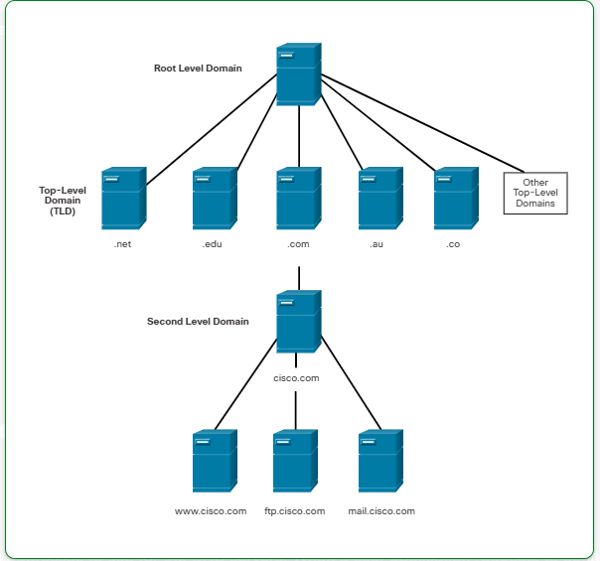

**Common DNS Commands**

Here are essential **DNS-related commands** for troubleshooting and verifying DNS resolution.

**1. nslookup (Windows, Linux, macOS)**

nslookup is used to query DNS servers and obtain domain name/IP address mappings.

**Basic Usage**

nslookup example.com

🔹 Retrieves the IP address of example.com.

**Find Mail (MX) Records**

nslookup -query=mx example.com

🔹 Shows mail server records for example.com.

**Find Name Server (NS) Records**

nslookup -query=ns example.com

🔹 Displays the authoritative name servers for example.com.

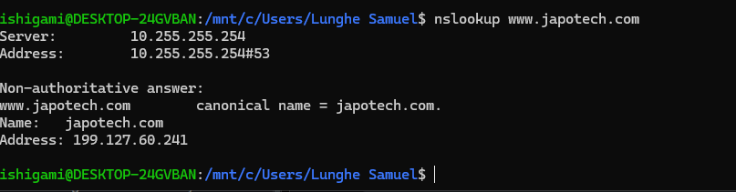

**2. dig (Linux, macOS)**

dig (Domain Information Groper) is a powerful DNS lookup tool.

**Basic Query**

dig example.com

🔹 Retrieves DNS information for example.com.

**Find Specific Record (A, MX, NS, TXT, etc.)**

dig example.com MX

dig example.com A

dig example.com TXT

🔹 Retrieves MX, A, and TXT records for example.com.

**Query a Specific DNS Server**

dig @8.8.8.8 example.com

🔹 Queries Google's DNS server (8.8.8.8) for example.com.

**3. host (Linux, macOS)**

The host command is a simple way to perform DNS lookups.

**Basic Query**

host example.com

🔹 Retrieves the IP address of example.com.

**Find Mail (MX) Records**

host -t MX example.com

🔹 Shows mail exchange records for example.com.

**4. traceroute / tracert**

traceroute (Linux/macOS) or tracert (Windows) shows the path packets take to a destination.

**Windows**

tracert example.com

**Linux/macOS**

traceroute example.com

🔹 Helps diagnose network routing issues.

**5. ping (Windows, Linux, macOS)**

Tests connectivity to a DNS server or website.

ping example.com

🔹 Checks if example.com is reachable.

**6. ipconfig / ifconfig**

Displays network configuration and DNS cache info.

**Windows (ipconfig)**

ipconfig /displaydns

🔹 Shows the local DNS cache.

ipconfig /flushdns

🔹 Clears the DNS cache.

**Linux/macOS (ifconfig or ip command)**

ifconfig

ip addr show

🔹 Displays network interfaces and IP addresses.

**7. systemd-resolve (Linux)**

systemd-resolve --status

🔹 Shows the current DNS resolver settings.

**8. PowerShell (Windows)**

Find DNS information using PowerShell.

Resolve-DnsName example.com

🔹 Retrieves DNS records.

**Summary of Commands**

| **Command** | **OS** | **Purpose** |
| --- | --- | --- |
| nslookup | Windows, Linux, macOS | Query DNS records |
| dig | Linux, macOS | Advanced DNS lookups |
| host | Linux, macOS | Quick DNS queries |
| traceroute / tracert | Linux/macOS, Windows | Shows packet route |
| ping | All | Tests connectivity |
| ipconfig / ifconfig | Windows / Linux, macOS | Network info & DNS cache |
| systemd-resolve | Linux | Check DNS resolver |
| Resolve-DnsName | Windows (PowerShell) | Lookup DNS records |

# Email Protocols

**Simple Mail Transfer Protocol (SMTP)**

* **SMTP** is used by email clients to send messages to their local email server. From there, the server decides whether the message is for a local mailbox or needs to be forwarded to another server.
* If the message is for another server, **SMTP** is also used to transfer the email between the two servers. SMTP operates on **port 25**.
* The process involves:
  + The sender's email client sending a message to the local mail server (ISP A's mail server).
  + If necessary, the message is forwarded to another server (ISP B's mail server).
  + ISP B stores the message for retrieval by the recipient when they check their mailbox.

**Post Office Protocol (POP3)**

* **POP3** is used to download email from a server to a client. It works by receiving and storing messages for the user on the server.
* Once the client connects, the messages are downloaded. By default, once accessed, messages are deleted from the server.
* POP3 uses **port 110**.
* This is ideal for users who prefer to store their emails locally and not leave them on the server.

**Internet Message Access Protocol (IMAP4)**

* **IMAP4** is a more modern email protocol that allows messages to be stored on the server, meaning the user can access them from multiple devices without losing synchronization.
* It differs from POP in that it keeps the messages on the server, unless deleted by the user.
* IMAP4 operates on **port 143** and is useful for users who need to access their email from different locations and devices.

**16.7.3 Text Messaging**

* **Text messaging**, often called instant messaging or chat, is a popular real-time communication method.
* **Instant Messaging (IM)** allows users to send and receive messages almost simultaneously. Both the sender and recipient are clients and servers in this type of communication, as they are able to send and receive messages at the same time.
* Text messaging is built into many applications, smartphone apps, and social media platforms.
  + **Examples of messaging apps** include Cisco Webex Teams, Microsoft Teams, WhatsApp, and Facebook Messenger. These applications are available across many operating systems and devices, and often offer mobile versions as well.
  + Besides text, these platforms typically allow the sharing of multimedia files such as documents, video, music, and audio.
* Users usually access these text messaging services through web-based clients integrated into platforms like social media or information-sharing sites, where they can chat in real-time with other users.

Both **email protocols** (SMTP, POP3, IMAP4) and **text messaging protocols** (instant messaging) are fundamental in modern communication, allowing users to interact in different ways, whether for formal communication (email) or informal, real-time communication (text messaging).

# 🔹 Virtual Terminals (VTY) in Networking

**1️⃣ What is a Virtual Terminal (VTY)?**

A **Virtual Terminal (VTY)** is a **logical connection** used for remote access to a network device (e.g., routers, switches) via command-line interfaces such as **Telnet or SSH**. It allows network administrators to manage devices without being physically present.

🔹 **Key Features:**  
✅ Remote access to network devices  
✅ Supports **Telnet (insecure) and SSH (secure)**  
✅ Configured using **VTY lines** on Cisco devices  
✅ Can support multiple simultaneous sessions

**2️⃣ VTY Lines in Cisco Devices**

Cisco devices have **VTY lines** (Virtual Terminal Lines), usually numbered from **0 to 15**, meaning up to **16 remote connections** can be active at the same time.

📌 **Default VTY lines on Cisco devices:**

line vty 0 4 # Allows 5 concurrent remote sessions (0 to 4)

You can configure more lines if needed.

**3️⃣ How to Configure VTY for Remote Access (Telnet/SSH)**

**🔹 1. Enable VTY and Set a Password**

Router(config)# line vty 0 4

Router(config-line)# password mypassword

Router(config-line)# login

Router(config-line)# exit

👉 **This allows Telnet but is insecure** since passwords are sent in plaintext.

**🔹 2. Secure VTY with SSH (Recommended)**

1️⃣ **Set a domain name (needed for SSH keys)**

Router(config)# ip domain-name example.com

2️⃣ **Generate SSH key pair**

Router(config)# crypto key generate rsa

3️⃣ **Enable SSH access on VTY lines**

Router(config)# line vty 0 4

Router(config-line)# transport input ssh

Router(config-line)# login local

Router(config-line)# exit

4️⃣ **Create a user for SSH authentication**

Router(config)# username admin privilege 15 password securepass

**4️⃣ Connecting to a Virtual Terminal**

✅ **Using Telnet (Insecure)**

telnet <router-ip>

🔹 Example: telnet 192.168.1.1

✅ **Using SSH (Secure)**

ssh admin@192.168.1.1

🔹 Example: ssh admin@192.168.1.1

**5️⃣ Why Use Virtual Terminals?**

🔹 **Remote Administration:** Manage routers/switches from anywhere.  
🔹 **Multi-Session Support:** Multiple users can access the device simultaneously.  
🔹 **Secure Access with SSH:** Prevents unauthorized access and eavesdropping.

Would you like a **step-by-step guide** on setting up SSH or Telnet for a specific device? 🚀

**Telnet vs. SSH: Understanding Remote Access Protocols**

**1️⃣ What Are Telnet and SSH?**

Both **Telnet and SSH** are protocols used for remote access to network devices (routers, switches, servers) via the command line. They allow administrators to configure and monitor devices remotely.

✅ **Telnet (Telecommunication Network)**  
🔹 A legacy protocol for remote access  
🔹 Sends data **in plaintext** (unsecured)  
🔹 Uses **port 23**  
🔹 No encryption – vulnerable to attacks

✅ **SSH (Secure Shell)**  
🔹 Secure alternative to Telnet  
🔹 Uses **encryption** to protect data  
🔹 Uses **port 22**  
🔹 Supports secure authentication and data integrity

**2️⃣ How Do They Work?**

**🔹 How Telnet Works**

1️⃣ A user initiates a **Telnet session** to a remote device using:

telnet <IP-Address>

2️⃣ The server **authenticates** the user using a **username/password**.  
3️⃣ Once authenticated, the user gets a **command-line interface** to control the device.  
4️⃣ Commands sent between the client and server **are not encrypted**, making it easy for attackers to intercept login credentials and session data.

📌 **Security Risk**:

* Since Telnet sends data in **plain text**, an attacker using a packet sniffer can easily **capture usernames and passwords**.
* Not recommended for use in modern networks.

**🔹 How SSH Works**

1️⃣ A user initiates an **SSH session** using:

ssh <username>@<IP-Address>

2️⃣ The SSH server **authenticates** the user using one of two methods:

* **Password authentication** (securely encrypted)
* **Public key authentication** (preferred for better security)  
  3️⃣ Once authenticated, the session is **fully encrypted**, preventing any third-party from reading or modifying the communication.  
  4️⃣ Commands and responses are exchanged securely.

📌 **Security Benefits of SSH:**  
✅ Uses **strong encryption** (AES, RSA, etc.)  
✅ Protects against **MITM (Man-in-the-Middle) attacks**  
✅ Supports **key-based authentication** for extra security

**3️⃣ Key Differences Between Telnet and SSH**

| **Feature** | **Telnet** | **SSH** |
| --- | --- | --- |
| **Port** | 23 | 22 |
| **Encryption** | ❌ No | ✅ Yes (AES, RSA, etc.) |
| **Security** | ❌ Not secure | ✅ Highly secure |
| **Authentication** | Username/Password | Password or Key-based |
| **Data Transmission** | Plaintext (Easily intercepted) | Encrypted (Safe from eavesdropping) |
| **Best for** | Private or legacy networks | Modern networks & internet |

**4️⃣ How to Configure SSH on a Cisco Router**

**🔹 Step 1: Enable SSH on a Cisco Router**

1️⃣ Set a **domain name** (needed for SSH keys)

Router(config)# ip domain-name example.com

2️⃣ Generate an **RSA key pair** for encryption

Router(config)# crypto key generate rsa

3️⃣ Set a **username and password** for authentication

Router(config)# username admin privilege 15 password securepass

4️⃣ Enable SSH on **VTY lines**

Router(config)# line vty 0 4

Router(config-line)# transport input ssh

Router(config-line)# login local

Router(config-line)# exit

5️⃣ Save the configuration

Router# write memory

**5️⃣ How to Connect Using SSH and Telnet**

✅ **Connect Using Telnet**

telnet <IP-Address>

🔹 Example: telnet 192.168.1.1  
❗ **Warning:** Insecure, use only on trusted local networks.

✅ **Connect Using SSH**

ssh <username>@<IP-Address>

🔹 Example: ssh admin@192.168.1.1  
🔒 **Much more secure than Telnet!**

**6️⃣ When to Use SSH vs. Telnet?**

✅ **Use SSH for:**  
🔹 Secure remote access  
🔹 Configuring routers, switches, and servers over the internet  
🔹 Transmitting sensitive data

🚫 **Avoid Telnet unless:**  
🔹 You are on a **completely private** and trusted network  
🔹 The device does **not support SSH** (rare cases)

**7️⃣ Final Thoughts**

* **Always prefer SSH over Telnet** for security reasons.
* SSH encrypts all communications, making it safe for remote access.
* Telnet should be **disabled** on modern networks unless absolutely necessary.

# Web Client and Web Server Communication

**1. What is a Web Client?**

A **web client** is any device or application (e.g., web browser) that requests web pages or other resources from a **web server**.

Examples:

* **Web browsers** (Chrome, Firefox, Edge)
* **Mobile applications**
* **Command-line tools** (cURL, wget)

**2. What is a Web Server?**

A **web server** is software that handles client requests and delivers web pages or other resources.

Examples:

* **Apache HTTP Server**
* **NGINX**
* **Microsoft IIS**
* **Node.js (Express.js)**

**3. How Web Clients and Servers Communicate**

Communication follows the **Client-Server Model** using the **HTTP/HTTPS** protocol.

**Steps of Communication**

1. **Client Sends a Request**
   * A browser requests a web page by entering a URL (e.g., https://example.com).
   * The request is sent using **HTTP/HTTPS**.
2. **Server Processes the Request**
   * The web server checks for the requested resource (HTML, CSS, JavaScript, images, etc.).
   * If the resource exists, it sends a **response**.
   * If the resource is missing, the server returns an **HTTP 404 Not Found** error.
3. **Client Receives and Renders the Response**
   * The browser processes the response and displays the web page.
   * If additional resources are needed (e.g., images, CSS, JavaScript), the browser makes separate requests.

**4. Understanding the Socket in Web Communication**

A **socket** is an endpoint for communication between the web client and the web server. It is identified by:

* **IP Address** (e.g., 192.168.1.1)
* **Port Number** (e.g., 80 for HTTP, 443 for HTTPS)

**Example: Establishing a Connection Using a Socket**

* The client creates a **socket** and connects to the server’s **socket** (IP + Port).
* The server listens for incoming connections on a specific **port** (e.g., 80 for HTTP).
* Once connected, data is exchanged through the socket.

**5. Example of a Web Request and Response**

**Client (Browser) Request:**

GET /index.html HTTP/1.1

Host: example.com

User-Agent: Mozilla/5.0

Accept: text/html

**Server Response:**

HTTP/1.1 200 OK

Content-Type: text/html

Content-Length: 1256

<html>

<head><title>Welcome</title></head>

<body><h1>Hello, World!</h1></body>

</html>

**6. Summary of Web Communication**

| **Component** | **Description** |
| --- | --- |
| **Web Client** | Requests web pages (Browser, Mobile App) |
| **Web Server** | Processes requests and sends responses (Apache, NGINX) |
| **HTTP/HTTPS** | Protocols used for communication |
| **Socket** | Endpoint for data exchange (IP + Port) |
| **GET/POST** | Common HTTP request methods |

# WebSockets: Real-Time Web Communication

**1. What is WebSocket?**

WebSocket is a **full-duplex** communication protocol that allows continuous, bidirectional data exchange between a **client** and a **server** over a **single TCP connection**.

Unlike HTTP, which follows a **request-response** model, WebSocket enables real-time communication **without repeatedly sending requests**.

**2. Key Features of WebSockets**

* **Persistent connection**: Stays open until closed by either the client or server.
* **Low latency**: Eliminates the overhead of establishing new connections.
* **Bidirectional communication**: Both client and server can send messages at any time.
* **Uses TCP (port 80 or 443)**: Works seamlessly with firewalls and proxies.

**3. How WebSockets Work**

1. **Handshake (Upgrade Request)**
   * The client sends an HTTP request to **upgrade** the connection to WebSocket.
   * If the server supports WebSocket, it responds with an **HTTP 101 Switching Protocols** status.
2. **Persistent Connection**
   * Once the connection is established, the client and server can send and receive messages at any time.
3. **Closing the Connection**
   * Either side can **terminate** the connection when communication is no longer needed.

**4. WebSocket Example**

**Client WebSocket Request (Handshake)**

GET /chat HTTP/1.1

Host: example.com

Upgrade: websocket

Connection: Upgrade

Sec-WebSocket-Key: x3JJHMbDL1EzLkh9YZrdRA==

Sec-WebSocket-Version: 13

**Server Response (Handshake Success)**

HTTP/1.1 101 Switching Protocols

Upgrade: websocket

Connection: Upgrade

Sec-WebSocket-Accept: HSmrc0sMlYUkAGmm5OPpG2HaGWk=

**Message Exchange (After Handshake)**

* **Client sends message:** "Hello Server"
* **Server responds:** "Hello Client"

**5. WebSocket vs HTTP**

| **Feature** | **WebSocket** | **HTTP** |
| --- | --- | --- |
| Communication Type | Full-duplex | Request-response |
| Connection | Persistent | Reopens per request |
| Latency | Low | Higher |
| Use Case | Real-time apps | Standard web pages |

**6. WebSocket Use Cases**

* **Chat Applications** 🗨️
* **Live Stock Market Feeds** 📈
* **Online Multiplayer Games** 🎮
* **Live Sports Scores** 🏆
* **IoT (Internet of Things) Communication** 🌐

**WebSockets in IoT Communication 🌐🔌**

WebSockets play a crucial role in **real-time data exchange** for IoT applications. They enable **low-latency, full-duplex communication** between IoT devices, cloud servers, and user applications.

**🔹 Use Cases of WebSockets in IoT Communication**

**1. Smart Home Automation 🏡**

* WebSockets allow IoT devices like **smart lights, thermostats, and security cameras** to communicate with a central hub or mobile app **instantly**.
* Example: A user turns on a smart light from their phone, and the **light responds immediately** via WebSockets.

**2. Real-Time Sensor Data Streaming 📡**

* IoT sensors (e.g., **temperature, humidity, gas, motion detectors**) send continuous **real-time** data to a cloud server.
* Example: A **weather station** streams live temperature and humidity readings to a dashboard using WebSockets.

**3. Industrial IoT (IIoT) & Smart Manufacturing 🏭**

* Machines and robotic arms in factories **send status updates** to control systems via WebSockets.
* Example: A **fault detection system** notifies engineers in real-time when a machine malfunctions.

**4. Smart Healthcare 🏥**

* WebSockets enable real-time **patient monitoring** (e.g., heart rate, oxygen levels) by transmitting data from IoT **wearable devices** to doctors.
* Example: A smartwatch detects an **irregular heartbeat** and immediately alerts a doctor.

**5. Connected Vehicles & Smart Traffic 🚗🚦**

* Vehicles and traffic control systems use WebSockets for **live GPS tracking, speed monitoring, and accident alerts**.
* Example: A **fleet management system** receives real-time location data from delivery trucks.

**6. Smart Agriculture 🌾🚜**

* IoT sensors in farms monitor **soil moisture, temperature, and crop conditions**, sending real-time updates to farmers via WebSockets.
* Example: **Irrigation systems** automatically adjust water supply based on sensor data.

**7. Remote Surveillance & Security Systems 🎥🔐**

* WebSockets enable **real-time video streaming** and instant motion detection alerts for security cameras.
* Example: A **smart doorbell camera** streams live video to a homeowner's smartphone.

**🔹 Why Use WebSockets in IoT?**

✅ **Low Latency** – Immediate updates without delays.  
✅ **Efficient** – Reduces network overhead compared to traditional HTTP polling.  
✅ **Persistent Connection** – Devices stay connected for continuous communication.  
✅ **Bidirectional** – Devices and servers can send/receive messages anytime.

Here’s a **WebSocket example** for an **IoT application** using **Node.js** for the server and a Python script for an IoT device (e.g., a temperature sensor).

**🔹 WebSocket IoT Example: Real-Time Temperature Monitoring**

**1️⃣ WebSocket Server (Node.js)**

This server receives **temperature data** from an IoT device and broadcasts it to all connected clients.

const WebSocket = require("ws");

const server = new WebSocket.Server({ port: 8080 });

console.log("WebSocket Server started on ws://localhost:8080");

server.on("connection", (ws) => {

console.log("New device connected");

ws.on("message", (message) => {

console.log("Received:", message);

// Broadcast data to all connected clients

server.clients.forEach(client => {

if (client.readyState === WebSocket.OPEN) {

client.send(message);

}

});

});

ws.on("close", () => {

console.log("Device disconnected");

});

});

**2️⃣ IoT Device (Python)**

This script simulates an **IoT sensor** that sends temperature data to the WebSocket server.

import websocket

import time

import json

import random

ws = websocket.WebSocket()

ws.connect("ws://localhost:8080")

while True:

temperature = round(random.uniform(20, 30), 2) # Simulated temperature

data = {"device": "Temperature Sensor", "temperature": temperature}

ws.send(json.dumps(data))

print(f"Sent: {data}")

time.sleep(2) # Send data every 2 seconds

**3️⃣ Web Client (JavaScript)**

This client connects to the WebSocket server and **displays real-time temperature updates**.

<!DOCTYPE html>

<html lang="en">

<head>

<title>IoT WebSocket Client</title>

</head>

<body>

<h1>Real-Time Temperature Data</h1>

<div id="data"></div>

<script>

const ws = new WebSocket("ws://localhost:8080");

ws.onmessage = (event) => {

const data = JSON.parse(event.data);

document.getElementById("data").innerHTML =

`<p>Temperature: ${data.temperature}°C</p>`;

};

</script>

</body>

</html>

**📌 How It Works**

1️⃣ The **IoT device (Python script)** generates a **random temperature** and sends it to the **WebSocket server**.  
2️⃣ The **WebSocket server (Node.js)** receives the data and **broadcasts it** to all connected clients.  
3️⃣ The **Web client (HTML + JS)** displays the **real-time temperature data** dynamically.

**🔹** FTP Clients and Servers: Overview & How They Work

**1️⃣ What is FTP?**

**FTP (File Transfer Protocol)** is a protocol used for transferring files between a **client** and a **server** over a network (LAN or Internet). It operates on **port 21** for command control and **port 20** for data transfer (in active mode).

**2️⃣ FTP Server & Client Model**

* **FTP Server**: A computer that stores files and allows clients to access them.
* **FTP Client**: A program or command-line tool that connects to the FTP server to upload or download files.

📌 **Common FTP Clients**:

* FileZilla
* WinSCP
* Cyberduck
* Command-line FTP (ftp command)

📌 **Common FTP Servers**:

* vsftpd (Linux)
* ProFTPD (Linux)
* FileZilla Server (Windows)

**3️⃣ FTP Connection Modes**

🔹 **Active Mode:**

* The client opens a **command channel** to port **21** on the server.
* The server initiates a **data connection** back to the client.
* Firewalls may block the server’s incoming connection, causing issues.

🔹 **Passive Mode (PASV):**

* The client requests the server to **open a port** for data transfer.
* The client then connects to this **random port** instead of expecting a connection.
* **PASV mode is more firewall-friendly** and widely used.

**4️⃣ FTP Commands (CLI Usage)**

📌 **Basic FTP Commands** (Linux/Windows Terminal)

ftp <server-ip>

Once connected:

* ls → List files
* cd <dir> → Change directory
* get <file> → Download a file
* put <file> → Upload a file
* mget * → Download multiple files
* mput * → Upload multiple files
* bye → Close connection

📌 **Example Usage**

ftp 192.168.1.100

Then login with **username/password**, and use get or put to transfer files.

**5️⃣ Secure FTP Alternatives**

FTP is **not secure** because data is transmitted **unencrypted**. Use these secure alternatives:  
✔ **SFTP (SSH File Transfer Protocol)** → Uses SSH for encryption.  
✔ **FTPS (FTP Secure)** → FTP over TLS/SSL encryption.

# 14. URI, URN, and URL: Understanding the Differences

In networking and web development, **URI, URN, and URL** are often used interchangeably, but they have distinct meanings.

**1. URI (Uniform Resource Identifier)**

A **URI** is a generic term for anything that uniquely identifies a resource on the internet. It can be a **URL**, a **URN**, or both.

🔹 **Example of a URI:**

https://www.example.com/index.html

urn: isbn:0451450523

👉 **Think of URI as an umbrella term** that includes URLs and URNs.

**2. URL (Uniform Resource Locator)**

A **URL** is a type of **URI** that specifies the **location** of a resource **AND how to access it**. It includes:

* **Protocol** (e.g., HTTP, FTP)
* **Domain Name or IP Address**
* **Path to the resource**

🔹 **Example of a URL:**

https://www.example.com/index.html

ftp://files.example.com/download.zip

👉 **If it tells you *where* a resource is and *how* to access it, it’s a URL.**

**3. URN (Uniform Resource Name)**

A **URN** is a **unique, location-independent** identifier for a resource, but it doesn’t specify how to access it.

🔹 **Example of a URN:**

urn:isbn:0451450523 (Identifies a book by its ISBN)

urn:ietf:rfc:3986 (Identifies an RFC document)

👉 **If it uniquely names something but doesn’t specify its location, it’s a URN.**

**4. Key Differences**

| **Feature** | **URI** | **URL** | **URN** |
| --- | --- | --- | --- |
| Identifies a resource | ✅ | ✅ | ✅ |
| Specifies location | ❌ | ✅ | ❌ |
| Specifies access method (protocol) | ❌ | ✅ | ❌ |
| Can be used to retrieve a resource | ❌ | ✅ | ❌ |

**5. Real-World Analogy**

Imagine a **library** 📚:

* **URN** → The ISBN of a book (e.g., ISBN 978-3-16-148410-0) 📖
* **URL** → The physical location of the book (e.g., "Aisle 3, Shelf 2") 🏛️
* **URI** → Could be either of the two!

**6. Summary**

* **URI**: Any identifier for a resource (URN or URL).
* **URL**: Identifies *and* locates a resource (includes protocol).
* **URN**: Identifies a resource *without* specifying its location or access method.

# 15. Difference Between Bandwidth and Throughput

| **Feature** | **Bandwidth** | **Throughput** |
| --- | --- | --- |
| **Definition** | The maximum data transfer capacity of a network link, measured in bits per second (bps). | The actual amount of data successfully transmitted over a network in a given time. |
| **Measurement Unit** | Typically measured in **bps (bits per second)**, Kbps, Mbps, or Gbps. | Also measured in **bps (bits per second)** but reflects real-time performance. |
| **Indicates** | **Potential** speed of a network connection. | **Actual** speed experienced by users. |
| **Factors Affecting It** | Determined by the network infrastructure (cables, routers, etc.). | Affected by congestion, latency, packet loss, and network errors. |
| **Example** | A fiber optic connection may have a **1 Gbps bandwidth**, meaning it can handle up to 1 Gbps of data transfer. | Due to network congestion, the actual **throughput** may be only **600 Mbps**. |

**Key Takeaway:**

* **Bandwidth** is like a highway's total lane capacity.
* **Throughput** is the number of cars actually passing through in a given time.

**Bandwidth vs. Throughput: A Detailed Explanation with Examples**

Imagine you are driving on a highway. The **total number of lanes** represents **bandwidth**, while the **number of cars that actually pass through per second** represents **throughput**. If traffic congestion occurs, fewer cars move through than the total lane capacity, just like how network congestion can reduce throughput.

**1. What is Bandwidth?**

**Definition:** Bandwidth is the **maximum** data transfer capacity of a network connection. It determines how much data can be sent or received per second, typically measured in:

* **bps (bits per second)**
* **Kbps (Kilobits per second)**
* **Mbps (Megabits per second)**
* **Gbps (Gigabits per second)**

**Example:**

If you have a **100 Mbps** internet plan, that means your network **can** transmit up to **100 Megabits per second** under ideal conditions.

However, **this doesn’t mean** you’ll always get 100 Mbps speed while browsing or downloading. That’s where throughput comes in.

**2. What is Throughput?**

**Definition:** Throughput is the **actual** amount of data successfully transmitted over the network in a given time. It is affected by:

* **Network congestion (high traffic slows it down)**
* **Signal interference (especially on Wi-Fi networks)**
* **Hardware limitations (old routers or slow devices)**
* **Packet loss (some data packets may need to be retransmitted, reducing speed)**

**Example:**

Let’s say you have a **100 Mbps** internet connection (bandwidth), but when you run a speed test, you only get **60 Mbps**.

* This means your **throughput** is 60 Mbps, which is **lower** than the maximum possible bandwidth due to congestion, interference, or other factors.

**3. Key Differences Between Bandwidth and Throughput**

| **Feature** | **Bandwidth** | **Throughput** |
| --- | --- | --- |
| **Definition** | The maximum data transfer capacity of a network. | The actual data transfer rate at a given moment. |
| **Measures** | Potential speed. | Real-time performance. |
| **Unit** | bps, Kbps, Mbps, Gbps. | bps, Kbps, Mbps, Gbps. |
| **Example** | A 1 Gbps fiber-optic connection. | Only 800 Mbps may be usable due to network traffic. |
| **Affects** | Theoretical limits of the network. | Real-world user experience. |
| **Can It Change?** | Fixed unless you upgrade your plan. | Varies depending on network conditions. |

**4. Real-World Example**

Let’s say you are downloading a large file.

* Your internet provider offers a **200 Mbps** bandwidth.
* Due to congestion, interference, or server limitations, your **actual download speed** (throughput) may only be **120 Mbps**.
* This means you are **not using the full capacity** of your bandwidth.

**5. Final Takeaway**

* **Bandwidth** = Highway **capacity** (potential speed).
* **Throughput** = **Actual traffic flow** (real-world speed).
* **Higher bandwidth doesn’t always mean higher throughput** due to network conditions.

Here’s a simple visual representation of **Bandwidth vs. Throughput**:

**🚗 Highway Analogy**

Imagine a **4-lane highway** where each lane can handle **100 cars per minute**.

1. **Bandwidth (Theoretical Maximum Capacity)**
   * The highway **can** allow up to **400 cars per minute** (4 lanes × 100 cars).
   * This is like a **400 Mbps** internet connection.
2. **Throughput (Actual Data Transfer Rate)**
   * Due to **traffic congestion, accidents, or speed limits**, only **250 cars** actually move per minute.
   * This is like **250 Mbps** being the actual usable speed.

**Network Example**

📶 **You have a 100 Mbps Wi-Fi plan.**  
🔽 **Downloading a file** during peak hours:

* Your bandwidth is **100 Mbps**, but **only 50 Mbps** is available due to congestion.
* Your **throughput = 50 Mbps**, not 100 Mbps.

Here’s a simple diagram to illustrate it:

📡 **Bandwidth (Total Capacity)**

[============================] → 100 Mbps (Ideal Speed)

📶 **Throughput (Actual Speed)**

[========= ] → 50 Mbps (Real-World Speed)

# Clients and Servers: Understanding the Basics

In networking, **clients and servers** are two key components that enable communication and data exchange over a network.

**1. What is a Client?**

A **client** is a device (computer, smartphone, or software application) that **requests services or resources** from a server. Clients rely on servers to provide data, store files, or process requests.

**Examples of Clients**

* **Web Browser (Chrome, Firefox, Edge)** → Requests web pages from a web server.
* **Email Application (Outlook, Gmail app)** → Requests emails from a mail server.
* **Streaming Apps (Netflix, YouTube)** → Requests and plays videos from media servers.

**Key Characteristics of Clients**

✅ Initiates communication with the server.  
✅ Consumes resources or services provided by the server.  
✅ Typically has a **user interface** for interaction.

**2. What is a Server?**

A **server** is a powerful computer or software program that **responds to client requests** and provides data or services. Servers are designed to handle multiple requests simultaneously.

**Examples of Servers**

* **Web Server (Apache, Nginx, IIS)** → Delivers web pages to browsers.
* **File Server** → Stores and manages shared files.
* **Database Server (MySQL, PostgreSQL)** → Stores and retrieves data requested by applications.
* **Game Server** → Hosts multiplayer online games.

**Key Characteristics of Servers**

✅ Waits for client requests and responds.  
✅ Stores and manages data.  
✅ Can handle **multiple clients** at once.

**3. Client-Server Communication Process**

🔹 **Step 1:** The client sends a request to the server (e.g., opening a website).  
🔹 **Step 2:** The server processes the request.  
🔹 **Step 3:** The server sends back the requested data (e.g., the web page loads).

🔄 This interaction follows a **request-response model** over protocols like **HTTP, FTP, or SMTP**.

**4. Key Differences Between Clients and Servers**

| **Feature** | **Client** | **Server** |
| --- | --- | --- |
| **Role** | Requests services/data | Provides services/data |
| **Examples** | Browser, Email App, Mobile App | Web Server, Database Server, File Server |
| **Who Initiates Communication?** | Client | Waits for requests |
| **Power & Storage** | Usually low to medium | High processing power and large storage |
| **Simultaneous Connections** | Connects to one or more servers | Handles multiple clients at once |

**5. Real-World Example: Website Access**

1️⃣ **Client:** You type www.google.com into Chrome (browser).  
2️⃣ **Request:** The browser sends an HTTP request to Google’s **web server**.  
3️⃣ **Server Response:** Google’s web server sends back the search page.  
4️⃣ **Client Displays Data:** Your browser loads the page, and you can now use Google.

**6. Conclusion**

* **Clients** request services, while **servers** provide them.
* The internet works on the **client-server model**, enabling seamless communication.
* Common protocols used: **HTTP (web browsing), FTP (file transfer), SMTP (email sending).**

**Types of Servers in Networking**

Servers come in different types, each serving a specific function. Below are the most common types of servers:

**1. Web Server 🌐**

A **web server** stores and delivers web pages to clients (browsers) over the internet.  
📌 **Protocol Used:** HTTP/HTTPS

🔹 **Examples:**

* Apache
* Nginx
* Microsoft IIS

🔹 **Use Case:**  
When you visit www.google.com, a web server sends the webpage to your browser.

**2. File Server 📁**

A **file server** provides a centralized location where users can store, access, and share files over a network.  
📌 **Protocol Used:** FTP, SMB, NFS

🔹 **Examples:**

* Windows Server File Sharing
* Samba (Linux-based)
* Network Attached Storage (NAS)

🔹 **Use Case:**  
In an office, employees can store and retrieve documents from a file server instead of keeping them on individual computers.

**3. Database Server 🗄️**

A **database server** manages and stores large amounts of structured data and responds to queries from clients.  
📌 **Protocol Used:** SQL

🔹 **Examples:**

* MySQL
* PostgreSQL
* Microsoft SQL Server

🔹 **Use Case:**  
Online banking systems store customer account details on a database server.

**4. Email Server 📧**

An **email server** handles the sending, receiving, and storage of emails.  
📌 **Protocols Used:** SMTP (sending), IMAP & POP3 (receiving)

🔹 **Examples:**

* Microsoft Exchange
* Postfix
* Gmail Servers

🔹 **Use Case:**  
When you send an email via Gmail, an email server routes your message to the recipient’s mail server.

**5. DNS Server 🌍**

A **DNS (Domain Name System) server** translates domain names (e.g., www.google.com) into IP addresses.  
📌 **Protocol Used:** DNS

🔹 **Examples:**

* Google Public DNS (8.8.8.8)
* Cloudflare DNS (1.1.1.1)
* OpenDNS

🔹 **Use Case:**  
When you enter www.facebook.com, a DNS server finds the correct IP address to connect your browser to the Facebook web server.

**6. Proxy Server 🛡️**

A **proxy server** acts as an intermediary between a client and the internet, improving security and caching data for faster access.  
📌 **Protocol Used:** HTTP, HTTPS

🔹 **Examples:**

* Squid Proxy
* Nginx
* Cloudflare

🔹 **Use Case:**  
Companies use proxy servers to **restrict access** to certain websites and **protect** internal networks.

**7. Application Server 🖥️**

An **application server** runs and manages business applications for clients.  
📌 **Protocol Used:** HTTP, HTTPS, WebSockets

🔹 **Examples:**

* Apache Tomcat
* JBoss
* IBM WebSphere

🔹 **Use Case:**  
When using an online shopping app, the application server handles product searches and transactions.

**8. Game Server 🎮**

A **game server** hosts multiplayer games, allowing players to connect and interact.  
📌 **Protocol Used:** TCP/UDP

🔹 **Examples:**

* Minecraft Servers
* Counter-Strike Servers
* Fortnite Servers

🔹 **Use Case:**  
When playing **Call of Duty** online, a game server keeps all players connected in real-time.

**9. Cloud Server ☁️**

A **cloud server** is a virtual server hosted on the internet, providing computing power and storage.  
📌 **Service Providers:** AWS, Google Cloud, Microsoft Azure

🔹 **Use Case:**  
Google Drive and Dropbox use cloud servers to store and sync files across devices.

**10. Print Server 🖨️**

A **print server** manages and controls network printers, allowing multiple users to share a printer.  
📌 **Protocol Used:** IPP (Internet Printing Protocol)

🔹 **Use Case:**  
In an office, employees can send print jobs to a shared printer via the print server.

**11. VoIP Server 📞**

A **VoIP (Voice over IP) server** enables internet-based phone calls instead of traditional telephone networks.  
📌 **Protocol Used:** SIP, RTP

🔹 **Examples:**

* Asterisk
* Cisco Call Manager

🔹 **Use Case:**  
Companies use VoIP servers for internal communication via Skype or Zoom.

**Summary Table**

| **Server Type** | **Function** |
| --- | --- |
| **Web Server** 🌐 | Hosts and delivers websites. |
| **File Server** 📁 | Stores and shares files over a network. |
| **Database Server** 🗄️ | Manages and stores structured data. |
| **Email Server** 📧 | Sends, receives, and stores emails. |
| **DNS Server** 🌍 | Converts domain names into IP addresses. |
| **Proxy Server** 🛡️ | Acts as a gateway for security and caching. |
| **Application Server** 🖥️ | Runs business applications. |
| **Game Server** 🎮 | Hosts online multiplayer games. |
| **Cloud Server** ☁️ | Provides cloud-based computing and storage. |
| **Print Server** 🖨️ | Manages network printers. |
| **VoIP Server** 📞 | Handles internet-based phone calls. |

# Peer-to-Peer (P2P) Network: Overview & Key Concepts

A **Peer-to-Peer (P2P) network** is a decentralized network where computers (or devices) communicate **directly with each other** without relying on a central server.

**1. What is a Peer-to-Peer Network?**

🔹 In a **P2P network**, all devices (called **peers**) are **equal** and can act as both **clients and servers**.  
🔹 Each peer can **send, receive, and share resources** (e.g., files, data, processing power) directly with other peers.  
🔹 Unlike the **Client-Server Model**, where a central server controls data flow, P2P networks **distribute** tasks among all connected devices.

**2. Key Features of P2P Networks**

✅ **Decentralized** → No central server; all peers share resources.  
✅ **Scalable** → More peers can join without overloading a single server.  
✅ **Resource Sharing** → Peers share files, bandwidth, and processing power.  
✅ **Resilient** → If one peer fails, the network continues working.  
✅ **Efficient for Large Data Transfer** → Common in file-sharing and blockchain technology.

**3. Types of P2P Networks**

**A. Pure P2P Network**

📌 **Definition:** Every device is equal, with no central authority or indexing server.

🔹 **Example:**

* Bitcoin & other blockchain networks (fully decentralized transactions).
* Some file-sharing applications like **Freenet**.

**B. Hybrid P2P Network**

📌 **Definition:** Uses a **centralized server** for indexing/searching, but data transfer happens directly between peers.

🔹 **Example:**

* **Napster** (early file-sharing service)
* **BitTorrent** (uses a tracker for indexing but allows peer-to-peer file transfer).

**C. Structured P2P Network**

📌 **Definition:** Organizes peers into a specific structure (e.g., Distributed Hash Table - DHT) for **efficient search and retrieval**.

🔹 **Example:**

* **Kademlia** (used in some torrent clients like eMule and BitTorrent DHT).

**D. Unstructured P2P Network**

📌 **Definition:** Peers connect randomly, making searching less efficient but easy to set up.

🔹 **Example:**

* **Gnutella** (used by LimeWire and BearShare for file sharing).

**4. Advantages of P2P Networks**

✅ **No Central Point of Failure** – If one peer goes offline, the network continues.  
✅ **Cost-Effective** – No need for expensive central servers.  
✅ **Faster File Transfers** – Large files can be downloaded in pieces from multiple peers.  
✅ **Scalable** – More peers can join without affecting performance.  
✅ **Supports Decentralized Applications (DApps)** – Used in blockchain and cryptocurrency networks.

**5. Disadvantages of P2P Networks**

❌ **Security Risks** – No central authority means higher risk of malware and unauthorized access.  
❌ **Difficult to Manage** – No administrator to control traffic or prevent unauthorized sharing.  
❌ **Performance Issues** – Speed depends on the number of active peers and their internet connections.  
❌ **Legal Issues** – Some P2P networks are used for piracy (e.g., illegal file sharing).

**6. Real-World Applications of P2P Networks**

| **Application Area** | **Example** |
| --- | --- |
| **File Sharing** | BitTorrent, eMule, Gnutella |
| **Blockchain & Cryptocurrency** | Bitcoin, Ethereum |
| **Decentralized Messaging** | Signal (peer-to-peer encryption) |
| **Distributed Computing** | SETI@home (uses peer computers for data processing) |
| **VoIP Communication** | Skype (early versions used P2P) |
| **Streaming & Gaming** | PeerTube (decentralized video streaming) |

**7. Peer-to-Peer vs. Client-Server Model**

| **Feature** | **Peer-to-Peer (P2P)** | **Client-Server** |
| --- | --- | --- |
| **Structure** | Decentralized | Centralized |
| **Data Sharing** | Directly between peers | Through a central server |
| **Reliability** | High (if many peers are available) | Depends on server uptime |
| **Security** | Lower (risk of malicious peers) | Higher (centralized security) |
| **Scalability** | High | Limited by server capacity |
| **Example** | BitTorrent, Bitcoin | Websites, Email Servers |

**8. Conclusion**

* **P2P networks** are ideal for **decentralized applications, file sharing, and cryptocurrency**.
* They **eliminate the need for central servers** but require **security measures** to prevent abuse.
* The future of **Web3, blockchain, and decentralized applications (DApps)** depends heavily on **P2P technology**.

**You said:**

# Network Components: Essential Devices and Their Functions

A computer network consists of various **hardware** and **software** components that work together to enable communication, data transfer, and connectivity.

**1. Hardware Components of a Network**

**A. End Devices (Hosts)**

📌 **Definition:** Devices that initiate or receive network communication.

🔹 **Examples:**

* **Computers (PCs, Laptops, Servers)** – Used for computing tasks and data processing.
* **Mobile Devices (Smartphones, Tablets)** – Wireless communication and internet access.
* **Printers & Scanners** – Network-enabled devices for document processing.
* **Smart Devices (IoT Devices, Smart TVs)** – Connect to the network for automation and control.

**B. Networking Devices (Intermediary Devices)**

📌 **Definition:** Devices that connect and manage data traffic within a network.

🔹 **Examples:**  
1️⃣ **Router** – Connects different networks (e.g., home network to the internet), assigns IP addresses, and manages data traffic.  
2️⃣ **Switch** – Connects multiple devices in a LAN and forwards data based on MAC addresses.  
3️⃣ **Hub** – A basic device that broadcasts data to all connected devices (less efficient than a switch).  
4️⃣ **Modem** – Converts digital data into signals for internet access (used for DSL, fiber, or cable connections).  
5️⃣ **Access Point (AP)** – Provides **Wi-Fi** connectivity by extending network coverage.  
6️⃣ **Firewall** – Protects a network by monitoring and filtering incoming/outgoing traffic.

**C. Transmission Media**

📌 **Definition:** The medium through which data travels in a network.

🔹 **Examples:**  
✅ **Wired Media**

* **Twisted Pair Cables (Ethernet, Cat5, Cat6)** – Used for LAN connections.
* **Coaxial Cable** – Used in broadband and cable TV networks.
* **Fiber Optic Cable** – High-speed data transmission using light signals.

✅ **Wireless Media**

* **Radio Waves (Wi-Fi, Bluetooth, Cellular)** – Used for wireless communication.
* **Microwave & Satellite Communication** – Used for long-distance networking.

**2. Software Components of a Network**

**A. Network Operating System (NOS)**

📌 **Definition:** A system that manages network resources and communication.  
🔹 **Examples:** Windows Server, Linux Ubuntu Server, Cisco IOS.

**B. Network Protocols**

📌 **Definition:** Rules that govern data transmission in a network.  
🔹 **Examples:**

* **TCP/IP** – Standard for internet communication.
* **HTTP/HTTPS** – Used for web browsing.
* **FTP** – Transfers files between computers.
* **DNS** – Converts domain names to IP addresses.

**C. Security Software**

📌 **Definition:** Protects the network from threats and attacks.  
🔹 **Examples:** Firewalls, Antivirus, Intrusion Detection Systems (IDS).

**3. Network Infrastructure Types**

🔹 **Local Area Network (LAN)** – Covers a small area like a home or office.  
🔹 **Wide Area Network (WAN)** – Connects multiple locations over long distances.  
🔹 **Metropolitan Area Network (MAN)** – Covers a city or large campus.  
🔹 **Wireless Networks (Wi-Fi, 4G, 5G)** – Enables wireless communication.

**4. Summary Table: Network Components & Their Functions**

| **Component** | **Function** |
| --- | --- |
| **Router** | Connects networks, directs data, assigns IPs |
| **Switch** | Connects multiple devices, forwards data efficiently |
| **Hub** | Broadcasts data to all connected devices |
| **Modem** | Converts digital signals for internet access |
| **Access Point** | Provides wireless connectivity |
| **Firewall** | Secures the network by filtering traffic |
| **Cables (Ethernet, Fiber, Coaxial)** | Transmit data over a wired connection |
| **Wireless Signals (Wi-Fi, Bluetooth, LTE, 5G)** | Enable wireless communication |
| **Network Protocols (TCP/IP, HTTP, FTP, DNS)** | Define data transmission rules |

# ISP Connectivity: Understanding Internet Service Providers (ISPs)

**Internet Service Providers (ISPs)** are organizations that offer internet access to individuals, businesses, and other organizations. They provide the necessary infrastructure, services, and support to enable users to connect to the internet. ISP connectivity refers to the various types of internet connections that ISPs offer and how they deliver these connections to end-users.

**1. What is an ISP?**

📌 **Definition:**  
An **Internet Service Provider (ISP)** is a company that provides customers with access to the internet. ISPs also offer services like email, web hosting, and sometimes software packages. ISPs can vary in terms of the type of connection they provide, speed, reliability, and cost.

**2. Types of ISP Connectivity**

There are different methods that ISPs use to connect users to the internet. The choice of connection depends on factors like location, availability, and the user's needs.

**A. Dial-up Connection**

📌 **Description:**

* **Oldest and slowest** form of internet access.
* Uses a **telephone line** to connect to the ISP.
* Limited bandwidth, with speeds around **56 kbps**.

🔹 **Advantages:**

* Widely available in remote areas where other connections are not possible.

🔹 **Disadvantages:**

* Extremely slow speed.
* Occupies the phone line, preventing phone use during internet access.
* Outdated and rarely used today.

**B. Digital Subscriber Line (DSL)**

📌 **Description:**

* A type of broadband that uses **telephone lines** but does not interfere with phone use.
* Offers higher speeds than dial-up, ranging from **256 kbps to 100 Mbps** depending on the plan and distance from the exchange.

🔹 **Advantages:**

* Always-on connection (no need to dial in).
* Faster speeds compared to dial-up.

🔹 **Disadvantages:**

* Speed decreases with distance from the provider’s infrastructure.
* Limited availability in rural or remote areas.

**C. Cable Internet**

📌 **Description:**

* Uses **coaxial cable** infrastructure, typically used for cable TV, to provide internet connectivity.
* Speeds range from **10 Mbps to 1 Gbps**.

🔹 **Advantages:**

* Faster than DSL, with higher bandwidth.
* Widely available in urban and suburban areas.

🔹 **Disadvantages:**

* Shared bandwidth with other users in the same area can cause slower speeds during peak usage times.

**D. Fiber Optic Broadband**

📌 **Description:**

* Uses **fiber-optic cables**, which transmit data as light signals, providing extremely fast internet speeds.
* Can reach speeds of **1 Gbps to 10 Gbps** or higher.

🔹 **Advantages:**

* Extremely fast and reliable.
* High bandwidth, allowing for simultaneous data-heavy activities like streaming, gaming, and video conferencing.

🔹 **Disadvantages:**

* Expensive to install and maintain.
* Limited availability, especially in rural areas.

**E. Satellite Internet**

📌 **Description:**

* Connects to the internet via a satellite dish.
* Speeds can range from **10 Mbps to 100 Mbps**, but can vary depending on the satellite service.

🔹 **Advantages:**

* Available almost anywhere, ideal for remote or rural areas.
* Can be installed in locations where cable or fiber-optic connections are not feasible.

🔹 **Disadvantages:**

* High latency (delay in signal transmission) due to the long distance to satellites.
* Weather can affect the signal quality.
* Data caps may apply.

**F. Mobile Broadband (4G, 5G)**

📌 **Description:**

* Provides internet access via cellular networks using **4G** or **5G** technology.
* 5G offers significantly faster speeds than 4G, potentially reaching up to **10 Gbps** in the future.

🔹 **Advantages:**

* High-speed internet without requiring wired connections.
* Widely available in urban areas and expanding in rural areas.
* Flexible as it is portable, allowing users to connect anywhere with network coverage.

🔹 **Disadvantages:**

* May have data limits or throttling based on the plan.
* Signal strength and speed depend on proximity to cell towers and network congestion.

**G. Fixed Wireless**

📌 **Description:**

* A wireless internet connection that uses radio signals to provide internet access.
* Often used in rural areas where wired connections are unavailable.

🔹 **Advantages:**

* High-speed broadband without the need for wires.
* Faster than satellite internet with lower latency.

🔹 **Disadvantages:**

* Limited by distance from the base station and can be impacted by weather conditions.

**H. Leased Line / Dedicated Connection**

📌 **Description:**

* A dedicated internet connection, typically used by businesses or organizations that need **consistent, high-speed** access.
* Provides **symmetrical speeds** (same upload and download speeds), commonly ranging from **2 Mbps to 10 Gbps** or higher.

🔹 **Advantages:**

* High, consistent speeds.
* More reliable for critical applications.
* Provides a direct, private line with no shared bandwidth.

🔹 **Disadvantages:**

* Expensive compared to other types of connectivity.
* Not widely available for residential use.

**3. Key ISP Services**

* **Broadband Internet:** High-speed internet with a variety of connectivity options (fiber, cable, DSL).
* **Email Hosting:** Providing email services for customers.
* **Web Hosting:** Offering space for websites to be published and accessed on the internet.
* **DNS Services:** Managing the translation of domain names into IP addresses.
* **Cloud Services:** Providing cloud storage, backup, and other computing resources.
* **VoIP (Voice over IP):** Providing internet-based phone services.

**4. Choosing an ISP**

When selecting an ISP, consider the following factors:

1. **Speed Requirements** – Do you need fast internet for gaming, streaming, or business purposes?
2. **Availability** – Does the ISP offer service in your location?
3. **Reliability** – Does the ISP have a reputation for uptime and minimal outages?
4. **Cost** – What is your budget for internet services?
5. **Customer Support** – Is the ISP responsive to issues and troubleshooting?
6. **Data Limits** – Does the ISP impose data caps or throttling?

**5. ISP vs. Broadband**

* **ISP** is the company that provides you with access to the internet.
* **Broadband** is the type of internet connection offered by ISPs that provides high-speed internet access.

**6. Conclusion**

Understanding **ISP connectivity** helps you choose the right internet service for your needs. Whether it's **fiber-optic** for speed, **satellite** for remote areas, or **mobile broadband** for portability, there's an option for everyone.

# Mobile Devices and Wi-Fi: How They Work Together

**Mobile devices** and **Wi-Fi** are crucial in modern communication, providing portability and internet connectivity for users on the go. Here's an overview of mobile devices and how they connect to Wi-Fi networks.

**1. Mobile Devices**

**📌 Definition:**

**Mobile devices** refer to portable electronic gadgets that can connect to networks, access the internet, and run various applications. They include smartphones, tablets, laptops, and other handheld devices.

**A. Types of Mobile Devices**

1. **Smartphones** – Handheld devices with calling, texting, internet browsing, and app capabilities.
2. **Tablets** – Larger touch-screen devices that function similarly to smartphones but are primarily used for media consumption and productivity tasks.
3. **Laptops** – Portable computers that provide a full range of computing capabilities and typically include Wi-Fi connectivity.
4. **Wearables** – Devices like smartwatches that also rely on mobile networks or Wi-Fi for connectivity.

**B. Mobile Device Features**

* **Operating Systems (OS):** Mobile devices run on operating systems like **Android**, **iOS**, and **Windows**, which manage hardware, software, and network connections.
* **Touch Screens:** Mobile devices typically have touchscreens for user interaction.
* **Wireless Communication:** Mobile devices are equipped with several wireless communication technologies like **Wi-Fi**, **Bluetooth**, **LTE/5G**, and **NFC**.
* **Battery Power:** Mobile devices rely on battery power, making them portable and suitable for use on the go.

**2. Wi-Fi (Wireless Fidelity)**

**📌 Definition:**

**Wi-Fi** is a technology that allows devices to connect to the internet wirelessly via radio waves. It uses **radio frequencies** to transmit data between devices and routers, providing **high-speed internet access** over short to medium distances.

**A. How Wi-Fi Works**

Wi-Fi operates based on the **IEEE 802.11** standards, using **radio waves** to communicate between devices like smartphones and routers. Here’s how it works:

1. **Wi-Fi Router/Access Point (AP):**  
   The router connects to an internet service (ISP) and acts as a central hub. It sends and receives data from the internet over **cable or fiber** and transmits this data wirelessly to connected devices via radio waves.
2. **Wireless Communication:**  
   The device (e.g., smartphone or laptop) connects to the router using a **Wi-Fi adapter**. The Wi-Fi adapter transmits data through the **2.4 GHz or 5 GHz frequency bands**, which the router receives and vice versa. The device sends a request (e.g., loading a webpage), and the router forwards it to the internet.
3. **Data Transmission:**  
   The router uses encryption (e.g., WPA2 or WPA3) to secure the wireless connection and prevent unauthorized access. The device receives internet data over the air, and the communication happens in real time.

**B. Wi-Fi Standards**

Wi-Fi standards evolve to improve speed, range, and efficiency. Here are some common Wi-Fi standards:

1. **802.11b/g/n (Wi-Fi 4 & 5):** Provides **up to 600 Mbps** speeds and operates on the 2.4 GHz band.
2. **802.11ac (Wi-Fi 5):** Offers faster speeds (up to **3 Gbps**) and operates primarily on the 5 GHz band.
3. **802.11ax (Wi-Fi 6):** The latest standard, offering **up to 9.6 Gbps** speeds, improved efficiency, and better performance in crowded environments. Operates on both 2.4 GHz and 5 GHz bands.

**C. Wi-Fi vs. Cellular Networks (4G/5G)**

* **Wi-Fi** is ideal for **high-speed, low-latency** internet usage in fixed locations (e.g., home, office, public hotspots). It typically offers **better bandwidth** and lower cost.
* **Cellular Networks (4G/5G)** provide **wide-area coverage**, enabling internet access on the go, even when outside of Wi-Fi range. Cellular data tends to have **higher latency** compared to Wi-Fi but is more suitable for mobility.

**3. Mobile Devices and Wi-Fi Connectivity**

**📌 How Mobile Devices Connect to Wi-Fi:**

1. **Enable Wi-Fi on the Device:**
   * Go to the device's **settings** and switch on the **Wi-Fi** option.
2. **Scan for Networks:**
   * The device scans available Wi-Fi networks in the vicinity. These networks are usually listed by their **SSID (Service Set Identifier)**, which is the network name.
3. **Select a Network:**
   * The user selects a network to connect to. If the network is secured, a password (WPA2/WPA3 encryption) is required for access.
4. **Connection Established:**
   * Once the password is entered (if required), the mobile device is connected to the Wi-Fi network and can access the internet.

**B. Benefits of Wi-Fi for Mobile Devices:**

1. **Cost-Effective:**  
   Wi-Fi provides free or low-cost internet access compared to cellular data, especially when using public Wi-Fi networks (e.g., in cafes, libraries, airports).
2. **Faster Speeds:**  
   Wi-Fi, particularly **Wi-Fi 6**, provides faster data speeds compared to many mobile data connections, making it ideal for **streaming**, **gaming**, or **video conferencing**.
3. **Data Offloading:**  
   Mobile devices can offload data traffic to Wi-Fi when available to avoid exceeding mobile data limits and reduce cellular network congestion.
4. **Battery Efficiency:**  
   Using Wi-Fi over cellular data can help **save battery** life on mobile devices because Wi-Fi consumes less power than cellular radios, especially in areas with weak cellular signal.

**C. Managing Wi-Fi on Mobile Devices:**

1. **Network Selection:**  
   Mobile devices will automatically connect to known networks (like home Wi-Fi) or allow the user to manually select a network.
2. **Security:**  
   Users should connect to **secured networks** with encryption (WPA2/WPA3). Open networks, like those in public places, should be used cautiously as they are more vulnerable to attacks.
3. **Wi-Fi Assist/Smart Network Switching:**  
   Some devices offer features that automatically switch to mobile data when Wi-Fi signal quality is poor or disconnect from Wi-Fi if the signal is weak, ensuring uninterrupted service.

**4. Troubleshooting Wi-Fi on Mobile Devices**

1. **No Wi-Fi Signal:**
   * Ensure that **Wi-Fi** is turned on in the settings.
   * Check if the device is within **range** of the router.
   * Restart both the **router** and the **device** if necessary.
2. **Slow Wi-Fi Connection:**
   * Check if other devices are using bandwidth-heavy services (streaming, downloads).
   * Ensure the Wi-Fi channel is not congested (switch channels on the router if needed).
3. **Weak Signal:**
   * Ensure the router is in a central location.
   * Consider using Wi-Fi **extenders** or **mesh networks** for better coverage.

**5. Conclusion**

**Mobile devices** and **Wi-Fi** work together to provide seamless internet connectivity for on-the-go users. Understanding how these technologies work together helps ensure a better user experience with faster speeds, efficient data usage, and uninterrupted connectivity.

Would you like to explore any specific details further, such as Wi-Fi security or mobile data management?

# Building a Home Network: A Step-by-Step Guide

A **home network** allows multiple devices (computers, smartphones, tablets, smart TVs, IoT devices) to communicate and share an internet connection. A well-designed home network ensures **fast speeds, reliability, and security** for smooth online activities like streaming, gaming, and remote work.

**1. Components of a Home Network**

A home network consists of several key components:

**📌 Essential Components:**

1. **Modem** – Connects your home to the Internet Service Provider (ISP).
2. **Router** – Directs network traffic between devices and manages connections.
3. **Switch (Optional)** – Expands wired connections for multiple devices.
4. **Access Points (Optional)** – Extends Wi-Fi coverage in large homes.
5. **Ethernet Cables (Optional)** – Used for wired connections to improve speed and reliability.
6. **Wi-Fi Devices** – Smartphones, laptops, smart TVs, and IoT devices that connect wirelessly.

**2. Setting Up a Home Network**

Follow these steps to set up a home network effectively:

**A. Choose an Internet Service Provider (ISP)**

* Select an **ISP** based on speed, reliability, and data limits.
* Common internet types include **Fiber, DSL, Cable, or Satellite.**
* Choose a plan that meets your needs (e.g., 100 Mbps for streaming, 1 Gbps for gaming or remote work).

**B. Connect the Modem**

* The **modem** connects to the internet via a cable, DSL, or fiber connection.
* Plug the modem into a **power source** and connect it to the **ISP’s service line** (coaxial, phone line, or fiber).
* Some ISPs provide a **modem-router combo** (gateway device), which combines both functionalities.

**C. Set Up the Router**

* **Connect the router** to the modem using an **Ethernet cable**.
* Power on the router and wait for the **LED indicators** to stabilize.
* Routers may support **dual-band (2.4 GHz & 5 GHz) or tri-band (Wi-Fi 6E with 6 GHz).**
* **Place the router in a central location** for optimal Wi-Fi coverage.

**D. Configure the Router**

1. **Access the Router’s Admin Panel:**
   * Open a web browser and enter the router’s **default IP address** (e.g., 192.168.1.1 or 192.168.0.1).
   * Log in using the default username and password (found on the router or manual).
2. **Change Default Settings:**
   * **SSID (Network Name):** Set a unique Wi-Fi name.
   * **Wi-Fi Password:** Use a strong password (WPA2/WPA3 encryption).
   * **Admin Password:** Change the router login password to prevent unauthorized access.
   * **Enable Guest Network:** For visitors without exposing the main network.

**E. Connect Devices**

* **Wireless Devices:** Use the Wi-Fi network name (SSID) and password to connect smartphones, laptops, smart TVs, and tablets.
* **Wired Devices:** Plug Ethernet cables from the router into PCs, gaming consoles, or smart home hubs for stable connections.

**F. Optimize Wi-Fi Performance**

1. **Position the Router Properly:**
   * Place it in a **central location**, away from walls and electronic interference.
   * Avoid placing it near microwaves or cordless phones.
2. **Use the Right Wi-Fi Band:**
   * **2.4 GHz:** Longer range but slower speed (best for IoT devices).
   * **5 GHz:** Faster speed but shorter range (best for gaming, streaming).
3. **Upgrade to Wi-Fi 6 or Mesh Systems:**
   * **Wi-Fi 6 (802.11ax)** routers improve speed and efficiency in crowded networks.
   * **Mesh Wi-Fi** systems help extend coverage in large homes.

**G. Secure the Network**

1. **Use WPA3 Encryption:** Ensures strong security for Wi-Fi networks.
2. **Disable WPS (Wi-Fi Protected Setup):** Vulnerable to hacking.
3. **Regularly Update Router Firmware:** Fixes bugs and improves security.
4. **Enable MAC Address Filtering:** Allows only known devices to connect.
5. **Use a Firewall:** Most routers have built-in **firewalls** to protect against cyber threats.

**3. Expanding the Home Network**

If your home network needs better coverage or more connections, consider the following:

**A. Wired Network Expansion**

* Use **Ethernet cables** for faster, more stable connections.
* Add an **Ethernet switch** if more wired connections are needed.

**B. Wireless Network Expansion**

* **Wi-Fi Extenders:** Boost weak Wi-Fi signals.
* **Mesh Wi-Fi Systems:** Provide seamless coverage across large areas.
* **Powerline Adapters:** Use electrical wiring to extend the network.

**4. Troubleshooting Home Network Issues**

1. **Slow Internet Speed:**
   * Restart the router and modem.
   * Check if multiple devices are using bandwidth-heavy activities (streaming, downloads).
   * Contact your ISP to confirm your service plan.
2. **Wi-Fi Not Working:**
   * Ensure Wi-Fi is enabled on the router and device.
   * Move closer to the router or remove obstacles.
3. **Frequent Disconnections:**
   * Update router firmware.
   * Check for interference from other devices.
4. **Can’t Access Router Settings:**
   * Reset the router and use default login credentials.

**5. Conclusion**

Building a **home network** involves setting up a **modem, router, and connected devices** while ensuring **security and performance optimization**. A properly configured home network enables **fast internet speeds, reliable connectivity, and protection from cyber threats.**

# Communication Principles

Communication is the process of exchanging information between two or more entities using various **signals, symbols, or messages**. It plays a critical role in networking, telecommunications, and human interaction.

**1. Basic Elements of Communication**

A typical communication system consists of the following components:

**📌 Key Components:**

1. **Sender (Transmitter)** – The source of the message (e.g., person, device, or machine).
2. **Message** – The actual data or information being transmitted.
3. **Encoding** – Converting the message into a signal (e.g., electrical, optical, or radio waves).
4. **Transmission Medium** – The channel through which the message travels (e.g., wired or wireless networks).
5. **Receiver** – The destination that decodes the message.
6. **Decoding** – Converting the received signal back into its original form.
7. **Feedback** – Response from the receiver to confirm message delivery.
8. **Noise** – Any interference that affects message clarity (e.g., signal loss, distortion, or environmental factors).

**📡 Example:**

In a **Wi-Fi network**, a smartphone (sender) sends data packets (message) through radio waves (medium) to a router (receiver), which then decodes the signal and forwards it to the internet.

**2. Types of Communication**

**A. Analog vs. Digital Communication**

* **Analog Communication:** Signals are **continuous** (e.g., radio, TV broadcasting).
* **Digital Communication:** Signals are in **discrete binary form (0s and 1s)** (e.g., Wi-Fi, Ethernet, mobile networks).

**B. Wired vs. Wireless Communication**

* **Wired Communication:** Uses physical cables (e.g., Ethernet, fiber optics).
* **Wireless Communication:** Uses radio waves (e.g., Wi-Fi, Bluetooth, cellular networks).

**C. Simplex, Half-Duplex, and Full-Duplex**

1. **Simplex:** One-way communication (e.g., TV broadcast).
2. **Half-Duplex:** Two-way communication, but only one direction at a time (e.g., walkie-talkies).
3. **Full-Duplex:** Simultaneous two-way communication (e.g., phone calls, Ethernet).

**3. Communication Models**

**A. OSI Model (Open Systems Interconnection)**

A **seven-layer model** used for network communication:

1. **Physical Layer** – Transmits raw data (e.g., cables, radio waves).
2. **Data Link Layer** – Handles MAC addresses, error detection.
3. **Network Layer** – Manages IP addresses, routing.
4. **Transport Layer** – Ensures reliable data transfer (TCP/UDP).
5. **Session Layer** – Manages communication sessions.
6. **Presentation Layer** – Encrypts and formats data.
7. **Application Layer** – Interfaces with user applications (e.g., web browsers, email).

**B. TCP/IP Model**

A **four-layer model** used for internet communication:

1. **Network Access Layer** – Physical transmission.
2. **Internet Layer** – Routing (IP addresses).
3. **Transport Layer** – Ensures data integrity (TCP/UDP).
4. **Application Layer** – Supports user applications (HTTP, FTP).

**4. Key Principles of Effective Communication**

1. **Clarity** – Messages should be clear and concise.
2. **Accuracy** – Data should be transmitted without errors.
3. **Efficiency** – Optimized use of bandwidth and resources.
4. **Security** – Encryption and authentication to prevent unauthorized access.
5. **Reliability** – Mechanisms for error correction and retransmission.

**5. Applications of Communication Principles**

* **Networking:** Internet, LAN, WAN communication.
* **Telecommunications:** Mobile networks, VoIP.
* **IoT:** Smart devices exchanging data.
* **Broadcasting:** TV, radio transmission.

# The Internet and Standards

The **Internet** is a global network that connects millions of devices, enabling communication, data exchange, and access to online resources. It relies on **networking standards** to ensure interoperability between different systems, devices, and networks.

**1. What is the Internet?**

The **Internet** is a vast network of interconnected networks, allowing computers, mobile devices, and servers worldwide to communicate using standardized protocols. It is based on **packet-switched networking**, where data is broken into packets and transmitted across different paths.

**📌 Key Characteristics:**

* **Global Connectivity** – Links billions of devices worldwide.
* **Packet-Switched Communication** – Data is divided into small packets.
* **Decentralized Architecture** – No single controlling entity.
* **Uses TCP/IP Protocol** – The backbone of internet communication.
* **Supports Multiple Services** – Web browsing, emails, cloud computing, etc.

**2. What Are Networking Standards?**

**Networking standards** are **rules and protocols** that define how devices communicate over a network. These ensure compatibility, security, and efficiency across different manufacturers and technologies.

**📡 Why Are Standards Important?**

✅ Enable **interoperability** between different devices.  
✅ Ensure **efficient and reliable** communication.  
✅ Support **scalability** for large networks.  
✅ Enhance **security and data integrity**.

**3. Key Internet Standards Organizations**

Several organizations define and regulate **internet standards**:

**📜 Key Standardization Bodies:**

1. **IETF (Internet Engineering Task Force)**
   * Develops **internet protocols (TCP/IP, HTTP, DNS)**.
2. **IEEE (Institute of Electrical and Electronics Engineers)**
   * Defines **Wi-Fi (802.11), Ethernet (802.3)** standards.
3. **ISO (International Organization for Standardization)**
   * Responsible for **OSI model** and networking protocols.
4. **W3C (World Wide Web Consortium)**
   * Establishes **web standards (HTML, CSS, JavaScript)**.
5. **ICANN (Internet Corporation for Assigned Names and Numbers)**
   * Manages **domain names and IP addresses**.

**4. Important Internet Protocols and Standards**

Different standards govern how data is transmitted over the Internet:

**🌐 Internet Protocol Suite (TCP/IP Model)**

| **Layer** | **Protocols** | **Function** |
| --- | --- | --- |
| **Application** | HTTP, FTP, DNS, SMTP | Supports user applications like web browsing, email. |
| **Transport** | TCP, UDP | Ensures reliable/unreliable data transmission. |
| **Internet** | IP (IPv4, IPv6), ICMP | Handles addressing and routing of packets. |
| **Network Access** | Ethernet, Wi-Fi | Manages physical and data link transmission. |

**📶 Networking Standards and Technologies**

| **Standard** | **Purpose** |
| --- | --- |
| **Ethernet (IEEE 802.3)** | Defines wired LAN communication. |
| **Wi-Fi (IEEE 802.11)** | Wireless network communication. |
| **IPv4 / IPv6** | Internet addressing schemes. |
| **DNS (Domain Name System)** | Translates domain names to IP addresses. |
| **HTTP/HTTPS** | Web communication protocols. |

**5. How the Internet Works**

1. **A user requests a website** (e.g., entering www.google.com).
2. **DNS translates** the domain name into an **IP address**.
3. **A request is sent** to the web server using **HTTP/HTTPS**.
4. **The server processes the request** and **sends data** back.
5. **Packets travel through routers and networks** to reach the user.
6. **The browser renders** the webpage for display.

📌 *This entire process happens within milliseconds!*

**6. The Future of Internet Standards**

As technology evolves, new standards are emerging:  
✅ **IPv6 adoption** for more internet addresses.  
✅ **5G and Wi-Fi 6** for faster wireless networks.  
✅ **Quantum networking** for ultra-secure communication.  
✅ **AI and automation** in network management.

# Network Communication Models

A **Network Communication Model** defines how data is transmitted between devices in a network. These models establish structured rules, protocols, and layers to ensure **efficient, reliable, and secure** communication.

**1. What is a Network Communication Model?**

A **Network Communication Model** is a framework that standardizes how devices exchange data over a network. It ensures that different hardware and software components can communicate regardless of their manufacturer or technology.

**📌 Why Are These Models Important?**

✅ Enable **interoperability** between different systems.  
✅ Provide a **layered approach** to networking.  
✅ Help in **troubleshooting and network management**.  
✅ Support **scalability** for complex networks.

**2. The Two Main Network Communication Models**

There are **two primary models** used in networking:

1. **OSI Model (Open Systems Interconnection)** – A theoretical, 7-layer model.
2. **TCP/IP Model (Transmission Control Protocol/Internet Protocol)** – A practical, 4-layer model used on the Internet.

**3. OSI Model (Open Systems Interconnection)**

Developed by the **International Organization for Standardization (ISO)**, the **OSI Model** consists of **seven layers**, each responsible for a specific network function.

**📜 OSI Model Layers & Functions:**

| **Layer** | **Function** | **Example Protocols** |
| --- | --- | --- |
| **7. Application** | Provides network services to applications | HTTP, FTP, SMTP |
| **6. Presentation** | Data encryption, compression, formatting | SSL/TLS, JPEG, GIF |
| **5. Session** | Manages sessions between applications | NetBIOS, RPC |
| **4. Transport** | Ensures end-to-end communication, reliability | TCP, UDP |
| **3. Network** | Handles IP addressing and routing | IP, ICMP, ARP |
| **2. Data Link** | Manages MAC addressing and error detection | Ethernet, Wi-Fi, PPP |
| **1. Physical** | Transmits raw data over the medium | Cables, Fiber optics, Radio waves |

**📌 OSI Model Key Features:**

✅ **Standardized framework** for understanding networking.  
✅ **Helps troubleshoot** networking issues layer by layer.  
✅ **Separates functions** to make networking modular and scalable.

**4. TCP/IP Model (Internet Model)**

The **TCP/IP Model** is a **real-world, practical** model that governs the Internet. It consists of **four layers** and combines some OSI model layers.

**📡 TCP/IP Model Layers & Functions:**

| **Layer** | **Function** | **Example Protocols** |
| --- | --- | --- |
| **4. Application** | Handles end-user applications | HTTP, FTP, SMTP, DNS |
| **3. Transport** | Ensures reliable or fast data transmission | TCP, UDP |
| **2. Internet** | Manages IP addressing and routing | IP, ICMP, ARP |
| **1. Network Access** | Physical transmission and MAC addressing | Ethernet, Wi-Fi |

**📌 TCP/IP Model Key Features:**

✅ Used for **Internet communication**.  
✅ More **practical** than OSI, with fewer layers.  
✅ **Supports routing and addressing** for global networks.

**5. OSI vs. TCP/IP Model**

| **Feature** | **OSI Model** | **TCP/IP Model** |
| --- | --- | --- |
| **Number of Layers** | 7 | 4 |
| **Developed By** | ISO | DoD (U.S. Department of Defense) |
| **Usage** | Theoretical framework | Practical internet model |
| **Flexibility** | More structured | More adaptable |
| **Reliability** | Strict layer separation | More integrated |

**📌 Which Model Is Better?**

* **OSI Model** is great for **understanding and troubleshooting** networks.
* **TCP/IP Model** is widely used **in real-world networking and the Internet**.

**6. How Data Moves Through the Models**

**📌 Example: Loading a Website (www.example.com)**

1. **Application Layer:** A user enters the URL in a browser (HTTP/HTTPS).
2. **Transport Layer:** TCP divides the webpage into packets.
3. **Internet Layer:** IP addresses the packets and routes them.
4. **Network Access Layer:** Ethernet/Wi-Fi transmits the data over the network.
5. **The Server Responds:** The same process happens in reverse!

**7. Key Takeaways**

🔹 **The OSI Model** is a **structured** 7-layer model for understanding networking.  
🔹 **The TCP/IP Model** is a **practical** 4-layer model used on the Internet.  
🔹 Both models **help ensure reliable communication** between devices.  
🔹 Understanding these models is essential for **network engineers, administrators, and IT professionals**.

# TCP/IP Model: Protocol or Reference Model?

The **TCP/IP model** serves both as a **protocol model** and a **reference model**, but in different contexts.

**1. TCP/IP as a Protocol Model**

A **protocol model** defines specific networking protocols used for communication. In this sense, **TCP/IP is a protocol model** because it consists of standardized **protocols like TCP, IP, HTTP, UDP, FTP, and more**, which enable network communication.

**📌 Why is TCP/IP a Protocol Model?**

✅ Defines actual **protocols used in real networks** (e.g., Internet).  
✅ Includes **rules for packet transmission, addressing, and routing**.  
✅ Used by **devices worldwide** for network communication.

For example, when you **send an email**, the **SMTP (Simple Mail Transfer Protocol)** in the TCP/IP model handles email delivery. This is a **protocol in action**, making TCP/IP a **protocol model**.

**2. TCP/IP as a Reference Model**

A **reference model** is a conceptual framework that describes **how networking functions should be structured**. The **TCP/IP model is also a reference model** because it provides a **guideline for designing networks**, but it is less theoretical than the **OSI model**.

**📌 Why is TCP/IP a Reference Model?**

✅ Defines **network communication layers** but does not enforce strict implementation.  
✅ Helps developers and engineers **design and build networks**.  
✅ Used as a **framework for understanding and improving network protocols**.

For example, **new networking technologies like 5G and IoT follow TCP/IP principles** to ensure compatibility, making TCP/IP a **reference model**.

**3. Summary: TCP/IP Model as Both**

| **Aspect** | **TCP/IP as a Protocol Model** | **TCP/IP as a Reference Model** |
| --- | --- | --- |
| **Definition** | A set of actual networking protocols used for communication. | A framework that guides network communication design. |
| **Focus** | Real-world implementation and communication. | Conceptual structure for understanding networking. |
| **Example** | Uses TCP for reliable transmission and IP for addressing. | Defines 4 layers (Application, Transport, Internet, Network Access) to standardize network communication. |
| **Flexibility** | Specific to TCP/IP stack protocols. | Can evolve to include new networking technologies. |

**Final Answer:**

✔ **TCP/IP is both a protocol model (real protocols in use) and a reference model (a conceptual guide for network communication).**

# Network Media

**1. What is Network Media?**

Network media refers to the **physical or wireless channels** used to transmit data between devices in a network. It serves as the **communication pathway** for data exchange in networking.

**2. Types of Network Media**

Network media can be classified into **two main categories**:

* **Wired Media (Physical Cables)**
* **Wireless Media (Wireless Signals)**

**3. Wired Media (Guided Media)**

Wired media use **physical cables** to transmit data. These are more **secure, faster, and reliable** compared to wireless media.

**📌 Types of Wired Media:**

| **Type** | **Description** | **Speed & Use Case** |
| --- | --- | --- |
| **Twisted Pair Cable** | Two insulated copper wires twisted together to reduce interference. Common in Ethernet networks. | **Up to 10 Gbps** (CAT6) |
| **Coaxial Cable** | Has a single copper conductor with insulation and shielding to minimize interference. Used for TV and broadband. | **Up to 10 Gbps** |
| **Fiber Optic Cable** | Uses light signals to transmit data over long distances with high speed. Best for backbone networks. | **Up to 100 Gbps** |

**💡 Key Features of Wired Media:**

✅ **Stable & Reliable** – Less affected by interference.  
✅ **Higher Speeds** – Can support **Gigabit & Terabit speeds**.  
✅ **Security** – Harder to intercept compared to wireless.  
🚫 **Limitations** – Expensive and difficult to install over long distances.

**4. Wireless Media (Unguided Media)**

Wireless media use **radio waves, microwaves, or infrared** to transmit data without physical cables.

**📡 Types of Wireless Media:**

| **Type** | **Description** | **Speed & Range** |
| --- | --- | --- |
| **Radio Waves (Wi-Fi, Bluetooth)** | Used in home networks, mobile devices, and IoT. | **Up to 10 Gbps (Wi-Fi 6E)**, range **up to 100m** |
| **Microwave** | Used in satellite and long-distance communication. | **Up to 10 Gbps**, range **up to 100 km** |
| **Infrared (IR)** | Used in remote controls and short-range communication. | **Up to 4 Mbps**, range **a few meters** |

**💡 Key Features of Wireless Media:**

✅ **Easy to install** – No physical cables required.  
✅ **Mobile and Flexible** – Supports **portable devices**.  
🚫 **Limitations** – **Interference**, **lower security**, and **slower speeds** than wired media.

**5. Choosing the Right Network Media**

The choice depends on **speed, cost, security, and distance**.

| **Factor** | **Best Choice** |
| --- | --- |
| **High speed** | Fiber Optic Cable |
| **Long-distance** | Fiber Optic or Microwave |
| **Low cost** | Twisted Pair Cable |
| **Wireless connectivity** | Wi-Fi or Cellular Networks |
| **Secure communication** | Wired connections |

**6. Summary**

🔹 **Wired Media** – Twisted pair, coaxial, and fiber optic cables. More reliable but requires installation.  
🔹 **Wireless Media** – Wi-Fi, Bluetooth, microwave, and infrared. Flexible but prone to interference.  
🔹 **The best media choice depends on speed, security, and distance requirements.**

Would you like a **detailed comparison between fiber optics and Wi-Fi?** 🚀

# Encapsulation and Ethernet Frame

**1. What is Encapsulation?**

Encapsulation is the **process of adding headers and trailers** to data as it moves through the **networking layers** in the TCP/IP or OSI model. It ensures that data is properly formatted for transmission across a network.

**📌 Steps in Encapsulation (TCP/IP Model):**

1️⃣ **Application Layer** – User data is generated (e.g., an email or a webpage).  
2️⃣ **Transport Layer** – Adds a **TCP/UDP header** (e.g., port numbers).  
3️⃣ **Internet Layer** – Adds an **IP header** (e.g., source and destination IP addresses).  
4️⃣ **Network Access Layer** – Adds an **Ethernet frame (MAC address) and a trailer**.

🔹 **Encapsulation Example:**

* A message **"Hello"** is sent.
* TCP adds a **TCP header** (e.g., source/destination ports).
* IP adds an **IP header** (e.g., sender/receiver IP).
* Ethernet adds a **MAC address and a trailer**.
* The **frame is transmitted over the network**.

**2. What is an Ethernet Frame?**

An **Ethernet frame** is a **structured unit of data** used for communication in an **Ethernet network**. It includes information needed for data transmission between **devices in a LAN (Local Area Network)**.

**📌 Structure of an Ethernet Frame:**

| **Field** | **Size** | **Description** |
| --- | --- | --- |
| **Preamble** | **7 Bytes** | Synchronizes sender and receiver. |
| **Start Frame Delimiter (SFD)** | **1 Byte** | Signals the start of the frame. |
| **Destination MAC Address** | **6 Bytes** | Identifies the receiving device. |
| **Source MAC Address** | **6 Bytes** | Identifies the sending device. |
| **EtherType / Length** | **2 Bytes** | Specifies protocol type (IPv4, IPv6, etc.). |
| **Payload (Data)** | **46 - 1500 Bytes** | Contains the actual data being sent. |
| **Frame Check Sequence (FCS)** | **4 Bytes** | Detects errors using CRC (Cyclic Redundancy Check). |

**📡 How an Ethernet Frame Works:**

* The **frame is created at the Network Access Layer**.
* The **MAC addresses** ensure the data reaches the correct device.
* The **FCS field** checks for errors in transmission.
* The **Ethernet frame is transmitted over the network** (e.g., via a switch).

**3. Encapsulation and Ethernet Frame Together**

Encapsulation ensures that an **Ethernet frame** is correctly structured for transmission. The **frame carries the encapsulated data** from one device to another.

🔹 **Example:**  
1️⃣ A web request is made.  
2️⃣ The request is **encapsulated** through the layers.  
3️⃣ The **Ethernet frame** is created and sent across the network.  
4️⃣ The receiving device **decapsulates** the data to process it.

**4. Summary**

✔ **Encapsulation** is the process of adding headers and trailers as data moves through networking layers.  
✔ **An Ethernet Frame** is the final structure used to send data over an Ethernet network.  
✔ **Ethernet Frames contain MAC addresses, data, and an error-checking mechanism** to ensure proper delivery.

Here’s a diagram illustrating **Encapsulation and Ethernet Frame**:

**Encapsulation Process (TCP/IP Model)**

Application Layer: [ Data ]

Transport Layer: [ TCP Header ] + [ Data ]

Internet Layer: [ IP Header ] + [ TCP Header ] + [ Data ]

Network Access Layer:[ MAC Header ] + [ IP Header ] + [ TCP Header ] + [ Data ] + [ FCS ]

**Ethernet Frame Structure**

| Preamble | SFD | Destination MAC | Source MAC | EtherType | Payload (Data) | FCS |

| **Field** | **Size** | **Function** |
| --- | --- | --- |
| **Preamble** | 7 Bytes | Synchronization for receiver. |
| **SFD (Start Frame Delimiter)** | 1 Byte | Marks the start of the frame. |
| **Destination MAC** | 6 Bytes | Identifies the receiving device. |
| **Source MAC** | 6 Bytes | Identifies the sender. |
| **EtherType/Length** | 2 Bytes | Indicates protocol (IPv4, IPv6, etc.). |
| **Payload (Data)** | 46-1500 Bytes | Contains encapsulated data. |
| **FCS (Frame Check Sequence)** | 4 Bytes | Detects transmission errors. |

**How It Works:**

1️⃣ **Data is generated** at the application layer.  
2️⃣ The transport layer **adds TCP/UDP headers**.  
3️⃣ The network layer **adds an IP header**.  
4️⃣ The data link layer **creates an Ethernet frame** (adds MAC addresses and FCS).  
5️⃣ The frame is **sent over the network** to the destination.  
6️⃣ The receiver **decapsulates** the frame, extracting the original data.

# 28. The Access Layer in Networking

The **Access Layer** is the **first layer** in a hierarchical network design. It connects end-user devices (computers, phones, IoT devices) to the network and provides basic network access.

**📌 Functions of the Access Layer**

1️⃣ **Device Connectivity** – Connects end-user devices like PCs, printers, and IP phones to the network.  
2️⃣ **Switching and MAC Address Learning** – Uses switches to forward frames based on MAC addresses.  
3️⃣ **VLAN Segmentation** – Supports Virtual LANs (VLANs) for better network management and security.  
4️⃣ **Security Enforcement** – Includes **Port Security, Access Control Lists (ACLs), and Authentication** (e.g., 802.1X).  
5️⃣ **Power over Ethernet (PoE)** – Supplies power to devices like VoIP phones and wireless access points (APs).  
6️⃣ **Quality of Service (QoS)** – Prioritizes network traffic, ensuring smooth communication for VoIP and video calls.

**📡 Access Layer Devices**

* **Switches** – Core devices for forwarding data at Layer 2 (Data Link).
* **Access Points (APs)** – Provide wireless connectivity in Wi-Fi networks.
* **Hubs (Legacy)** – Outdated devices that broadcast data to all ports.
* **Firewalls (Basic)** – Can be implemented for access control.

**📊 Position in Network Hierarchy**

📌 The **Access Layer** is part of the **three-tier network design**:  
1️⃣ **Core Layer** – High-speed backbone that interconnects major parts of the network.  
2️⃣ **Distribution Layer** – Aggregates traffic from the Access Layer and enforces policies.  
3️⃣ **Access Layer** – Connects end devices and provides network access.

**🔄 How It Works in a Network**

1️⃣ A user **connects to a switch** at the access layer.  
2️⃣ The switch **learns the MAC address** and forwards frames intelligently.  
3️⃣ If connected via Wi-Fi, the **access point** assigns an IP using DHCP.  
4️⃣ The switch sends data **up to the Distribution Layer** for processing.

**🔎 Summary**

✔ The **Access Layer is the first point of connection** for end-user devices.  
✔ It **enforces security, manages VLANs, and enables QoS**.  
✔ **Switches, APs, and PoE-enabled devices** are key components.  
✔ Data flows **from Access → Distribution → Core Layer** in a structured network.

# How a Switch Builds the MAC Address Table

A **switch** learns and stores **MAC addresses** in a table called the **MAC Address Table** or **CAM (Content Addressable Memory) Table**. This process is essential for **efficient forwarding of frames** in a network.

**📌 Steps to Build the MAC Address Table**

1️⃣ **Receives a Frame**

* The switch **listens** for incoming frames on its ports.
* Each Ethernet frame contains a **Source MAC Address** and a **Destination MAC Address**.

2️⃣ **Learns the Source MAC Address**

* The switch **extracts** the Source MAC Address from the frame.
* It **records the MAC address and the port number** where it was received.
* Example entry in the MAC table:

MAC Address Port

00:1A:2B:3C:4D:5E Port 1

3️⃣ **Looks Up the Destination MAC Address**

* The switch **checks the MAC table** to see if the Destination MAC is already known.
* **If found:** It forwards the frame out of the corresponding port.
* **If not found:** It floods the frame to **all ports** except the source port (**unknown unicast flooding**).

4️⃣ **Updates and Ages Entries**

* If a device **moves** to a different port, the switch **updates the MAC table**.
* **Aging Timer**: If no traffic is seen from a MAC address for a certain period (default: **5 minutes**), it is removed to free memory.

**🔎 Example of a MAC Table in a Switch**

| **MAC Address** | **Port Number** |
| --- | --- |
| 00:1A:2B:3C:4D:5E | 1 |
| A1:B2:C3:D4:E5:F6 | 3 |
| 11:22:33:44:55:66 | 5 |

**📊 Summary**

✔ **Switches learn MAC addresses automatically** from incoming frames.  
✔ They **store** MAC addresses in a **MAC Table (CAM Table)**.  
✔ If the **destination MAC is unknown**, the switch **floods** the frame.  
✔ **Aging timers** remove inactive entries to optimize performance.

# The Purpose of Internet Protocol (IP)

The **Internet Protocol (IP)** is a fundamental network protocol that enables communication between devices across networks, including the internet. It is responsible for **addressing, routing, and delivering data packets** between source and destination devices.

**📌 Main Functions of IP**

1️⃣ **Addressing**

* Each device on a network has a **unique IP address** (IPv4 or IPv6).
* Helps identify **source and destination devices** in a network.
* Example: 192.168.1.1 (IPv4) or 2001:db8::1 (IPv6).

2️⃣ **Packet Routing**

* IP **determines the best path** for data to travel across networks.
* Uses **routers** to forward packets to their destination.
* Supports **dynamic routing protocols** like OSPF and BGP.

3️⃣ **Fragmentation and Reassembly**

* Splits large data into **smaller packets** to fit network constraints.
* Reassembles packets at the destination to restore the original message.

4️⃣ **Encapsulation**

* Wraps data in an **IP header** before sending it over the network.
* The header contains **source/destination IP addresses, TTL, protocol, etc.**

5️⃣ **Best-Effort Delivery (Connectionless)**

* IP does not guarantee delivery, ordering, or error correction.
* Works with **Transport Layer protocols (TCP for reliability, UDP for speed).**

**🌍 IP Versions**

✔ **IPv4** (e.g., 192.168.1.1) – Uses **32-bit addresses**, limited in availability.  
✔ **IPv6** (e.g., 2001:db8::1) – Uses **128-bit addresses**, supports more devices.

**🔎 Summary**

✔ **IP provides unique addressing** for devices on a network.  
✔ **Routes data** efficiently across networks.  
✔ **Splits and reassembles packets** to fit network requirements.  
✔ **Does not guarantee delivery** (relies on TCP for reliability).

**Networks and Hosts in Networking**

In networking, **networks** and **hosts** are key components that enable communication between devices.

**🌍 What is a Network?**

A **network** is a group of **interconnected devices** (computers, servers, mobile devices, etc.) that can share data and resources.

🔹 **Types of Networks:**  
1️⃣ **Local Area Network (LAN)** – Covers a small area (e.g., home, office).  
2️⃣ **Wide Area Network (WAN)** – Covers large distances (e.g., the internet).  
3️⃣ **Metropolitan Area Network (MAN)** – Covers a city or large campus.  
4️⃣ **Personal Area Network (PAN)** – Small network around an individual (e.g., Bluetooth).

**🖥️ What is a Host?**

A **host** is any device that has an **IP address** and can send or receive data on a network.

🔹 **Examples of Hosts:**  
✔ Computers (PCs, laptops)  
✔ Smartphones  
✔ Servers (Web servers, email servers)  
✔ IoT devices (Smart TVs, sensors)

**🌐 Relationship Between Networks and Hosts**

* **Hosts connect to networks** using wired (Ethernet) or wireless (Wi-Fi) connections.
* **A network assigns each host a unique IP address** for communication.
* **Hosts communicate with each other** using protocols like TCP/IP.

**🔎 Summary**

✔ **A network connects multiple hosts** to enable communication.  
✔ **Hosts are devices with unique IP addresses** that send/receive data.  
✔ **Networks can be LAN, WAN, MAN, or PAN**, depending on size.

# IPv4 (Internet Protocol Version 4) Explained

**IPv4 (Internet Protocol Version 4)** is the **fourth version** of the Internet Protocol (IP) and is the most widely used **addressing system** for devices on a network. It provides a **unique numerical address** for each device, allowing communication across networks, including the Internet.

**🖥️ IPv4 Address Format**

🔹 An **IPv4 address** is a **32-bit** number, divided into **four octets** (8-bit sections).  
🔹 Each octet is represented as a **decimal number** (0-255) and separated by dots (.).  
🔹 Example:

192.168.1.1

* 192 → **First octet**
* 168 → **Second octet**
* 1 → **Third octet**
* 1 → **Fourth octet**

**📌 IPv4 Address Classes**

IPv4 addresses are categorized into **five classes (A-E)** based on their **first octet**:

| **Class** | **First Octet Range** | **Default Subnet Mask** | **Usage** |
| --- | --- | --- | --- |
| **A** | 1 - 126 | 255.0.0.0 | Large networks (e.g., big companies) |
| **B** | 128 - 191 | 255.255.0.0 | Medium-sized networks |
| **C** | 192 - 223 | 255.255.255.0 | Small networks (e.g., home, office) |
| **D** | 224 - 239 | **N/A** (Multicast) | Used for Multicast |
| **E** | 240 - 255 | **Reserved** | Experimental use |

🔹 **Class A-C** are for regular **host addressing**.  
🔹 **Class D** is for **multicast** (sending data to multiple devices).  
🔹 **Class E** is **reserved** for future use.

**🔐 Private vs. Public IPv4 Addresses**

IPv4 has **private** and **public** addresses:

✔ **Private IP Addresses** (Used inside networks, not routable on the internet)

* Class A: 10.0.0.0 – 10.255.255.255 10.0.0.0/8
* Class B: 172.16.0.0 – 172.31.255.255 172.16.0.0/12
* Class C: 192.168.0.0 – 192.168.255.255 192.168.0.0/16

✔ **Public IP Addresses** (Used on the internet, globally unique)

* Assigned by **Internet Service Providers (ISPs)**
* Example: 8.8.8.8 (Google DNS)

**🔄 Subnetting in IPv4**

Subnetting divides a large network into **smaller networks (subnets)**.  
Example:

* 192.168.1.0/24 means 256 IPs (192.168.1.0 - 192.168.1.255).
* 192.168.1.0/26 means 64 IPs (192.168.1.0 - 192.168.1.63).

Subnetting helps **reduce network congestion** and **improves security**.

**🌍 IPv4 Limitations & IPv6**

✔ IPv4 **supports about 4.3 billion** unique addresses, but due to the rapid growth of the internet, addresses are running out.  
✔ **IPv6 (128-bit addressing)** was introduced to solve this problem, offering **a nearly unlimited number of addresses**.

**🔎 Summary**

✔ **IPv4 uses 32-bit addressing** (4 octets, 0-255).  
✔ **Divided into Classes A-E**, with A-C for host addressing.  
✔ **Private & Public IPs**, with private for internal use.  
✔ **Subnetting optimizes IP address usage**.  
✔ **IPv4 is running out**, leading to **IPv6 adoption**.

**Classless Addressing in Networking (CIDR)**

**📌 What is Classless Addressing?**

**Classless Addressing**, also called **Classless Inter-Domain Routing (CIDR)**, is an IP addressing method that removes the **rigid class-based system (A, B, C)** and allows **more efficient IP allocation**.

🔹 Instead of **fixed class boundaries**, CIDR uses **variable-length subnet masks (VLSM)** to create **custom-sized networks** based on need.  
🔹 **Introduced in 1993**, CIDR helps **reduce IP address wastage** and **slow down IPv4 exhaustion**.

**🖥️ Example of Class-Based vs. Classless Addressing**

🔹 **Class-Based (Traditional)**

* Class C network: 192.168.1.0 with default mask **255.255.255.0**
  + Provides **256 IPs** (but many may be unused).

🔹 **Classless (CIDR/VLSM)**

* Subnet can be adjusted: 192.168.1.0/27 with mask **255.255.255.224**
  + Provides **only 32 IPs** (avoiding waste).

**📌 CIDR Notation (Subnet Masking in Classless Addressing)**

CIDR **specifies the number of bits used for the network portion** using a **slash (/) notation**.

**Example:**  
✔ 192.168.1.0/24 → **First 24 bits** define the network, last **8 bits** for hosts.  
✔ 192.168.1.0/26 → **First 26 bits** define the network, last **6 bits** for hosts.

🔹 **Subnet Mask for CIDR:**

| **CIDR Notation** | **Subnet Mask** | **Host IPs Available** |
| --- | --- | --- |
| /24 | 255.255.255.0 | 256 (254 usable) |
| /26 | 255.255.255.192 | 64 (62 usable) |
| /30 | 255.255.255.252 | 4 (2 usable) |

**✅ Benefits of Classless Addressing (CIDR)**

✔ **Saves IP addresses** by allowing flexible subnet sizes.  
✔ **Reduces routing table size**, improving internet performance.  
✔ **Supports hierarchical addressing**, making it scalable.  
✔ **Allows better IP address allocation** based on network needs.

**🌍 Why Was CIDR Introduced?**

IPv4 **had limited addresses** and **classful addressing** wasted many IPs. CIDR was created to **increase efficiency** and **extend IPv4 lifespan** before transitioning to IPv6.

**🔎 Summary**

✔ **CIDR (Classless Addressing)** removes strict IP classes (A, B, C).  
✔ Uses **variable-length subnet masks (VLSM)** for efficient allocation.  
✔ **CIDR notation (/24, /27) defines the network size.**  
✔ **Saves IP addresses** and improves **network scalability**.

**How to Perform Classless Addressing (CIDR & VLSM)**

Classless addressing allows **flexible subnetting** using **CIDR (Classless Inter-Domain Routing)** and **VLSM (Variable-Length Subnet Masking)** instead of rigid Class A, B, and C boundaries. This is useful for **efficient IP address allocation** and reducing wastage.

**🔹 Steps to Perform Classless Addressing (CIDR & VLSM)**

1️⃣ **Identify the Total IP Range**

* Choose a **starting IP address** and a **CIDR prefix** (e.g., 192.168.1.0/24).
* /24 means the **first 24 bits** are for the **network** and the remaining **8 bits** for hosts.

2️⃣ **Determine the Subnet Mask for Each Network**

* Instead of using a **fixed** subnet mask (255.255.255.0 for /24), CIDR allows flexible subnetting.
* Example:
  + /26 → 255.255.255.192 → **64 IPs** (62 usable).
  + /28 → 255.255.255.240 → **16 IPs** (14 usable).

3️⃣ **Assign IP Ranges Based on Need**

* Large subnets get **larger blocks**, small subnets get **smaller blocks**.
* Example:
  + **Branch 1 needs 50 hosts** → 192.168.1.0/26 (64 IPs).
  + **Branch 2 needs 10 hosts** → 192.168.1.64/28 (16 IPs).
  + **Router-to-router link (2 IPs)** → 192.168.1.80/30 (4 IPs).

4️⃣ **Update Routing Tables**

* **CIDR uses route aggregation** to combine multiple small networks into one route.
* Instead of listing many individual routes, a **single route** like 192.168.1.0/24 covers all subnets.

**📌 Example of Classless Addressing (CIDR/VLSM)**

🔹 Given an **IP block**: 192.168.1.0/24  
🔹 You need to divide it among 3 departments:

* **Sales (50 devices)**
* **IT (10 devices)**
* **Admin (2 devices)**

| **Department** | **Hosts Needed** | **CIDR Block Assigned** | **Subnet Mask** | **IP Range** |
| --- | --- | --- | --- | --- |
| **Sales** | 50 | 192.168.1.0/26 | 255.255.255.192 | 192.168.1.0 - 192.168.1.63 |
| **IT** | 10 | 192.168.1.64/28 | 255.255.255.240 | 192.168.1.64 - 192.168.1.79 |
| **Admin** | 2 | 192.168.1.80/30 | 255.255.255.252 | 192.168.1.80 - 192.168.1.83 |

**🔎 Key Takeaways**

✔ **CIDR removes fixed class rules** and allows flexible subnet sizes.  
✔ **VLSM (Variable-Length Subnet Masking)** enables **custom-sized subnets**.  
✔ **Efficient use of IP addresses** prevents wastage.  
✔ **CIDR routing reduces the number of entries** in routing tables.

**IPv4 and Network Segmentation**

**📌 What is IPv4?**

IPv4 (**Internet Protocol version 4**) is the **fourth version of the IP protocol** used to uniquely identify devices on a network. It is a **32-bit address** system, represented in **dotted decimal notation** (e.g., 192.168.1.1).

✔ **IPv4 Address Format:** xxx.xxx.xxx.xxx (each xxx is 8 bits, ranging from 0-255).  
✔ **Example:** 192.168.1.10 → Binary: 11000000.10101000.00000001.00001010

**📌 What is Network Segmentation?**

**Network segmentation** is the process of dividing a large network into **smaller subnetworks (subnets)** to improve **efficiency, security, and performance**. This is done using **subnetting and VLANs**.

🔹 **Why segment a network?**  
✅ **Reduces network congestion** by isolating traffic.  
✅ **Enhances security** by controlling access between subnets.  
✅ **Improves performance** by reducing broadcast domains.  
✅ **Simplifies network management** by organizing devices logically.

**🔹 How IPv4 Supports Network Segmentation**

IPv4 enables **network segmentation** using: 1️⃣ **Subnetting**  
2️⃣ **Variable-Length Subnet Masking (VLSM)**  
3️⃣ **Classless Inter-Domain Routing (CIDR)**  
4️⃣ **Virtual LANs (VLANs)**

**📌 1. Subnetting (Dividing a Network into Subnets)**

Subnetting divides a **large network** into **smaller logical subnets**, using a **subnet mask**.

✔ **Example:**

* Given 192.168.1.0/24 (default subnet: 255.255.255.0 → 256 IPs).
* Split into **four** smaller subnets /26 (255.255.255.192) → **64 IPs each**.
* Resulting subnets:
  + 192.168.1.0/26 (64 IPs)
  + 192.168.1.64/26 (64 IPs)
  + 192.168.1.128/26 (64 IPs)
  + 192.168.1.192/26 (64 IPs)

✅ **Subnetting reduces network congestion** and **isolates traffic**.

**📌 2. Variable-Length Subnet Masking (VLSM)**

🔹 **VLSM allows different subnet sizes within the same network**  
🔹 Efficient when different departments **require different numbers of IPs**

✔ **Example:**  
A company with **100 devices, 30 devices, and 10 devices**

* 192.168.1.0/25 → 128 IPs (for 100 devices)
* 192.168.1.128/27 → 32 IPs (for 30 devices)
* 192.168.1.160/28 → 16 IPs (for 10 devices)

✅ **VLSM prevents wasted IP addresses** by assigning only what's needed.

**📌 3. CIDR (Classless Inter-Domain Routing)**

CIDR removes **rigid class boundaries** (Class A, B, C) and allows **custom subnet masks**.

✔ **Example:**  
Instead of using a **fixed /24 mask**, CIDR allows **more efficient allocations** like /26, /28.

✅ **CIDR reduces IP address wastage** and **optimizes routing tables**.

**📌 4. VLANs (Virtual LANs)**

🔹 VLANs segment a network **logically** instead of **physically**.  
🔹 Devices in different VLANs **cannot communicate directly** without a router.

✔ **Example:**

* **VLAN 10 (Marketing)** → 192.168.1.0/24
* **VLAN 20 (IT Dept)** → 192.168.2.0/24
* **VLAN 30 (Finance)** → 192.168.3.0/24

✅ **VLANs improve security, reduce broadcasts, and isolate traffic.**

**🔎 Summary**

✔ **IPv4 supports network segmentation** using **subnetting, VLSM, CIDR, and VLANs**.  
✔ **Subnetting** reduces congestion by creating smaller networks.  
✔ **VLSM** prevents wasted IP addresses by assigning different subnet sizes.  
✔ **CIDR** allows flexible address allocation beyond Class A, B, and C.  
✔ **VLANs** logically segment networks for **security and traffic control**.

# Unicast, Broadcast, and Multicast Communication

When devices communicate on a network, they use different types of transmission modes based on the number of recipients. These are **Unicast, Broadcast, and Multicast**.

**🔹 1. Unicast Communication (One-to-One)**

Unicast is a **one-to-one communication** where a single sender sends data to a **specific** receiver.

✔ **Example:**

* A computer (192.168.1.10) sends an HTTP request to a web server (192.168.1.20).
* Only the intended recipient (192.168.1.20) receives the message.

✔ **Characteristics:**  
✅ Direct **one-to-one** communication.  
✅ Used in web browsing, file transfers, VoIP calls.  
✅ More bandwidth-efficient than broadcast.

**🔹 2. Broadcast Communication (One-to-All)**

Broadcast is a **one-to-all** communication where a device sends data to **all devices** on the network.

✔ **Example:**

* A DHCP server sends an **IP address offer** to all devices on the network (255.255.255.255).
* ARP (Address Resolution Protocol) requests also use broadcasting.

✔ **Characteristics:**  
✅ **All devices in the network receive** the message.  
✅ Used for **network discovery protocols** like ARP, DHCP.  
✅ **Consumes more bandwidth** since all devices process the packet.  
✅ **Limited to local network (LAN)** – routers do not forward broadcasts.

✔ **Types of Broadcast:**  
1️⃣ **Limited Broadcast** → Sent to 255.255.255.255 (all devices in a local network).  
2️⃣ **Directed Broadcast** → Sent to the network’s **broadcast address** (e.g., 192.168.1.255 for 192.168.1.0/24).

**🔹 3. Multicast Communication (One-to-Many)**

Multicast is a **one-to-many** communication where a sender transmits data to a **specific group** of devices.

✔ **Example:**

* A **video streaming server** sends a live stream to multiple subscribers.
* **Routing protocols like OSPF** use multicast for communication between routers.

✔ **Characteristics:**  
✅ **Only subscribed devices receive the message** (efficient use of bandwidth).  
✅ Used for **IPTV, online video streaming, conferencing, routing updates**.  
✅ Uses **special multicast addresses** (e.g., 224.0.0.0 – 239.255.255.255).

✔ **Multicast Address Examples:**

* 224.0.0.1 → All hosts in a network.
* 224.0.0.5 → OSPF routers.
* 224.0.0.12 → DHCP relay agents.

**🔎 Summary Table**

| **Communication Type** | **Description** | **Example Use Cases** |
| --- | --- | --- |
| **Unicast** | One-to-One | Web browsing, emails, VoIP calls |
| **Broadcast** | One-to-All | ARP requests, DHCP requests |
| **Multicast** | One-to-Many | IPTV, video streaming, routing protocols |

**IPv6 (Internet Protocol Version 6) 📡**

IPv6 is the **latest version of the Internet Protocol**, designed to replace **IPv4** due to the exhaustion of available IPv4 addresses. It provides a **larger address space**, better security, and improved network performance.

**🔹 Why IPv6? (Limitations of IPv4)**

✔ **IPv4 uses 32-bit addresses** (≈ 4.3 billion addresses), which are almost exhausted.  
✔ **NAT (Network Address Translation)** is used in IPv4 to extend addresses, but it complicates network management.  
✔ IPv4 has **limited security** (e.g., lacks built-in encryption).  
✔ IPv4 **requires manual configuration**, while IPv6 supports **auto-configuration**.

**🔹 IPv6 Address Structure**

✔ IPv6 uses a **128-bit address** (vs. IPv4’s 32-bit).  
✔ Represented in **hexadecimal notation**, separated by colons (:).  
✔ **Example of an IPv6 address:**

2001:0db8:85a3:0000:0000:8a2e:0370:7334

✔ Can be **shortened** using :: (zero compression).

2001:db8:85a3::8a2e:370:7334 ✅ (shortened form)

**🔹 IPv6 Address Types**

IPv6 has **three main address types**:

1️⃣ **Unicast (One-to-One)**

* Identifies a **single device**.
* **Example:** 2001:db8::1
* Similar to IPv4 Unicast (192.168.1.1).

2️⃣ **Multicast (One-to-Many)**

* Sent to a **group of devices** that have joined a multicast group.
* **Example:** ff02::1 (all nodes in a local network).
* Replaces IPv4’s broadcast (255.255.255.255).

3️⃣ **Anycast (One-to-Closest)**

* Sent to **the nearest device** in a group of devices.
* Used in **CDN (Content Delivery Networks)** to connect to the closest server.

**🔹 IPv6 Address Categories**

✔ **Global Unicast Addresses (GUA) → Public IPv6 addresses**

* Similar to IPv4 public addresses (8.8.8.8).
* Example: 2001:db8::1.

✔ **Link-Local Addresses (LLA) → Automatic addresses**

* Used for **local network communication (LAN)**.
* Starts with **FE80::/10** (e.g., FE80::1).

✔ **Unique Local Addresses (ULA) → Private IPv6 addresses**

* Similar to IPv4 private IPs (192.168.x.x).
* Starts with **FC00::/7**.

✔ **Multicast Addresses → One-to-Many communication**

* Starts with **FF00::/8** (e.g., FF02::1 for all nodes).

**🔹 Key Features of IPv6**

✅ **Massive Address Space** → **340 undecillion** IPs (≈ **2^128**).  
✅ **Auto-Configuration** → No need for DHCP.  
✅ **No NAT (Network Address Translation)** → Direct end-to-end communication.  
✅ **Integrated Security** → Built-in **IPSec** for encryption.  
✅ **Efficient Routing** → Simplified **header structure** for faster processing.

**🔹 IPv6 vs IPv4 (Comparison Table)**

| **Feature** | **IPv4** | **IPv6** |
| --- | --- | --- |
| **Address Length** | 32-bit | 128-bit |
| **Address Notation** | Decimal (192.168.1.1) | Hexadecimal (2001:db8::1) |
| **Address Space** | ≈ 4.3 billion | ≈ 340 undecillion |
| **Subnetting** | Uses Subnet Masks | Uses Prefix Length (/64) |
| **Broadcast Support** | Yes | No (replaced by Multicast) |
| **Security** | External (IPSec optional) | Built-in IPSec |
| **Auto-Configuration** | Limited (DHCP) | Supported (SLAAC) |

**🔹 Transition from IPv4 to IPv6**

Since IPv4 is still widely used, **transition mechanisms** help move towards IPv6:  
🔹 **Dual Stack** → Devices support both IPv4 and IPv6.  
🔹 **Tunneling** → IPv6 packets are encapsulated inside IPv4.  
🔹 **Translation (NAT64)** → Converts IPv6 traffic to IPv4.

**🔎 Summary**

✔ IPv6 provides **a larger address space, better security, and efficient routing**.  
✔ Uses **128-bit addresses** and supports **auto-configuration**.  
✔ **Replaces IPv4 broadcast with multicast** and introduces **anycast**.  
✔ Supports **global, local, and multicast addresses**.  
✔ Transition from IPv4 uses **Dual Stack, Tunneling, and NAT64**.

**Dynamic Host Configuration Protocol (DHCP) 📡**

The **Dynamic Host Configuration Protocol (DHCP)** is a network protocol used to **automate the assignment of IP addresses** and other network configuration settings to devices in a network. It helps **reduce manual configuration** and ensures devices can easily connect to a network.

**🔹 Why is DHCP Needed?**

✔ In a large network, manually assigning IP addresses is **time-consuming and error-prone**.  
✔ Without DHCP, administrators would have to **manually configure** each device with an IP address, subnet mask, gateway, and DNS server.  
✔ DHCP **automates** this process, reducing errors and improving network efficiency.

**🔹 How DHCP Works (Process)**

When a device (client) connects to a network, it follows the **DORA process** to obtain an IP address from the DHCP server:

1️⃣ **D**iscover → The client sends a DHCP Discover message to find a DHCP server.  
2️⃣ **O**ffer → The DHCP server responds with an IP address offer.  
3️⃣ **R**equest → The client requests the offered IP address.  
4️⃣ **A**cknowledge → The DHCP server confirms and assigns the IP address.

📌 **Example:**

* A laptop connects to a Wi-Fi network.
* It sends a **DHCP Discover** message to find a DHCP server.
* The DHCP server responds with an **IP Offer** (e.g., 192.168.1.10).
* The laptop requests the IP (DHCP Request).
* The DHCP server **confirms** (DHCP Acknowledge), and the laptop is now online!

**🔹 Components of DHCP**

🔹 **DHCP Client** → The device requesting an IP (e.g., laptop, phone).  
🔹 **DHCP Server** → The server assigning IPs (e.g., router, dedicated server).  
🔹 **DHCP Lease** → The period an IP is assigned before renewal is needed.  
🔹 **DHCP Scope** → The range of IP addresses a server can assign (e.g., 192.168.1.10 - 192.168.1.100).

**🔹 DHCP Address Allocation Methods**

DHCP can assign IPs in **three ways**:

1️⃣ **Dynamic Allocation**

* The DHCP server assigns an **IP address for a limited time (lease)**.
* The device must **renew** the lease before it expires.
* Used in most networks (e.g., home Wi-Fi, office networks).

2️⃣ **Automatic Allocation**

* The DHCP server **permanently assigns** an IP to a device.
* Once assigned, the same device will **always get the same IP**.

3️⃣ **Static (Manual) Allocation**

* The network administrator **manually assigns** an IP to a device.
* Used for **printers, servers, and network devices** that need fixed IPs.

**🔹 DHCPv4 vs. DHCPv6**

| **Feature** | **DHCPv4** | **DHCPv6** |
| --- | --- | --- |
| Address Type | IPv4 (32-bit) | IPv6 (128-bit) |
| Address Assignment | Uses lease time | Uses IA (Identity Association) |
| Broadcast Support | Uses Broadcast | Uses Multicast |
| Auto-Configuration | No built-in support | Supports **SLAAC** (Stateless Address Auto-Configuration) |

**🔹 Advantages of DHCP**

✅ **Reduces manual work** → No need to configure IPs manually.  
✅ **Avoids IP conflicts** → DHCP ensures unique IP assignments.  
✅ **Centralized management** → Admins can control IP distribution from one place.  
✅ **Efficient IP usage** → Unused IPs are returned to the pool.

**🔹 Disadvantages of DHCP**

❌ **Security risks** → An attacker can set up a rogue DHCP server.  
❌ **Device dependency** → If the DHCP server fails, clients cannot get IPs.  
❌ **Short-term leases** → Can cause network disruptions if not renewed properly.

**🔎 Summary**

✔ DHCP **automates** IP address assignment using the **DORA process**.  
✔ It supports **Dynamic, Automatic, and Static allocation**.  
✔ **Reduces IP conflicts** and **simplifies network management**.  
✔ Works for both **IPv4 (DHCPv4) and IPv6 (DHCPv6)**.

# Networking Basics: Comprehensive Notes

**Chapter 1: Introduction to Networking**

**1.1 Communication Principles**

Networking is based on the principles of communication, where data is exchanged between devices over a network using predefined protocols.

**1.2 The Internet and Standards**

The Internet is a global network connecting millions of private, public, academic, business, and government networks. Organizations like the **IEEE**, **IETF**, and **ISO** set networking standards to ensure interoperability.

**1.3 Network Communication Models**

Networking follows models such as the **OSI Model** (7 layers) and the **TCP/IP Model** (4 layers) to define how data is transmitted and received.

**Chapter 2: Network Components and Connectivity**

**2.1 Network Components**

* **Clients and Servers**: Clients request services, while servers provide them.
* **Types of Servers**: Web servers, DNS servers, Mail servers, File servers, etc.
* **Peer-to-Peer Networks**: A decentralized network where devices share resources directly.

**2.2 ISP Connectivity**

An **Internet Service Provider (ISP)** provides access to the internet via technologies like **fiber optics, DSL, satellite, or mobile networks**.

**2.3 Mobile Devices and WiFi**

WiFi enables wireless network communication, allowing mobile devices such as smartphones and laptops to connect without physical cables.

**2.4 Building a Home Network**

A basic home network includes:

* **Router**: Directs traffic between home devices and the internet.
* **Switch**: Expands the network by connecting multiple devices.
* **Modem**: Converts signals between digital and analog formats for internet access.

**Chapter 3: Network Protocols and Addressing**

**3.1 Internet Protocol (IP) and Addressing**

IP is the principal communication protocol in networking that routes packets across networks.

* **IPv4**: Uses 32-bit addressing (e.g., 192.168.1.1).
* **IPv6**: Uses 128-bit addressing for a larger address space.

**3.2 Classless Addressing**

Classless Inter-Domain Routing (CIDR) replaces traditional class-based addressing, using subnet masks to allocate IPs efficiently.

**3.3 Network Segmentation**

Dividing a network into smaller segments improves performance and security by reducing congestion and isolating failures.

**3.4 Unicast, Broadcast, and Multicast**

* **Unicast**: One-to-one communication.
* **Broadcast**: One-to-all communication.
* **Multicast**: One-to-many communication.

**Chapter 4: Network Devices and Data Transmission**

**4.1 Network Media**

Data transmission can be wired (copper cables, fiber optics) or wireless (WiFi, Bluetooth, radio waves).

**4.2 Encapsulation and Ethernet Frame**

Encapsulation involves wrapping data in different protocol headers before transmission. An Ethernet frame consists of:

* **Preamble**: Synchronization.
* **MAC addresses**: Source and destination identification.
* **Payload**: Data being transmitted.
* **Checksum**: Error detection.

**4.3 The Access Layer**

The Access Layer in networking refers to the layer where end devices connect to the network, often using switches and access points.

**4.4 How Switches Build MAC Tables**

Switches learn MAC addresses by analyzing incoming frames and storing them in a MAC table, which maps MAC addresses to physical ports.

**Chapter 5: Network Services and Protocols**

**5.1 Dynamic Host Configuration Protocol (DHCP)**

DHCP automatically assigns IP addresses to devices using the **DORA process**:

1. **Discover** (Client sends request)
2. **Offer** (Server offers an IP)
3. **Request** (Client requests the IP)
4. **Acknowledge** (Server assigns the IP)

**5.2 Transmission Control Protocol (TCP) and User Datagram Protocol (UDP)**

* **TCP**: Reliable, connection-oriented protocol (e.g., HTTP, FTP).
* **UDP**: Fast, connectionless protocol used in streaming and gaming.

**5.3 TCP/IP Model: Protocol or Reference Model?**

The **TCP/IP Model** serves both as a reference and protocol model, defining how data is transmitted across networks in four layers:

1. **Application Layer**
2. **Transport Layer**
3. **Internet Layer**
4. **Network Access Layer**

**5.4 Internet Control Message Protocol (ICMP)**

ICMP is used for error reporting and diagnostics, commonly seen in **ping commands**.

**5.5 Domain Name System (DNS)**

DNS translates domain names (e.g., google.com) into IP addresses.

**Conclusion**

These networking concepts form the foundation of modern communication systems. Understanding network models, protocols, addressing, and devices is essential for designing and troubleshooting networks effectively.

# 📌 Special IP Addresses Explained

Certain IP addresses have **special functions** in networking. These addresses serve **specific roles** in communication, testing, and management of networks. Below are some of the most important ones:

**1️⃣ Loopback Address (127.0.0.1) 🔄**

* **Purpose**: Used to test network interfaces on the same device.
* **Range**: 127.0.0.1 to 127.255.255.255
* **Example Usage**:
  + Run ping 127.0.0.1 on a computer → Tests if the device’s network stack is working correctly.
  + Used for **local server testing** (e.g., running a web server locally).
* **Key Fact**: Any traffic sent to 127.0.0.1 never leaves the device.

**2️⃣ Private IP Addresses (LAN) 🏠**

Used in local networks (home, office, school) and **not routable on the internet**.

| **Class** | **IP Range** | **Subnet Mask** | **Usage** |
| --- | --- | --- | --- |
| **Class A** | 10.0.0.0 – 10.255.255.255 | 255.0.0.0 | Large networks /8 |
| **Class B** | 172.16.0.0 – 172.31.255.255 | 255.240.0.0 | Medium networks /16 |
| **Class C** | 192.168.0.0 – 192.168.255.255 | 255.255.0.0 | Small networks (most common) /16 |

* **Example**:
  + Home routers often use 192.168.1.1 as a **gateway**.
  + Offices may use 10.0.0.1 for network devices.

🔹 Devices within the same private IP network can communicate **without internet**.

**3️⃣ Public IP Addresses 🌍**

* Assigned by **ISPs** (Internet Service Providers).
* Used to communicate over the **internet**.
* Examples:
  + Google’s public IP: 8.8.8.8
  + Facebook’s public IP: 157.240.22.35

**4️⃣ APIPA (Automatic Private IP Addressing) 🚨**

* **Range**: 169.254.0.0 – 169.254.255.255
* **Purpose**: Assigned **automatically** when DHCP is unavailable.
* **Key Fact**: Devices with APIPA **cannot access the internet** but can communicate within the local network.

**5️⃣ Multicast IP Addresses 📡**

* **Range**: 224.0.0.0 – 239.255.255.255
* Used for **group communication** (one-to-many).
* Example:
  + 224.0.0.1 → All devices on a local network.
  + 224.0.0.5 → OSPF routers (routing protocol).

**6️⃣ Broadcast Address 📢**

* **Purpose**: Used to send a message to **all devices** in a network.
* **Example**:
  + **For a network 192.168.1.0/24, the broadcast address is 192.168.1.255**.
  + Sending data to 192.168.1.255 means all devices in 192.168.1.0/24 will receive it.

**7️⃣ Default Gateway 🚪**

* **Purpose**: The router’s IP that allows communication outside the local network.
* **Example**:
  + Home router: 192.168.1.1
  + Enterprise network: 10.1.1.1

**8️⃣ Reserved & Special Addresses 🚀**

| **Address** | **Purpose** |
| --- | --- |
| 0.0.0.0 | Refers to **all IP addresses** in a network (used in routing) |
| 255.255.255.255 | Limited broadcast (reaches all devices in a network) |
| 100.64.0.0 – 100.127.255.255 | Carrier-Grade NAT (used by ISPs) |

**🔹 Summary Table of Special IPs**

| **Type** | **IP Range / Example** | **Purpose** |
| --- | --- | --- |
| **Loopback** | 127.0.0.1 | Local testing |
| **Private IPs** | 10.x.x.x, 172.16.x.x, 192.168.x.x | Local networks |
| **Public IPs** | 8.8.8.8, 157.240.22.35 | Internet communication |
| **APIPA (Link-Local)** | 169.254.x.x | Assigned when DHCP fails |
| **Multicast** | 224.0.0.0 – 239.255.255.255 | Group communication |
| **Broadcast** | 192.168.1.255 | Message to all devices |
| **Default Gateway** | 192.168.1.1 | Route to external networks |
| **Reserved** | 0.0.0.0, 255.255.255.255 | Special functions |

# 📌 Understanding Network Architecture (Reliable Networks)

When people say "the internet is down," it usually means their **connection to the network** is lost, not that the entire internet is unavailable. For networks to be **reliable and efficient**, they must be built on **a structured network architecture**.

**🔹 What is Network Architecture?**

Network architecture refers to the **design and structure** of a network, including:  
✅ **Hardware & Infrastructure** – Routers, switches, cables, servers.  
✅ **Software & Protocols** – Rules that manage communication (e.g., TCP/IP, HTTP).  
✅ **Applications & Services** – Websites, email, video calls, IoT.

A **good network architecture** ensures that data can move efficiently **between devices, applications, and users** while maintaining performance and security.

**🔹 The Four Key Characteristics of Reliable Networks**

Network architects focus on four major characteristics when designing a network:

**1️⃣ Fault Tolerance 🔄**

* A fault-tolerant network **remains operational** even when some components fail.
* Uses **Redundancy** (backup paths) and **Load Balancing** to prevent downtime.
* Example:
  + If one router fails, another takes over automatically.

**2️⃣ Scalability 📈**

* The network should be able to grow **without losing performance**.
* Scalability happens when **designers** **follow accepted standards and protocols.**
* Example:
  + A university network starts with 500 users but can expand to 10,000 users.
* Uses **Hierarchical Design** → Divides network into layers (Core, Distribution, Access).

**3️⃣ Quality of Service (QoS) 🎥**

* Prioritizes network traffic for important applications.
* When the volume of traffic is greater than what can be transported across the network, devices will hold the packets in memory until resources become available to transmit them.  The focus of QoS is to prioritize time-sensitive traffic. The type of traffic, not the content of the traffic, is what is important.
* Example:
  + A **Zoom meeting** gets priority over a file download.
* Prevents **network congestion** by managing bandwidth effectively.

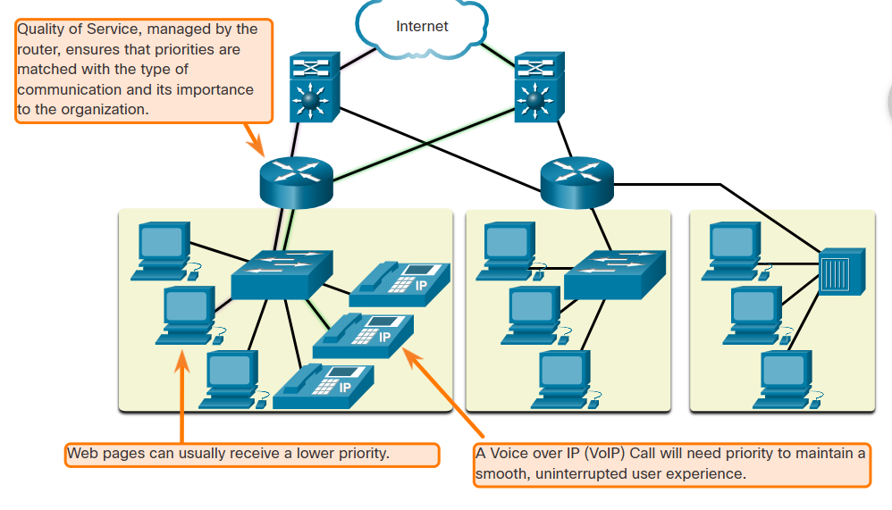

**4️⃣ Security 🔐**

* Protects data and devices from cyber threats.
* The network infrastructure, services, and the data contained on network-attached devices are crucial personal and business assets. Network administrators must address two types of network security concerns: network infrastructure security and information security.
* Securing the network infrastructure includes physically securing devices that provide network connectivity and preventing unauthorized access to the management software that resides on them, as shown in the figure.
* Network administrators must also protect the information contained within the packets being transmitted over the network, and the information stored on network attached devices. In order to achieve the goals of network security, there are three primary requirements.

-**Confidentiality** - Data confidentiality means that **only the intended** and authorized recipients can access and read data.

-**Integrity** - Data integrity assures users that the **information has not been altered** in transmission, from origin to destination.

-**Availability** - Data availability assures **users of timely and reliable access to data services** for authorized users.

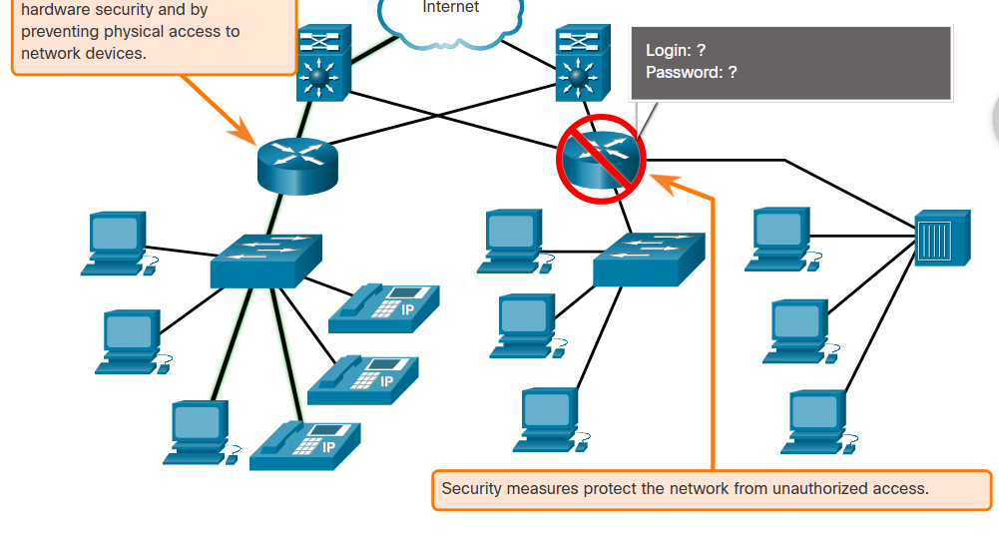

* Uses **firewalls, encryption, authentication (e.g., passwords, biometrics)**.
* Example:
  + Secure **VPNs** for remote work.
  + **Firewalls** block unauthorized access.

**📌 Summary Table of Network Architecture Aspects**

| **Aspect** | **Definition** | **Example** |
| --- | --- | --- |
| **Fault Tolerance** | Ensures network continues working even if parts fail | Backup routers, redundant paths |
| **Scalability** | Ability to expand without affecting performance | Adding more users/devices |
| **Quality of Service (QoS)** | Prioritizes important data like video calls | Zoom > File Downloads |
| **Security** | Protects network and data from attacks | Firewalls, encryption |

A **well-designed network** supports **reliable communication**, adapts to **growth**, prioritizes **important data**, and ensures **security**.

As networks evolve, we have learned that there are four basic characteristics that network architects must address to meet user expectations: Fault Tolerance, scalability, QoS, and security.

**A fault tolerant network** limits the number of affected devices during a failure. It allows quick recovery when such a failure occurs. These networks depend on multiple paths between the source and destination of a message. If one path fails, the messages are instantly sent over a different link.

A **scalable network** expands quickly to support new users and applications. It does this without degrading the performance of services that are being accessed by existing users. Networks can be scalable because the designers follow accepted standards and protocols.

**QoS** is an increasing requirement of networks today. As data, voice, and video content continue to converge onto the same network, QoS becomes a primary mechanism for managing congestion and ensuring reliable delivery of content to all users. Network bandwidth is measured in bps. When simultaneous communications are attempted across the network, the demand for network bandwidth can exceed its availability, creating network congestion. The focus of QoS is to prioritize time-sensitive traffic. The type of traffic, not the content of the traffic, is what is important.

Network administrators must address two types of **network security concerns**: network infrastructure security and information security. Network administrators must also protect the information contained within the packets being transmitted over the network, and the information stored on network attached devices. There are three primary requirements to achieve the goals of network security: Confidentiality, Integrity, and Availability.

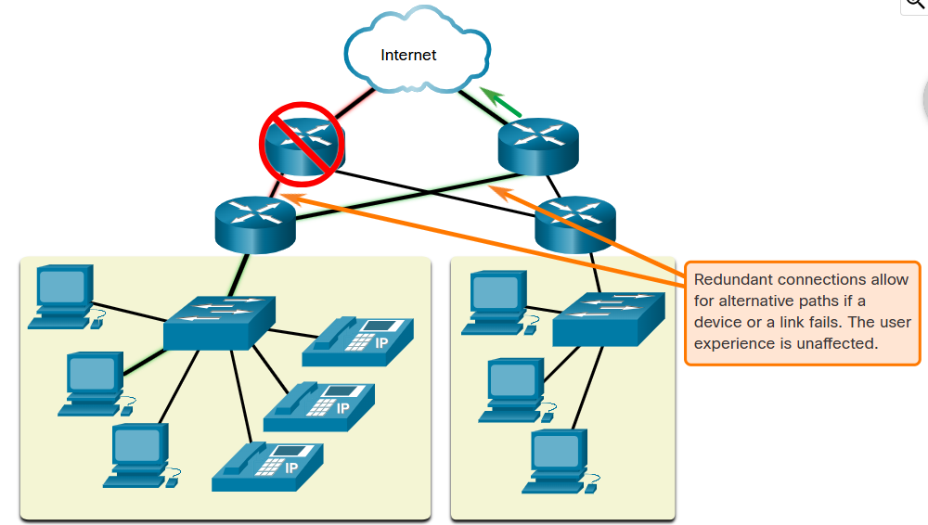

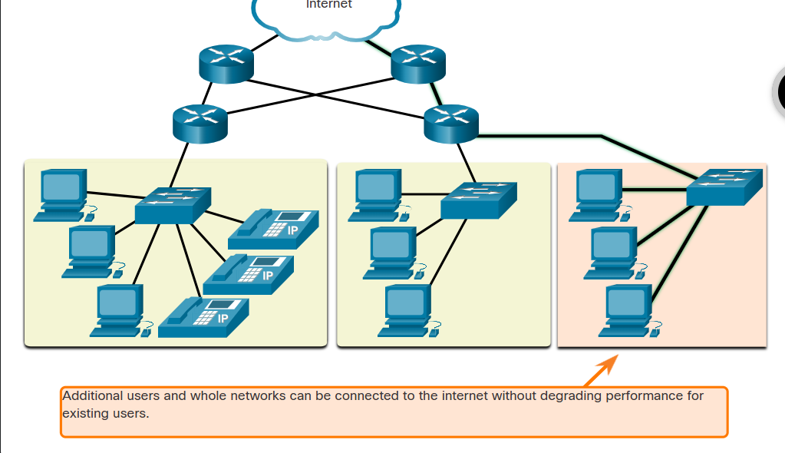

# 📌 Understanding Physical and Logical Addresses in Networking

In networking, **devices need unique identifiers** to communicate efficiently. These identifiers are categorized into **Physical (MAC) Addresses** and **Logical (IP) Addresses**.

To understand these concepts, let's compare them to **a person's name and address**:

* A **name** remains constant throughout life (like a MAC address).
* An **address** can change based on where the person lives (like an IP address).

**🔹 What is a Physical Address (MAC Address)?**

The **MAC (Media Access Control) address** is the **physical** address of a device. It is:  
✅ **Hardcoded into the Network Interface Card (NIC)** during manufacturing.  
✅ **Globally unique** – No two devices should have the same MAC address.  
✅ **Remains constant** regardless of the device’s location.

**🔹 MAC Address Format**

A MAC address is **48 bits long**, usually written as **six groups of two hexadecimal digits**, separated by colons (:) or dashes (-).

**Example:**  
00:1A:2B:3C:4D:5E

🔹 **Structure of a MAC Address**

| **Part** | **Description** |
| --- | --- |
| **First 3 bytes (OUI - Organizationally Unique Identifier)** | Identifies the manufacturer of the network device (e.g., Intel, Cisco, Dell). |
| **Last 3 bytes (Device Identifier)** | Unique number assigned by the manufacturer to a specific device. |

**🔹 What is a Logical Address (IP Address)?**

An **IP (Internet Protocol) address** is a **logical address** assigned to a device **based on its location** in a network.

✅ **Can change** when the device moves to a different network.  
✅ **Assigned dynamically (DHCP) or manually (Static IP)**.  
✅ **Needed for communication between networks (Routing)**.

**🔹 Structure of an IP Address**

An **IP address** consists of two parts:  
1️⃣ **Network Portion** – Identifies the network to which the device belongs.  
2️⃣ **Host Portion** – Identifies the specific device within the network.

**Example of an IPv4 Address:** 192.168.1.10

| **IP Address** | **Network Portion** | **Host Portion** |
| --- | --- | --- |
| 192.168.1.10 | 192.168.1 | 10 |

This means all devices in 192.168.1.x belong to the **same network**, while .10 is the **unique host**.

**🔹 Key Differences Between MAC and IP Addresses**

| **Feature** | **MAC Address** | **IP Address** |
| --- | --- | --- |
| **Definition** | Physical address of a device | Logical address assigned to a device |
| **Uniqueness** | Globally unique | Unique only within a network |
| **Assignment** | Assigned by manufacturer (permanent) | Assigned by network (can change) |
| **Format** | 48-bit hexadecimal | 32-bit (IPv4) or 128-bit (IPv6) |
| **Example** | 00:1A:2B:3C:4D:5E | 192.168.1.10 |
| **Used in** | Local Network Communication (Switching) | Global Network Communication (Routing) |
| **Changes when moving networks?** | ❌ No | ✅ Yes |

**🔹 Why Do We Need Both MAC and IP Addresses?**

Both addresses serve **different purposes** in network communication:  
✅ **MAC Address** → Used for communication within the same local network (Layer 2).  
✅ **IP Address** → Used for communication across different networks (Layer 3).

When a device sends data:  
1️⃣ **IP Address** is used to find the destination network.  
2️⃣ **MAC Address** is used to find the exact device on that network.

This process is handled by the **Address Resolution Protocol (ARP)**, which maps **IP addresses to MAC addresses**.

**🔹 Summary Table: Key Concepts**

| **Concept** | **Explanation** |
| --- | --- |
| **MAC Address** | A **physical, unchanging** identifier assigned to a device’s NIC by the manufacturer. Used for communication inside a **local network**. |
| **IP Address** | A **logical, changeable** address assigned to a device. Used for **communication across networks**. |
| **MAC vs. IP** | MAC is **permanent**, IP **changes** when moving networks. |
| **Network Portion** | Identifies the **network** in an IP address. |
| **Host Portion** | Identifies the **specific device** in that network. |
| **Why Both?** | MAC works **locally**, IP works **globally** for routing data. |

This ensures **accurate and efficient data transmission** across networks!

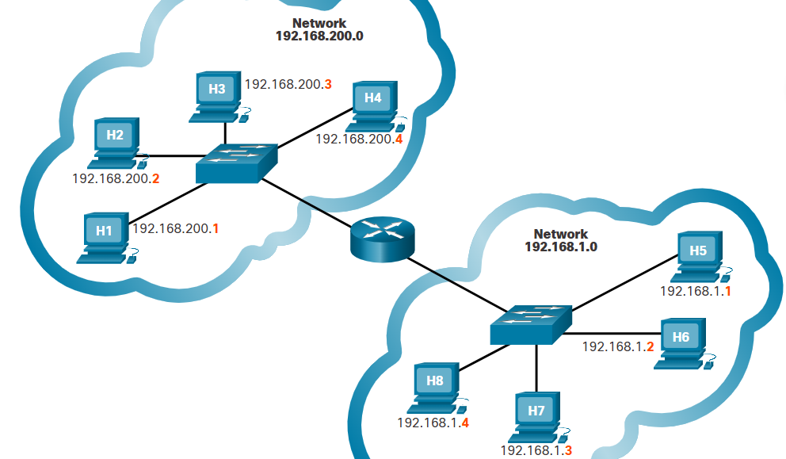

# 📌 Understanding Hierarchical Addressing in Networking

In networking, we use a **hierarchical addressing system** to efficiently **identify, locate, and communicate** between devices across vast networks.

Let’s break this down using an **analogy** and **real-world networking concepts**.

**🔹 Why is Hierarchical Addressing Important?**

Imagine trying to send a letter to a friend if **addresses didn’t exist**—only names. If there were millions of people with unique names but no structured location (no country, city, or street address), **finding a person would be impossible!**

Similarly, if networks relied **only on MAC addresses**, it would be extremely difficult to locate a device across the **entire internet**.

**🔹 Real-World Example of Hierarchical Addressing**

Just as **geographic locations** have a hierarchy:

1️⃣ **Continent:** North America  
2️⃣ **Country:** Canada  
3️⃣ **State/Province:** Nova Scotia  
4️⃣ **City:** Halifax

Networking also follows a structured hierarchy to locate and communicate with devices efficiently.

**🔹 MAC Addresses vs. IP Addresses in a Hierarchy**

**MAC Address (Flat Structure - No Hierarchy)**

* A **MAC (Media Access Control) address** is unique to a device but **doesn’t indicate location**.
* If networks **only used MAC addresses**, finding a device would be like searching for a **person by name alone**, without knowing their city or country.
* This would create **massive inefficiencies** due to broadcast traffic.

**IP Address (Hierarchical Structure)**

* **IP addresses** (Internet Protocol addresses) follow a **structured hierarchy**, making it easy to locate and communicate with devices across the internet.
* Just like an address identifies a house **in a city, state, and country**, an IP address **identifies a device within a network, a subnet, and the broader internet**.

**Example of an IPv4 Address:** 📌 192.168.1.10

| **Part** | **Description** |
| --- | --- |
| 192.168 | Network portion (like a country) |
| 1 | Subnet (like a city) |
| 10 | Host (specific device, like a house) |

**🔹 Why Networks are Divided into Hierarchical Sections**

🔸 **Better Performance:** Instead of one **large, unmanageable** network, breaking it into smaller networks improves efficiency.  
🔸 **Reduced Broadcast Traffic:** **Broadcasts** (messages sent to all devices) slow down networks. Dividing the network limits broadcast domains.  
🔸 **Easier Management:** A structured system allows network administrators to assign and locate IP addresses efficiently.  
🔸 **Faster Communication:** Routers can quickly direct data based on the **hierarchical** IP address structure.

**🔹 Example of How Hierarchy Works in a Network**

If you want to send data to **192.168.2.5**, your network follows a **step-by-step process**:

1️⃣ **Check if the device is in the same local network.**  
2️⃣ **If not, send data to a router** (like a postal sorting center).  
3️⃣ **Router checks the destination network** and forwards the data.  
4️⃣ **Data arrives at the correct subnet and then to the specific device.**

**🔹 Summary Table: Hierarchical vs. Flat Addressing**

| **Concept** | **MAC Address (Flat)** | **IP Address (Hierarchical)** |
| --- | --- | --- |
| **Structure** | Unique, but no location | Organized into networks & subnets |
| **Address Type** | Physical | Logical |
| **Scope** | Local network (LAN) | Global communication (Internet) |
| **Efficiency** | Causes high broadcast traffic | Reduces broadcast traffic |
| **Finding a Device** | Difficult across large networks | Easy due to structure |
| **Example** | 00:1A:2B:3C:4D:5E | 192.168.1.10 |

**📌 Key Takeaways**

✅ **MAC Addresses are like names**—they uniquely identify devices but don’t show where they are.  
✅ **IP Addresses are like home addresses**—they help locate devices efficiently in a structured way.  
✅ **Hierarchical networks improve efficiency** by breaking large networks into smaller, manageable parts.  
✅ **Broadcast traffic is minimized** with hierarchy, ensuring smooth communication across networks.

This is the foundation of **efficient data communication** in modern networks! 🚀

# 🔹 Importance of Hierarchical Design in Networking

A **hierarchical network design** is essential for creating **efficient, scalable, and manageable** networks. It ensures that networks operate smoothly, reduce congestion, and can grow without performance issues.

**🔹 What is Hierarchical Network Design?**

A **hierarchical design** divides **a network into layers**, each with a specific function. The most common model used is the **three-tier architecture**, which includes:

**1️. Core Layer (Backbone of the Network)**

* **Purpose:** Provides **high-speed switching and transport of data** across the network.
* **Key Features:**
  + Handles **high-volume traffic**.
  + Ensures **fast and reliable** data transmission.
  + **No direct device connections** (focuses on speed and stability).

The core layer is a **high-speed backbone layer** with redundant (backup) connections. It is responsible for **transporting large amounts of data** between multiple end networks. Core layer devices typically include very powerful, high-speed switches and routers, such as the Cisco Catalyst 9600 shown in the figure. The main goal of the core layer is to transport data quickly.

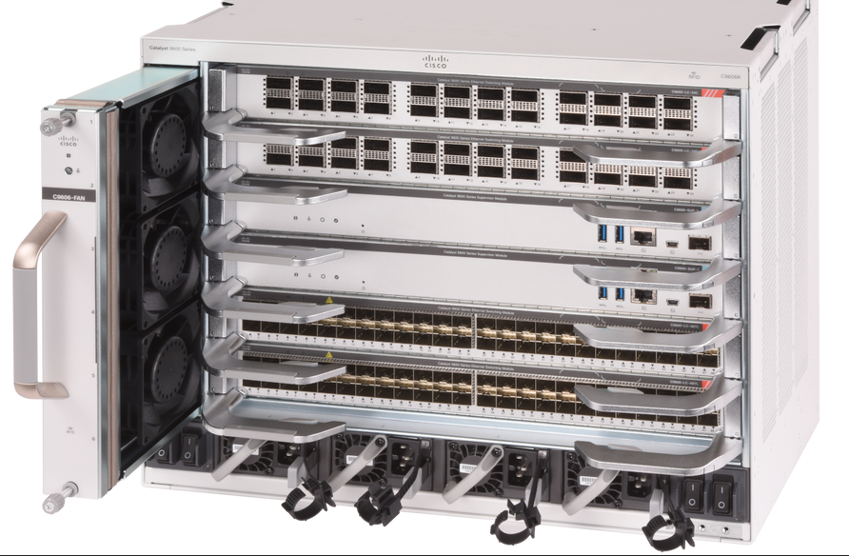

**2️. Distribution Layer (Routing & Filtering)**

* **Purpose:** **Controls and manages** traffic between **different parts of the network.**
* **Key Features:**
  + Uses **routing, filtering, and security policies** to regulate network traffic.
  + Ensures **efficient communication** between different subnets.
  + Provides **redundancy and load balancing**.

The distribution layer provides a **connection point for separate networks** and controls the flow of information between the networks. It typically contains more **powerful switches**, such as the Cisco C9300 series shown in the figure, than the access layer as **well as routers for routing** between networks. Distribution layer devices control the type and amount of traffic that flows from the access layer to the core layer.

Cisco C9300 Series

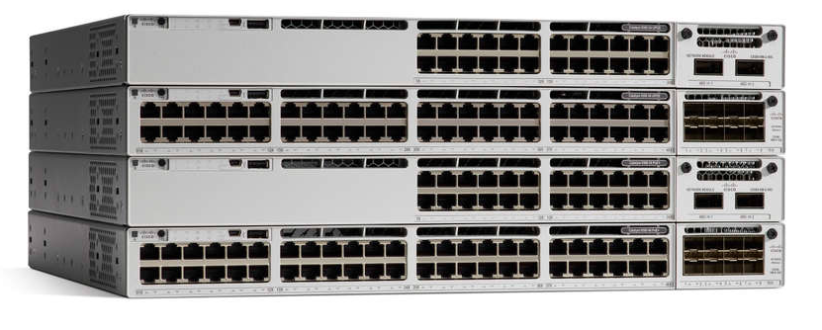

**3️. Access Layer (Device Connection Point)**

* **Purpose: Connects end-user devices (PCs, printers, IoT, etc.)** to the network.
* **Key Features:**
  + Handles **MAC addresses, VLANs, and authentication**.
  + Provides **wired and wireless** access.
  + Uses **switches, access points, and security policies**.

The access layer provides a connection point for end user devices to the network and allows multiple hosts to connect to other hosts through a network device, **usually a switch**, such as the Cisco 2960-XR shown in the figure, **or a wireless access point**. Typically, all devices within a single access layer will have the same network portion of the IP address.

If a message is destined for a local host, based on the network portion of the IP address, the message remains local. If it is destined for a different network, it is passed up to the distribution layer. Switches provide the connection to the distribution layer devices, usually a Layer 3 device such as a router or Layer 3 switch.

**Cisco 2960-XR**

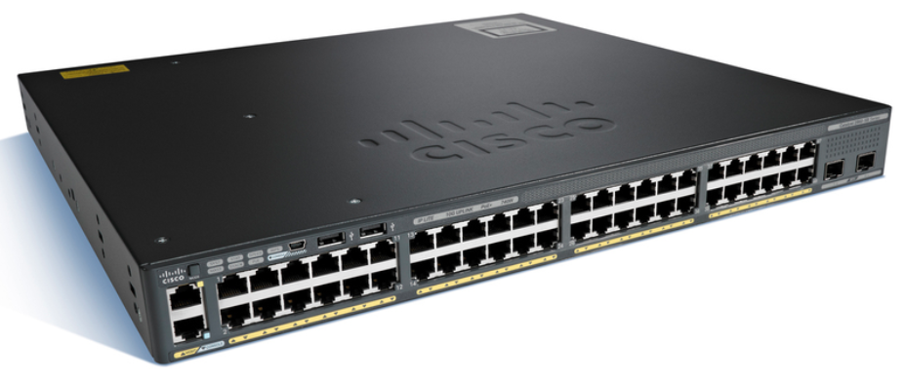

**🔹 Why is Hierarchical Network Design Important?**

**✅ 1. Scalability (Easy Network Growth)**

* Hierarchical networks allow **new devices and networks to be added** without affecting overall performance.
* The **modular structure** ensures smooth expansion as business needs grow.

**✅ 2. Performance and Speed**

* By **dividing traffic logically**, data flows faster and more efficiently.
* The **Core Layer is optimized for speed**, while the **Distribution Layer handles network control**.
* Prevents bottlenecks and network slowdowns.

**✅ 3. Reliability and Redundancy**

* If one part of the network **fails**, alternative paths ensure continuity.
* **Redundant links** at the Distribution and Core layers prevent total network failure.

**✅ 4. Security**

* Each layer **implements security policies** independently.
* Firewalls, authentication, and access control can be enforced at **different layers**.
* Limits the spread of attacks and unauthorized access.

**✅ 5. Easier Troubleshooting and Management**

* Problems can be **isolated to a specific layer**, making troubleshooting faster.
* Network administrators can **apply changes to specific layers** without affecting the entire network.

**✅ 6. Reduces Broadcast Traffic**

* Hierarchical design **segments networks into smaller domains** to minimize broadcast storms.
* Reduces unnecessary network congestion, improving efficiency.

**🔹 Summary Table: Benefits of Hierarchical Network Design**

| **Benefit** | **Description** |
| --- | --- |
| **Scalability** | Allows easy network expansion without affecting performance. |
| **Performance** | Ensures high-speed data transmission with optimized traffic flow. |
| **Reliability** | Redundant paths ensure network continuity during failures. |
| **Security** | Controls access and limits the spread of security threats. |
| **Easy Management** | Simplifies troubleshooting and network modifications. |
| **Reduces Traffic** | Divides networks to minimize broadcast storms and congestion. |

**📌 Conclusion**

A **hierarchical network design** is critical for **modern, scalable, and efficient** networking. It provides **better performance, reliability, security, and easier management**, ensuring that organizations can expand their networks smoothly while maintaining high efficiency.

IP addresses contain two parts. One part identifies the network portion. The network portion of the IP address will be the same for all hosts connected to the same local network. The second part of the IP address identifies the individual host on that network. Both the physical MAC and logical IP addresses are required for a computer to communicate on a hierarchical network.

The Network and Sharing Center on a PC shows your basic network information and set up connections, including your active networks and whether you are connected wired or wirelessly to the internet and within your LAN. You can view the properties of your connections here.

On an Ethernet network, the host MAC address is similar to a person's name. A MAC address indicates the individual identity of a specific host, but it does not indicate where on the network the host is located. If all hosts on the internet (millions and millions of them) were each identified by their unique MAC address only, imagine how difficult it would be to locate a single one. It is better to divide larger networks into smaller, more manageable pieces. One way to divide larger networks is to use a hierarchical design model.

Hierarchical networks scale well. The access layer provides a connection point for end user devices to the network and allows multiple hosts to connect to other hosts through a network device, usually a switch or a wireless access point. Typically, all devices within a single access layer will have the same network portion of the IP address. The distribution layer provides a connection point for separate networks and controls the flow of information between the networks. Distribution layer devices control the type and amount of traffic that flows from the access layer to the core layer. The core layer is a high-speed backbone layer with redundant connections. It is responsible for transporting large amounts of data between multiple end networks. The main goal of the core layer is to transport data quickly.

# ☁️ Cloud Computing & Virtualization 🌍

Cloud computing and virtualization are two key technologies shaping modern IT infrastructure. They allow businesses and individuals to optimize resources, enhance scalability, and improve efficiency.

**🔹 1. What is Cloud Computing?**

Cloud computing is the **delivery of computing services** (such as servers, storage, databases, networking, software, and analytics) **over the internet ("the cloud")** rather than on local computers or data centers.

**✅ Key Characteristics of Cloud Computing:**

* **On-demand self-service** – Users can access resources anytime.
* **Broad network access** – Services are available over the internet.
* **Resource pooling** – Multiple users share the same physical resources.
* **Scalability** – Resources can be increased or decreased as needed.
* **Measured Service** – Users pay only for what they use.

**🌍 Types of Cloud Computing Models:**

| **Model** | **Description** | **Examples** |
| --- | --- | --- |
| **Public Cloud** | Resources are available to multiple customers over the internet. | AWS, Google Cloud, Microsoft Azure |
| **Private Cloud** | Dedicated infrastructure for a single organization. | VMware, OpenStack, IBM Cloud Private |
| **Hybrid Cloud** | Combines public and private cloud services. | AWS Outposts, Google Anthos |
|  |  |  |

There are four primary cloud models:

* **Public clouds** - Cloud-based applications and services offered in a public cloud are made available to the general population. Services may be free or are offered on a pay-per-use model, such as paying for online storage. The public cloud uses the internet to provide services.
* **Private clouds** - Cloud-based applications and services offered in a private cloud are intended for a specific organization or entity, such as the government. A private cloud can be set up using the private network of an organization, though this can be expensive to build and maintain. A private cloud can also be managed by an outside organization with strict access security.
* **Hybrid clouds** - A hybrid cloud is made up of two or more clouds (example: part private, part public), where each part remains a separate object, but both are connected using a single architecture. Individuals on a hybrid cloud would be able to have degrees of access to various services based on user access rights.
* **Community clouds** - A community cloud is created for exclusive use by a specific community. The differences between public clouds and community clouds are the functional needs that have been customized for the community. For example, healthcare organizations must remain compliant with policies and laws (e.g., HIPAA) that require special authentication and confidentiality.

**🌐 Cloud Service Models (SPI Model):**

| **Model** | **Description** | **Examples** |
| --- | --- | --- |
| **IaaS (Infrastructure as a Service)** | Provides virtual machines, storage, and networking. | AWS EC2, Google Compute Engine |
| **PaaS (Platform as a Service)** | Offers platforms for app development without managing infrastructure. | Google App Engine, Microsoft Azure App Services |
| **SaaS (Software as a Service)** | Delivers fully managed software applications over the internet. | Gmail, Microsoft 365, Dropbox |

**🔹 2. What is Virtualization?**

Virtualization is the process of **creating virtual versions** of physical hardware resources, such as servers, storage, and networks. It allows multiple operating systems and applications to run on a single physical machine.

**✅ Types of Virtualization:**

| **Type** | **Description** | **Example Technologies** |
| --- | --- | --- |
| **Server Virtualization** | One physical server runs multiple virtual machines (VMs). | VMware ESXi, Microsoft Hyper-V |
| **Storage Virtualization** | Storage resources from multiple devices are combined. | SAN (Storage Area Network), NAS (Network-Attached Storage) |
| **Network Virtualization** | Virtual networks operate independently of physical networks. | VLANs, SDN (Software-Defined Networking) |
| **Desktop Virtualization** | Virtual desktops are hosted on a central server. | Citrix Virtual Apps, Windows Virtual Desktop |

**🌍 Benefits of Virtualization:**

* **Cost Savings** – Reduces hardware costs.
* **Efficiency** – Increases resource utilization.
* **Scalability** – Easily add or remove virtual resources.
* **Disaster Recovery** – Faster recovery from failures.
* **Isolation** – VMs operate independently, reducing security risks.

**🔹 Cloud Computing vs. Virtualization: What’s the Difference?**

| **Feature** | **Cloud Computing** | **Virtualization** |
| --- | --- | --- |
| **Definition** | Delivery of computing services over the internet. | Creating virtual versions of hardware and software. |
| **Usage** | Provides scalable computing power and services. | Allows multiple operating systems to run on one physical machine. |
| **Scalability** | High scalability and flexibility. | Limited by physical resources. |
| **Example** | AWS, Google Cloud | VMware, VirtualBox |

**📌 Conclusion**

Cloud computing and virtualization **complement each other** in modern IT infrastructure. Virtualization enables efficient **resource management**, while cloud computing provides **on-demand services** over the internet.

# What is a Data Center?

A **data center** is a dedicated facility used to house **computer systems**, **networking equipment**, **storage devices**, and **other IT infrastructure** to manage and store critical data. These centers serve as the backbone of modern computing and networking, providing the necessary environment for data processing, communication, and storage.

Organizations use data centers to **store, manage, and distribute data** efficiently while ensuring high availability, security, and redundancy.

**1. Components of a Data Center**

A well-functioning data center consists of several key components:

**a) Computing Infrastructure (Servers)**

* **Servers** are powerful computers that handle computing workloads.
* They process, store, and manage data for various applications like websites, cloud storage, AI, and enterprise systems.
* Modern data centers use **blade servers** and **rack-mounted servers** to optimize space and performance.

**b) Storage Systems**

* Includes **Hard Disk Drives (HDDs)**, **Solid-State Drives (SSDs)**, and **Storage Area Networks (SANs)**.
* Data is stored in **redundant arrays** to prevent data loss.
* Cloud-based storage systems allow for flexible and scalable storage solutions.

**c) Networking Infrastructure**

* **Switches, routers, and firewalls** manage data flow between systems.
* Fiber optic and high-speed Ethernet connections ensure fast data transmission.
* Redundant network paths are used to maintain connectivity in case of failures.

**d) Power Management**

* Data centers require **uninterruptible power supplies (UPS)** to prevent downtime.
* Backup generators provide additional power support.
* Power Distribution Units (PDUs) manage and distribute electrical power to equipment.

**e) Cooling and Environmental Control**

* Servers generate a lot of heat, requiring advanced **cooling systems** such as:
  + **Air conditioning units**
  + **Liquid cooling solutions**
  + **Cold and hot aisle containment** to optimize airflow.
* Humidity control prevents damage to sensitive electronic components.

**f) Security Systems**

* Data centers are protected through multiple layers of **physical and cybersecurity measures**:
  + **Physical security**: Biometric authentication, surveillance cameras, restricted access areas.
  + **Cybersecurity**: Firewalls, intrusion detection systems (IDS), encryption, and multi-factor authentication (MFA).

**g) Disaster Recovery and Backup**

* Data centers use redundant storage solutions for **disaster recovery**.
* **Backup servers** store critical data copies to prevent data loss in case of system failures.
* Cloud-based disaster recovery solutions provide remote backups.

**2. Types of Data Centers**

Data centers can be classified into different categories based on ownership, functionality, and technology.

**a) Enterprise Data Centers**

* Owned and operated by large organizations (e.g., Google, Microsoft, Amazon).
* Dedicated to internal business operations.
* High security and advanced infrastructure.

**b) Colocation Data Centers**

* Third-party facilities that **lease space, power, and cooling** to multiple businesses.
* Organizations **rent server space** instead of building their own data centers.
* Reduces operational costs for businesses.

**c) Cloud Data Centers**

* Fully managed by **cloud service providers** like AWS, Microsoft Azure, and Google Cloud.
* Offer **scalability**, **virtualization**, and **remote accessibility**.
* Companies use cloud services instead of maintaining physical data centers.

**d) Edge Data Centers**

* Smaller facilities located near end-users for **low-latency processing**.
* Used in **IoT, autonomous vehicles, and smart cities** for real-time data processing.
* Helps reduce network congestion by processing data closer to the source.

**3. Importance of Data Centers**

Data centers play a critical role in modern businesses, cloud computing, and the digital economy.

**a) Business Continuity and Disaster Recovery**

* Data centers ensure that businesses continue operating even during system failures.
* Redundant power supplies and backup solutions prevent downtime.

**b) Cloud Computing and Big Data**

* Supports **AI, machine learning, big data analytics**, and cloud-based applications.
* Enables remote work, software as a service (SaaS), and distributed computing.

**c) Security and Data Protection**

* Data centers implement strict security protocols to **prevent cyberattacks and data breaches**.
* Regular updates and security monitoring enhance data protection.

**d) Connectivity and Communication**

* Data centers enable fast and secure communication over the internet.
* Support **email, video conferencing, online gaming, and streaming services**.

**4. Future Trends in Data Centers**

Data center technology is continuously evolving to meet growing data demands.

**a) Green Data Centers**

* Use **renewable energy** and **efficient cooling** to reduce environmental impact.
* Companies like Google and Facebook invest in **carbon-neutral data centers**.

**b) AI and Automation**

* AI-powered **predictive analytics** help optimize server performance.
* Automated monitoring systems detect and fix issues **before failures occur**.

**c) 5G and Edge Computing**

* Edge data centers process **real-time data** for IoT, smart cities, and autonomous vehicles.
* 5G connectivity enables **faster data transfer** and ultra-low latency.

**Conclusion**

A **data center** is the foundation of modern digital infrastructure, providing the necessary resources for **cloud computing, data storage, and secure networking**. Whether owned by businesses or hosted by third-party providers, data centers ensure high availability, security, and performance for critical IT operations.

# Deep Dive into Virtualization

**1. What is Virtualization?**

Virtualization is the process of **creating virtual instances** of computing resources—such as servers, storage, networks, and applications—by abstracting them from the underlying physical hardware. This allows multiple virtual environments to run on a single physical system, **optimizing resource usage and improving efficiency**.

In traditional computing, each application runs on a dedicated physical machine, leading to **underutilized resources, increased costs, and management complexity**. Virtualization solves this by enabling multiple virtual machines (VMs) to operate independently on the same physical hardware.

**2. How Virtualization Works**

Virtualization relies on a **hypervisor**, a software layer that creates and manages virtual machines. The hypervisor abstracts the physical hardware and allocates resources dynamically to VMs, ensuring efficient utilization of computing power.

**a) Hypervisors: The Core of Virtualization**

A **hypervisor** (or Virtual Machine Monitor, VMM) allows multiple operating systems (OS) to share the same hardware.

**The hypervisor** is a **program, firmware, or hardware** that **adds an abstraction layer** on top of the physical hardware. The abstraction layer is used to create virtual machines which have access to all the hardware of the physical machine such as CPUs, memory, disk controllers, and NICs. Each of these virtual machines runs a complete and separate operating system. With virtualization, it is not uncommon for 100 physical servers to be consolidated as virtual machines on top of 10 physical servers that are using hypervisors.

There are two types:

1. **Type 1 Hypervisor (Bare-Metal Hypervisor)**
   * Runs directly on the host machine's hardware.
   * Examples: VMware ESXi, Microsoft Hyper-V, Xen, KVM.
   * Provides better performance and security.

Type 1 hypervisors are also called the “bare metal” approach because **the hypervisor is installed directly on the hardware**. Type 1 hypervisors are usually used on enterprise servers and data center networking devices.

With Type 1 hypervisors, the hypervisor is installed directly on the server or networking hardware. Then, instances of an OS are installed on the hypervisor, as shown in the figure. Type 1 hypervisors have direct access to the hardware resources; therefore, they are more efficient than hosted architectures. Type 1 hypervisors improve scalability, performance, and robustness.

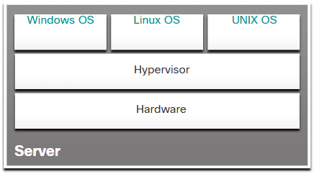

1. **Type 2 Hypervisor (Hosted Hypervisor)**
   * Runs on top of an existing OS.
   * Examples: VMware Workstation, Oracle VirtualBox.
   * Easier to set up but has some performance overhead.

A Type 2 hypervisor is **software that creates and runs VM instances**. The computer, on which a hypervisor is supporting one or more VMs, is a host machine. Type 2 hypervisors are also called **hosted hypervisors**. This is because the **hypervisor is installed on top of the existing OS**, such as macOS, Windows, or Linux. Then, one or more additional OS instances are installed on top of the hypervisor, as shown in the figure. A big advantage of Type 2 hypervisors is that management console software is not required.

Note: It is important to make sure that the host machine is robust enough to install and run the VMs, so that it does not run out of resources.

When a hypervisor is installed, it creates an **abstraction layer** that allows multiple **Virtual Machines (VMs)** to share the same physical hardware. Each VM runs its own OS, applications, and processes **independently**.

1. **Types of Virtualization**

There are several types of virtualization based on the components being virtualized:

**a) Server Virtualization**

* Divides a **physical server** into multiple virtual servers (VMs).
* Each VM runs an independent OS and applications.
* Improves **server utilization, scalability, and fault tolerance**.
* **Example:** Cloud providers like AWS, Google Cloud, and Azure use server virtualization to host virtual servers for businesses.

**b) Network Virtualization**

* Creates virtual network layers abstracted from physical network hardware.
* Uses **Software-Defined Networking (SDN)** to manage networks programmatically.
* Enables better **traffic management, security, and scalability**.
* **Example:** VLANs (Virtual LANs) and VPNs (Virtual Private Networks).

**c) Storage Virtualization**

* Combines multiple physical storage devices into a single, virtualized storage system.
* Simplifies storage management and **improves performance**.
* **Example:** Storage Area Networks (SANs) and Network Attached Storage (NAS).

**d) Desktop Virtualization**

* Hosts desktop environments on a central server, allowing users to access them remotely.
* Enables **Bring Your Own Device (BYOD)** policies and enhances security.
* **Example:** Virtual Desktop Infrastructure (VDI), such as Citrix and Microsoft Remote Desktop.

**e) Application Virtualization**

* Runs applications in a virtual environment separate from the underlying OS.
* Allows software to be deployed without modifying the host OS.
* **Example:** Windows App Virtualization (App-V), VMware ThinApp.

**f) Cloud Virtualization**

* Powers **cloud computing** by virtualizing compute, storage, and network resources.
* Enables **Infrastructure as a Service (IaaS)** and **Platform as a Service (PaaS)** models.
* **Example:** Amazon EC2, Google Compute Engine, Microsoft Azure Virtual Machines.

**4. Benefits of Virtualization**

Virtualization offers **several advantages** in IT infrastructure:

**a) Resource Optimization**

* Increases utilization of CPU, memory, and storage by **running multiple VMs** on a single machine.
* Reduces the need for multiple physical servers, saving hardware costs.

**b) Cost Efficiency**

* Reduces **capital expenses (CapEx)** and **operating expenses (OpEx)**.
* Requires fewer servers, leading to **lower power and cooling costs**.

**c) Scalability and Flexibility**

* Easily scale resources **up or down** based on demand.
* Cloud virtualization enables **on-demand resource provisioning**.

**d) Disaster Recovery and High Availability**

* Virtual machines can be **backed up and restored quickly** in case of failures.
* Live migration allows VMs to move between servers **without downtime**.

**e) Security and Isolation**

* VMs are **isolated** from one another, preventing security breaches.
* Snapshots and backups allow for **quick recovery from attacks**.

**f) Simplified IT Management**

* Centralized management of VMs through **hypervisors** and cloud platforms.
* Automated provisioning and monitoring using **orchestration tools** like Kubernetes.

**5. Challenges of Virtualization**

Despite its benefits, virtualization has some challenges:

**a) Performance Overhead**

* Virtual machines **share hardware resources**, leading to potential performance bottlenecks.
* Heavy workloads may require **dedicated physical servers** instead.

**b) Licensing and Compliance Issues**

* Some software vendors charge **per-VM licensing fees**, increasing costs.
* Regulatory compliance can be complex when data is stored in **multi-tenant environments**.

**c) Security Risks**

* If a hypervisor is compromised, all VMs running on it **are at risk**.
* Requires strong **security policies, patch management, and encryption**.

**d) Complexity in Management**

* Managing large-scale **virtualized environments** requires expertise.
* Performance monitoring and **resource allocation** can be challenging.

**6. Virtualization vs. Cloud Computing**

| **Feature** | **Virtualization** | **Cloud Computing** |
| --- | --- | --- |
| **Definition** | Creates virtual instances of computing resources. | Uses virtualized resources to offer on-demand services. |
| **Control** | Managed **in-house** by IT teams. | Managed **by cloud providers**. |
| **Infrastructure** | Runs on-premises servers. | Uses **remote data centers**. |
| **Scalability** | Requires **manual scaling** of resources. | Provides **automatic scaling**. |
| **Example** | Running multiple VMs on a single server. | Running cloud applications on AWS, Azure, or Google Cloud. |

Cloud computing **relies on virtualization** to provide services like **IaaS, PaaS, and SaaS**. However, virtualization can exist **without cloud computing**, especially in **private data centers**.

**7. Future Trends in Virtualization**

**a) Containerization (Lightweight Virtualization)**

* Containers (e.g., Docker, Kubernetes) provide **faster deployment** than traditional VMs.
* More efficient **resource utilization** and **portability**.

**b) AI-Powered Virtualization**

* AI-driven **automation and predictive analytics** optimize VM performance.
* Smart resource allocation improves efficiency.

**c) Serverless Computing**

* Eliminates the need for managing virtual servers.
* Cloud providers handle **scaling, security, and infrastructure management**.

**d) Quantum Virtualization**

* As quantum computing develops, **virtualized quantum environments** may emerge.
* Provides secure and high-performance computation.

**Conclusion**

Virtualization is a **revolutionary technology** that optimizes IT infrastructure by **abstracting computing resources** from physical hardware. It improves **efficiency, security, and scalability**, enabling modern cloud computing and enterprise IT.

# Ethernet Evolution: From 10 Mbps to 100 Gbps and Beyond

Ethernet has **evolved significantly** since its invention in 1973 by **Robert Metcalfe** at Xerox PARC. Over the years, Ethernet has become the **dominant networking technology** due to its scalability, cost-effectiveness, and ability to adapt to increasing speed demands.

**1. IEEE and Ethernet Standards**

The **Institute of Electrical and Electronics Engineers (IEEE)** defines and maintains Ethernet standards under the **802.3 working group**. Each standard specifies **speed, media type, and communication protocols**.

**Key Elements of Ethernet Notation**

For example, in **100BASE-T**:

* **100** → Speed in Mbps (Megabits per second).
* **BASE** → Baseband transmission (signals use the entire bandwidth of the cable).
* **T** → Twisted-pair cable.

**2. Evolution of Ethernet Speeds**

**a) Early Ethernet (10 Mbps) – 802.3 (1983)**

* Original Ethernet operated at **10 Mbps** using **coaxial cables (10BASE5 and 10BASE2)**.
* Later, **10BASE-T** introduced twisted-pair cables (Cat 3), improving ease of deployment.

**b) Fast Ethernet (100 Mbps) – 802.3u (1995)**

* **100BASE-TX** became the most popular standard, using **Cat 5 cables**.
* Allowed businesses and enterprises to upgrade their networks for higher performance.

**c) Gigabit Ethernet (1 Gbps) – 802.3z & 802.3ab (1999)**

* **1000BASE-T** enabled **1 Gbps speeds** over **Cat 5e** and later **Cat 6 cables**.
* Optical fiber versions (**1000BASE-SX, 1000BASE-LX**) provided longer-distance connections.

**d) 10-Gigabit Ethernet (10 Gbps) – 802.3ae (2002)**

* **10GBASE-T** runs over **Cat 6a** and **Cat 7** cables.
* Fiber options like **10GBASE-SR, 10GBASE-LR** extend connectivity over kilometers.

**e) 40-Gigabit & 100-Gigabit Ethernet (2010-2012)**

* **802.3ba** introduced **40GBASE-T and 100GBASE-T**.
* Primarily used in **data centers and backbone networks**.

**f) Terabit Ethernet (Future - Beyond 400 Gbps)**

* **IEEE 802.3bs (2017)** defined **400GBASE Ethernet**.
* Research is ongoing for **1 Terabit per second (Tbps) Ethernet**.

**3. Why Ethernet Has Succeeded**

✅ **Scalability** – Evolved from **10 Mbps to 400 Gbps**, adapting to modern needs.  
✅ **Cost-Effectiveness** – Affordable compared to proprietary networking technologies.  
✅ **Backwards Compatibility** – New standards support older Ethernet devices.  
✅ **Reliability & Standardization** – IEEE ensures uniform standards across industries.

Ethernet continues to evolve, ensuring **high-speed, low-latency networking** for cloud computing, data centers, and IoT.

Ethernet Frame

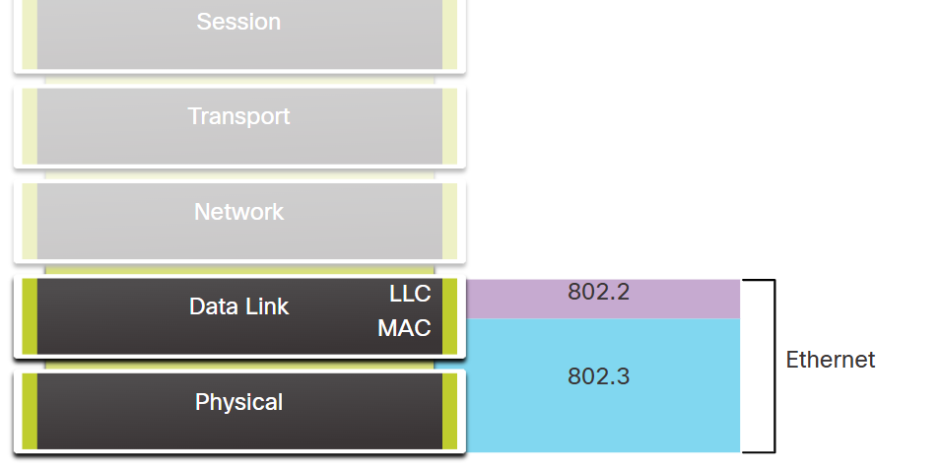

**Ethernet Encapsulation & OSI Model Integration**

Ethernet is a foundational technology in **Local Area Networks (LANs)**, responsible for defining how data is transmitted over wired communication channels such as **twisted pair, fiber-optic, and coaxial cables**. It operates in the **Data Link Layer (Layer 2) and the Physical Layer (Layer 1)** of the **OSI model**.

**1. Ethernet in the OSI Model**

Ethernet is defined at **two OSI layers**:

* **Layer 1 (Physical Layer):** Specifies the hardware components, transmission medium, and electrical signals.
* **Layer 2 (Data Link Layer):** Defines how data is formatted and addressed for transmission.

At **Layer 2**, Ethernet is divided into two sublayers:

1. **Logical Link Control (LLC) - IEEE 802.2:** Handles error checking, flow control, and communication with the network layer.
2. **Media Access Control (MAC) - IEEE 802.3:** Manages access to the physical medium and ensures data is sent and received correctly.

**2. Ethernet Frame Structure (Encapsulation)**

Before transmission, data from higher layers (such as an IP packet) is **encapsulated** in an **Ethernet frame**. The frame includes:

| **Field** | **Description** | **Size** |
| --- | --- | --- |
| **Preamble** | Synchronization pattern for the receiver | 7 Bytes |
| **Start Frame Delimiter (SFD)** | Marks the beginning of the frame | 1 Byte |
| **Destination MAC Address** | Address of the receiving device | 6 Bytes |
| **Source MAC Address** | Address of the sending device | 6 Bytes |
| **EtherType/Length** | Identifies protocol type (IPv4, IPv6, etc.) | 2 Bytes |
| **Data/Payload** | Actual data being transmitted | 46-1500 Bytes |
| **Frame Check Sequence (FCS)** | Error detection using CRC | 4 Bytes |

**Encapsulation Process**

1. The **LLC sublayer** adds control information to the data.
2. The **MAC sublayer** adds **MAC addresses** and forms the Ethernet frame.
3. The **frame is converted into electrical signals** for transmission at the **physical layer**.

**3. Ethernet Speed Evolution**

Ethernet supports increasing bandwidths to meet modern networking demands:

* **10 Mbps (Ethernet - 802.3)**
* **100 Mbps (Fast Ethernet - 802.3u)**
* **1 Gbps (Gigabit Ethernet - 802.3z & 802.3ab)**
* **10 Gbps (802.3ae)**
* **40 Gbps (802.3ba)**
* **100 Gbps (802.3bj & 802.3bs)**

**4. Importance of Ethernet Encapsulation**

🔹 **Standardization:** Ensures interoperability across different hardware and software.  
🔹 **Error Detection:** Uses **FCS (CRC-based error checking)** to detect corrupted frames.  
🔹 **Efficient Delivery:** MAC addresses allow proper frame forwarding.  
🔹 **Scalability:** Supports a wide range of speeds and media types.

Ethernet encapsulation plays a crucial role in reliable **wired communication** within modern networks.

**Data Link Sublayers**

IEEE 802 LAN/MAN protocols, including Ethernet, use the following two separate sublayers of the data link layer to operate. They are the Logical Link Control (LLC) and the Media Access Control (MAC), as shown in the figure.

Recall that LLC and MAC have the following roles in the data link layer:

**LLC Sublayer** - This IEEE 802.2 sublayer **communicates between the networking software at the upper layers** and the device hardware at **the lower layers**. It places information in the frame that identifies which network layer protocol is being used for the frame. This information allows multiple Layer 3 protocols, such as IPv4 and IPv6, to use the same network interface and media.

**MAC Sublayer** - This sublayer (IEEE 802.3, 802.11, or 802.15 for example) is implemented in hardware and is responsible for data encapsulation and media access control. It provides data link layer addressing and is integrated with various physical layer technologies.

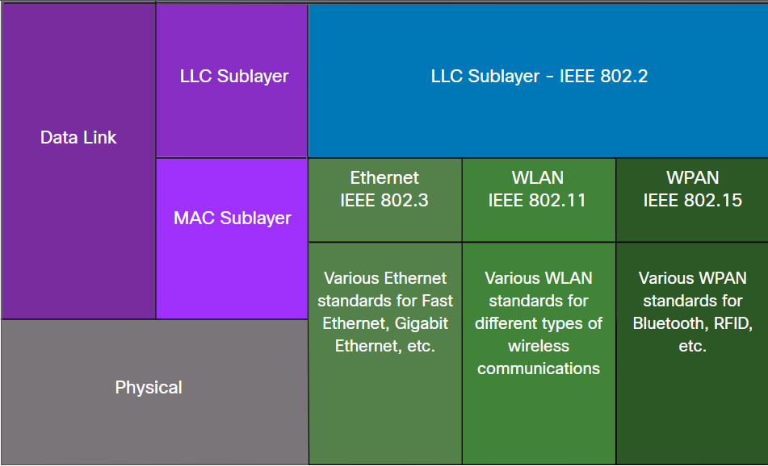

**MAC Sublayer**

The MAC sublayer is responsible for data encapsulation and accessing the media.

Data Encapsulation

IEEE 802.3 data encapsulation includes the following:

Ethernet frame - This is the internal structure of the Ethernet frame.

Ethernet Addressing - The Ethernet frame includes both a source and destination MAC address to deliver the Ethernet frame from Ethernet NIC to Ethernet NIC on the same LAN.

Ethernet Error detection - The Ethernet frame includes a frame check sequence (FCS) trailer used for error detection.

Accessing the Media

As shown in the figure, the IEEE 802.3 MAC sublayer includes the specifications for different Ethernet communications standards over various types of media including copper and fiber.

Ethernet Standards in the MAC Sublayer

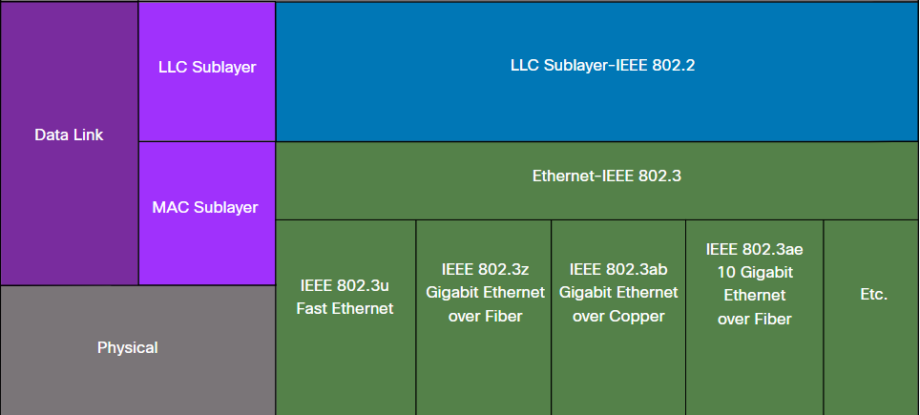

# Data Link Sublayers & MAC Sublayer in Ethernet

Ethernet, as a widely used LAN technology, follows the **IEEE 802 standards**, which divide the **Data Link Layer (Layer 2)** into two distinct sublayers:

1. **Logical Link Control (LLC) Sublayer (IEEE 802.2)**
2. **Media Access Control (MAC) Sublayer (IEEE 802.3, 802.11, 802.15, etc.)**

**1. Data Link Sublayers in Ethernet**

| **Sublayer** | **Standard** | **Function** |
| --- | --- | --- |
| **LLC (Logical Link Control)** | IEEE 802.2 | Identifies the network layer protocol (e.g., IPv4, IPv6) |
| **MAC (Media Access Control)** | IEEE 802.3 (Ethernet) | Encapsulation, addressing, error detection, and media access control |

**1.1 LLC Sublayer (IEEE 802.2)**

* Interfaces between the **network layer (Layer 3)** and the **MAC sublayer**.
* Allows multiple network protocols (e.g., IPv4, IPv6) to share the same physical network.
* Identifies the protocol used in the frame and ensures correct delivery.

**1.2 MAC Sublayer (IEEE 802.3, 802.11, 802.15)**

* Defines Ethernet framing and addressing (MAC addresses).
* Handles **error detection** through Frame Check Sequence (FCS).
* Implements **media access control methods** like **CSMA/CD** (for legacy networks).

**2. MAC Sublayer Functions in Ethernet**

The **MAC sublayer** plays a critical role in Ethernet by defining **encapsulation** and **access control** mechanisms.

**2.1 Data Encapsulation in the MAC Sublayer**

The MAC sublayer structures the **Ethernet frame** with key fields:

1. **Preamble & Start Frame Delimiter (SFD)** – Synchronization
2. **Destination & Source MAC Addresses** – Identifies sender & receiver
3. **EtherType/Length** – Specifies network protocol (IPv4, IPv6, ARP, etc.)
4. **Payload (Data)** – Carries upper-layer data
5. **Frame Check Sequence (FCS)** – Error detection

**2.2 Media Access Control: CSMA/CD & Full-Duplex**

* **Legacy Ethernet (Half-Duplex):** Used **Carrier Sense Multiple Access with Collision Detection (CSMA/CD)** to avoid transmission collisions on shared media (hubs, bus topology).
* **Modern Ethernet (Full-Duplex):** Uses **switches** to allow simultaneous bidirectional communication, eliminating collisions and **CSMA/CD is no longer needed**.

**3. Evolution of Ethernet Standards in the MAC Sublayer**

The **IEEE 802.3 MAC sublayer** specifies different **Ethernet standards** based on **speed** and **media type**.

| **Ethernet Standard** | **Speed** | **Media Type** |
| --- | --- | --- |
| **IEEE 802.3** | 10 Mbps | Coaxial (Legacy) |
| **IEEE 802.3u (Fast Ethernet)** | 100 Mbps | Twisted-Pair, Fiber |
| **IEEE 802.3z (Gigabit Ethernet over Fiber)** | 1 Gbps | Fiber |
| **IEEE 802.3ab (Gigabit Ethernet over Copper)** | 1 Gbps | Twisted-Pair |
| **IEEE 802.3ae (10 Gigabit Ethernet over Fiber)** | 10 Gbps | Fiber |
| **IEEE 802.3ba (40/100 Gigabit Ethernet)** | 40/100 Gbps | Fiber |

Modern networks rely on **Gigabit Ethernet (1 Gbps and above)**, using **fiber-optic** or high-speed twisted-pair cables.

**Conclusion**

The **MAC sublayer** is essential for **framing, addressing, error detection, and media access control** in Ethernet. While **CSMA/CD was used in early half-duplex networks**, today's Ethernet LANs operate in **full-duplex mode using switches**, making **collision detection unnecessary**. Ethernet continues to evolve, supporting **higher speeds and various media types**, ensuring **scalability and efficiency** in modern networks.

# Ethernet Frame Fields

The minimum Ethernet frame size is **64 bytes** and the expected maximum is **1518 bytes**. This includes all bytes from the destination MAC address field through the frame check sequence (FCS) field. **The preamble field is not included when describing the size of the frame.**

Note: The frame size may be larger if additional requirements are included, such as VLAN tagging. VLAN tagging is beyond the scope of this course.

Any frame **less than 64 bytes** in length is considered a **“collision fragment” or “runt frame”** and is **automatically discarded by receiving stations.** Frames with more than 1500 bytes of data are considered **“jumbo” or “baby giant frames”.**

If the size of a transmitted frame is less than the minimum, or greater than the maximum, the receiving device drops the frame. Dropped frames are likely to be the result of collisions or other unwanted signals. They are considered invalid. *Jumbo frames are usually supported by most Fast Ethernet and Gigabit Ethernet switches and NICs.*

The figure shows each field in the Ethernet frame. Refer to the table for more information about the function of each field.

Ethernet Frame Fields

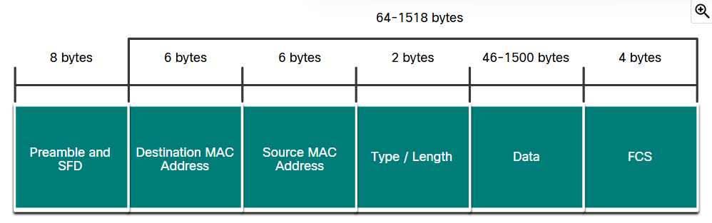

**All frames must be at least 64 bytes long**. **Additional bits called a "pad"** are used to increase the size of small frames to the minimum size.

**The LLC sublayer is responsible for controlling the network interface card through software drivers.**

# Media Access Control (MAC) Address – Deep Dive

A **MAC (Media Access Control) address** is a **unique identifier** assigned to a **network interface card (NIC)** of a device at the **data link layer (Layer 2)** of the **OSI model**. It is used to ensure that data packets are sent to the correct destination within a local network (LAN).

**1. MAC Address Structure**

A MAC address is a **48-bit (6-byte) hexadecimal address**, usually written in one of the following formats:

* **Colon-separated:** 00:1A:2B:3C:4D:5E
* **Hyphen-separated:** 00-1A-2B-3C-4D-5E
* **Dot-separated:** 001A.2B3C.4D5E

**1.1 Breakdown of a MAC Address**

A MAC address consists of two main parts:

| **Bits** | **Field** | **Description** |
| --- | --- | --- |
| **First 24 bits (3 bytes)** | **Organizationally Unique Identifier (OUI)** | Manufacturer’s identifier assigned by the IEEE |
| **Last 24 bits (3 bytes)** | **Network Interface Controller (NIC) Specific** | Unique value assigned by the manufacturer |

🔹 **Example MAC Address:** 00:1A:2B:3C:4D:5E

* 00:1A:2B → **OUI** (Manufacturer’s Identifier, e.g., Intel, Cisco, etc.)
* 3C:4D:5E → **NIC Specific** (Device-Specific Part)

**1.2 MAC Address Special Bits**

Two important bits in the MAC address determine special behaviors:

| **Bit Position** | **Meaning** | **Description** |
| --- | --- | --- |
| **1st Bit (LSB of First Byte)** | **Unicast (0) / Multicast (1)** | 0 → Unicast, 1 → Multicast |
| **2nd Bit (MSB of First Byte)** | **Globally Unique (0) / Locally Administered (1)** | 0 → IEEE-assigned, 1 → Custom-defined |

**2. MAC Address Types**

There are **three types** of MAC addresses based on their usage in network communication:

| **Type** | **Purpose** | **MAC Address Range** |
| --- | --- | --- |
| **Unicast MAC** | Packet sent to a single destination | Unique MAC address of a device |
| **Broadcast MAC** | Packet sent to all devices on the LAN | FF:FF:FF:FF:FF:FF |
| **Multicast MAC** | Packet sent to a specific group of devices | Starts with 01:00:5E (IPv4) or 33:33 (IPv6) |

**3. Unicast, Broadcast, and Multicast Communication**

MAC addresses help define **how data is transmitted** over a LAN.

**3.1 Unicast Communication**

🔹 **Definition:**  
A **unicast** transmission is a one-to-one communication where a frame is sent from **one device (source MAC) to another device (destination MAC)**.

🔹 **Example:**  
When a computer sends an HTTP request to a web server on the same network, the Ethernet frame will have:

* **Source MAC:** MAC address of the sender's NIC
* **Destination MAC:** MAC address of the web server

💡 **Key Features:**

* Used for direct device-to-device communication
* More efficient as only one device receives the frame
* Works in both **switched** and **routed** networks

**3.2 Broadcast Communication**

🔹 **Definition:**  
A **broadcast** transmission is a one-to-all communication where a frame is sent to **all devices** on a network segment.

🔹 **MAC Address Used:**  
FF:FF:FF:FF:FF:FF (All bits are 1s)

🔹 **Example:**

* **ARP Request:** A device asks, *"Who has this IP? Tell me your MAC address!"*
* **DHCP Discover:** A new device requests an IP address from a DHCP server.

💡 **Key Features:**

* Used for **network discovery and address resolution**
* Every device on the LAN must **process the frame**
* Consumes **more network bandwidth**

🔻 **Broadcast Storm Issue**:  
Too many broadcast packets can **overload the network**, causing a **broadcast storm**. This is why VLANs and routers are used to **segment networks** and limit broadcast domains.

**3.3 Multicast Communication**

🔹 **Definition:**  
A **multicast** transmission is a one-to-many communication where a frame is sent to **a specific group of devices** rather than all devices.

🔹 **MAC Address Range:**

* **IPv4 Multicast MAC:** 01:00:5E:xx:xx:xx
* **IPv6 Multicast MAC:** 33:33:xx:xx:xx:xx

🔹 **Example:**

* **Streaming Video (e.g., IPTV):** A multicast group is used for devices that need to receive a live video stream.
* **Routing Protocols (e.g., OSPF, EIGRP):** Routers communicate updates via multicast.

💡 **Key Features:**

* More efficient than **broadcast** because only specific group members receive the frames.
* Used in **VoIP, IPTV, conferencing, and routing protocols**.

🔻 **Multicast Filtering:**  
Network switches use **IGMP Snooping** to ensure that multicast traffic is forwarded only to the **devices that have subscribed** to the multicast group, avoiding unnecessary traffic.

**4. How Switches Use MAC Addresses**

Ethernet switches maintain a **MAC address table (CAM table)** to intelligently forward frames.

**4.1 Learning Phase**

* The switch learns **MAC addresses** by examining the **source MAC** of incoming frames.
* It stores **the MAC along with the port number.**

**4.2 Forwarding Phase**

* When a switch receives a **frame**, it checks the **destination MAC**.
  + **If the MAC is in the table** → Forward to the correct port.
  + **If the MAC is unknown** → Flood the frame to all ports (**except source port**).

**4.3 Aging & Updating**

* MAC address entries expire after **a certain period** (default ~5 minutes).
* Dynamic updates keep the table **efficient and accurate**.

**5. MAC Address Filtering & Security**

Attackers can **spoof MAC addresses** to gain unauthorized access. To mitigate this:

| **Security Feature** | **Function** |
| --- | --- |
| **Port Security** | Limits the number of MAC addresses per switch port. |
| **Dynamic ARP Inspection (DAI)** | Prevents ARP spoofing attacks. |
| **MAC Address Filtering** | Allows only specific MAC addresses to access the network. |

**6. MAC Address vs. IP Address**

| **Feature** | **MAC Address** | **IP Address** |
| --- | --- | --- |
| **Layer** | Layer 2 (Data Link) | Layer 3 (Network) |
| **Uniqueness** | Unique to a device | Can change based on network |
| **Scope** | Works in LAN | Works across networks (WAN) |
| **Used by** | Switches (L2) | Routers (L3) |
| **Format** | 48-bit Hexadecimal | 32-bit (IPv4) / 128-bit (IPv6) |
| **Example** | 00:1A:2B:3C:4D:5E | 192.168.1.1 / 2001:db8::1 |

**Conclusion**

* The **MAC address** is a **hardware address** used for **local network communication**.
* It supports **unicast, broadcast, and multicast** traffic.
* Ethernet **switches use MAC address tables** to forward frames **efficiently**.
* Security features like **port security, ARP inspection, and filtering** protect against MAC-based attacks.
* The MAC address works alongside **IP addresses** to ensure seamless **network communication**.

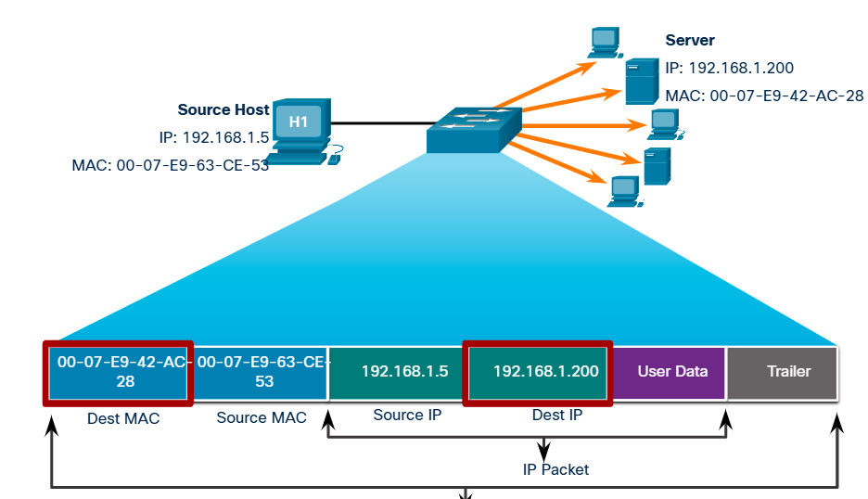

# How MAC Address Tables Work

A switch maintains a **MAC address table** (also called the **Content Addressable Memory (CAM) table**) that maps **MAC addresses to switch ports**.

| **MAC Address** | **Port Number** |
| --- | --- |
| AA:BB:CC:DD:EE:01 | Port 1 |
| AA:BB:CC:DD:EE:02 | Port 2 |
| AA:BB:CC:DD:EE:03 | Port 3 |
| AA:BB:CC:DD:EE:04 | Port 4 |

Whenever a **new frame** arrives at a switch port, the switch checks the **source MAC address** and updates the table. If the **destination MAC is known**, it forwards the frame out of the corresponding port. If the **destination MAC is unknown**, it **floods the frame** to all ports (except the source port).

**2. Multiple MAC Addresses on a Single Switch Port**

When a **switch is connected to another switch**, all devices connected to the second switch are **reachable through a single port** on the first switch.

**Example: Switch-to-Switch Connection**

**Network Setup:**

* **Switch A (Root Switch)**
* **Switch B (Downstream Switch)**
* **Devices 1, 2, and 3 are connected to Switch B**

**MAC Address Table on Switch A**

| **MAC Address** | **Port Number** |
| --- | --- |
| AA:BB:CC:DD:EE:01 (Device 1) | Port 2 (Connected to Switch B) |
| AA:BB:CC:DD:EE:02 (Device 2) | Port 2 (Connected to Switch B) |
| AA:BB:CC:DD:EE:03 (Device 3) | Port 2 (Connected to Switch B) |
| FF:FF:FF:FF:FF:FF (Broadcast) | All Ports |

💡 **What’s Happening?**

* Switch A sees traffic from **multiple MAC addresses** on **Port 2** because all devices behind Switch B are sending frames.
* Switch A **associates multiple MAC addresses** with Port 2.

**3. How Frames are Forwarded in Multi-Switch Networks**

**Scenario: Device 1 sends a frame to Device 3**

1. **Device 1 → Switch B**: The frame enters Switch B.
2. **Switch B → Switch A**: If Switch B does not have the MAC address of Device 3 in its table, it forwards the frame to Switch A.
3. **Switch A checks MAC Table**:
   * If it knows where Device 3 is, it forwards the frame to the correct port.
   * If not, it floods the frame.
4. **Switch B receives the frame and delivers it to Device 3**.

**Scenario: Device 2 sends a broadcast (ARP request)**

1. Device 2 sends an **ARP request** (Who has IP X.X.X.X? Tell Device 2).
2. Switch B floods the broadcast to all ports.
3. Switch A **receives the broadcast on Port 2** and floods it to other ports (except Port 2).
4. All connected devices, including those on Switch A, receive the ARP request.

**4. Benefits of MAC Address Learning on Switches**

* **Efficient Forwarding:** Switches **learn** where each MAC address is located and **only forward frames to the correct port**.
* **Reduced Broadcasts:** Instead of **flooding** all frames, the switch can **unicast** traffic when it knows the destination MAC.
* **Loop Prevention:** If multiple switches exist, **Spanning Tree Protocol (STP)** prevents **loops** and network flooding.

**5. MAC Address Aging & Dynamic Learning**

* **Aging Timer:** MAC addresses are removed from the table after **5 minutes of inactivity** (default).
* **Relearning:** If a device moves to a different port, the switch updates the MAC table dynamically.

**Conclusion**

* When **one switch connects to another switch**, multiple MAC addresses can be learned on a **single port**.
* The **upstream switch (Switch A)** maintains a **MAC table entry for each device** behind the **downstream switch (Switch B)**.
* Efficient **frame forwarding** helps reduce unnecessary broadcasts and improves network performance.

# Show the Entire MAC Address Table

show mac address-table

This command displays **all learned MAC addresses**, their corresponding VLANs, interface ports, and types (static/dynamic).

**Example Output:**

Switch# show mac address-table

Mac Address Table

-------------------------------------------

Vlan Mac Address Type Ports

---- ----------- -------- -----

1 0001.5c4b.2b01 DYNAMIC Fa0/1

1 000a.8a47.5e92 DYNAMIC Fa0/2

10 00e0.b0e9.2b22 DYNAMIC Gi0/1

📌 **Columns Explained:**

* **Vlan:** The VLAN to which the MAC address belongs.
* **Mac Address:** The learned MAC address.
* **Type:**
  + DYNAMIC: Learned dynamically by the switch.
  + STATIC: Manually configured or from port security.
* **Ports:** The interface where the MAC address was learned.

**2. Show MAC Addresses for a Specific Interface**

show mac address-table interface FastEthernet 0/1

This command filters MAC addresses **only** for Fa0/1.

**Example Output:**

Switch# show mac address-table interface Fa0/1

Mac Address Table

-------------------------------------------

Vlan Mac Address Type Ports

---- ----------- -------- -----

1 0001.5c4b.2b01 DYNAMIC Fa0/1

**3. Clear the MAC Address Table**

clear mac address-table dynamic

This **clears all dynamically learned MAC addresses**, forcing the switch to relearn them.

**Bonus: Debugging & Additional Commands**

**Monitor MAC Address Learning in Real-Time**

debug ethernet mac

**Verify Port Security MAC Addresses**

If **Port Security** is enabled, you can check secure MAC addresses using:

show port-security address

**Check Spanning Tree MAC Table**

show spanning-tree address

This helps troubleshoot MAC address issues in a **Spanning Tree Protocol (STP)** environment.

**Conclusion**

show mac address-table → Displays all learned MAC addresses.

show mac address-table interface Fa0/1 → MAC addresses on a specific port.

clear mac address-table dynamic → Clears learned MAC addresses.

# OSI Model Data Encapsulation Explained

**Data encapsulation** is the process of adding headers and trailers to data as it moves **down** the layers of the **OSI model** during transmission. The process is reversed (**decapsulation**) when data is received.

**Encapsulation Steps (Sender Side)**

When a sender transmits data, it **passes through all 7 OSI layers** and gets encapsulated at each step:

1. **Application Layer (Layer 7)**
   * **Data** is created by applications (e.g., web browser, email client).
   * Examples: HTTP request, SMTP email.
2. **Presentation Layer (Layer 6)**
   * Converts data into a **format** the recipient understands (e.g., encryption, compression).
   * Example: Data is compressed using Gzip.
3. **Session Layer (Layer 5)**
   * **Establishes, manages, and terminates communication sessions.**
   * Example: A TCP session is created between a web server and browser.
4. **Transport Layer (Layer 4)**
   * **Encapsulation Begins Here:**
   * Data is **segmented** into smaller pieces for transmission.
   * Each segment gets a **TCP or UDP header**, containing **source/destination ports** and **sequence numbers**.
   * Example: TCP segment for reliable data transmission.
5. **Network Layer (Layer 3)**
   * **Encapsulates the segment into a Packet**
   * Adds an **IP header** with **source/destination IP addresses**.
   * Example: The IP address of a web server (192.168.1.1) is added.
6. **Data Link Layer (Layer 2)**
   * **Encapsulates the packet into a Frame**
   * Adds a **MAC address header** for physical addressing.
   * Includes an **FCS (Frame Check Sequence)** for error detection.
   * Example: The MAC address of the next router is added.
7. **Physical Layer (Layer 1)**
   * Converts the frame into **binary bits (0s and 1s)** for transmission.
   * Example: Data is transmitted as **electrical signals (copper)** or **light pulses (fiber optic)**.

**Decapsulation Steps (Receiver Side)**

At the receiving end, the process is **reversed** (decapsulation):

1. **Physical Layer**: Receives bits and converts them into frames.
2. **Data Link Layer**: Extracts the packet and verifies MAC addresses.
3. **Network Layer**: Reads the IP header and forwards the packet.
4. **Transport Layer**: Reassembles segments and verifies order.
5. **Session Layer**: Manages session continuity.
6. **Presentation Layer**: Decrypts and decompresses data.
7. **Application Layer**: The final data is presented to the user.

**Encapsulation Example (Web Browsing)**

When you visit www.example.com:

1. **Application Layer**: Your browser creates an HTTP GET request.
2. **Transport Layer**: TCP segments the request and assigns a port number (80 for HTTP).
3. **Network Layer**: The IP header is added (Source IP: 192.168.1.10, Destination IP: 93.184.216.34).
4. **Data Link Layer**: The MAC header is added for physical delivery.
5. **Physical Layer**: Bits are sent through the network cable to the router.

On the web server, **decapsulation** occurs, and the response (web page) follows the same process back to your browser.

**Summary of Encapsulation Units**

| **OSI Layer** | **Encapsulation Unit** | **Example** |
| --- | --- | --- |
| Application | Data | HTTP Request |
| Transport | Segment (TCP) / Datagram (UDP) | TCP Header (Port 80) |
| Network | Packet | IP Header (Source/Destination IP) |
| Data Link | Frame | MAC Header (Source/Destination MAC) |
| Physical | Bits | Electrical signals |

**Conclusion**

* **Encapsulation** ensures structured **data transmission** across networks.
* **Each layer adds specific headers** to enable delivery, addressing, and error handling.
* **Decapsulation** reverses the process on the receiving end.

To accomplish end-to-end communications across network boundaries, network layer protocols perform four basic operations:

Addressing end devices - End devices must be configured with a unique IP address for identification on the network.

Encapsulation - The network layer encapsulates the protocol data unit (PDU) from the transport layer into a packet. The encapsulation process adds IP header information, such as the IP address of the source (sending) and destination (receiving) hosts. The encapsulation process is performed by the source of the IP packet.

Routing - The network layer provides services to direct the packets to a destination host on another network. To travel to other networks, the packet must be processed by a router. The role of the router is to select the best path and direct packets toward the destination host in a process known as routing. A packet may cross many routers before reaching the destination host. Each router a packet crosses to reach the destination host is called a hop.

De-encapsulation - When the packet arrives at the network layer of the destination host, the host checks the IP header of the packet. If the destination IP address within the header matches its own IP address, the IP header is removed from the packet. After the packet is de-encapsulated by the network layer, the resulting Layer 4 PDU is passed up to the appropriate service at the transport layer. The de-encapsulation process is performed by the destination host of the IP packet.

Unlike the transport layer (OSI Layer 4), which manages the data transport between the processes running on each host, network layer communication protocols (i.e., IPv4 and IPv6) specify the packet structure and processing used to carry the data from one host to another host. Operating without regard to the data carried in each packet allows the network layer to carry packets for multiple types of communications between multiple hosts.

IP encapsulates the transport layer (the layer just above the network layer) segment or other data by adding an IP header. The IP header is used to deliver the packet to the destination host.

The figure illustrates how the transport layer PDU is encapsulated by the network layer PDU to create an IP packet.

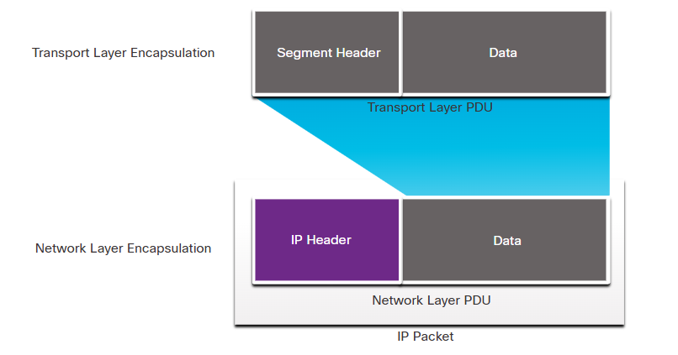

# Characteristics of IP (Internet Protocol)

The **Internet Protocol (IP)** is the primary network layer protocol used for delivering packets across interconnected networks. It has several fundamental characteristics that define its behavior and operation.

**1. Connectionless**

* **No prior setup**: IP does not establish a connection between the sender and receiver before sending data.
* **Each packet is independent**: Every IP packet is treated individually and can take a different route to the destination.
* **No session management**: Unlike TCP, IP does not keep track of ongoing communication sessions.

✅ **Analogy:** Sending letters via postal mail – each letter (packet) is sent separately without confirming if the recipient is available.

**2. Best-Effort Delivery (Unreliable Protocol)**

* **No guarantees**: IP does not guarantee that packets will arrive at the destination.
* **No error recovery**: If a packet is lost, corrupted, or delayed, IP does not attempt to resend it.
* **No order assurance**: Packets may arrive **out of order**, and reassembly is handled by higher layers like TCP.
* **No congestion control**: If the network is congested, packets may be **dropped** without notification.

✅ **Analogy:** Sending multiple postcards—some may arrive late, out of order, or get lost without confirmation.

🛠 **Solution:** TCP (at Layer 4) provides reliability by tracking packets, acknowledging receipt, and retransmitting lost data.

**3. Media Independent**

* **Works over any medium**: IP operates over various physical network technologies, including **copper cables, fiber-optic, and wireless**.
* **Different data link layer technologies**: IP can be carried over **Ethernet, Wi-Fi (802.11), cellular networks (5G), satellite links, etc.**
* **Addressing is consistent**: Regardless of the medium, IP addresses remain the same for logical network communication.

❗ **Exception:**

* IP is dependent on **Maximum Transmission Unit (MTU)**.
* The size of an IP packet must conform to the MTU of the underlying network (e.g., Ethernet has an MTU of **1500 bytes**).

✅ **Analogy:** A package can be transported via **truck, airplane, or ship**, but the **address format remains the same**.

**Conclusion**

| **Characteristic** | **Description** | **Analogy** |
| --- | --- | --- |
| **Connectionless** | No setup before transmission, each packet is independent | Sending letters individually |
| **Best-Effort** | No delivery guarantees, no error recovery | Sending postcards with no tracking |
| **Media Independent** | Works over different physical mediums | A package shipped by truck, plane, or boat |

While **IP is simple and efficient**, **higher-layer protocols (like TCP) add reliability** when needed.

**Example: Packet Delivery Using IP and TCP 🚀**

Let's compare **how IP and TCP work together** when sending data over a network, using a real-world analogy.

**Scenario: Sending an Email 📧**

Imagine you are sending an email from **your laptop** (Sender) to your friend’s **computer** (Receiver). The process involves **IP** for addressing and routing and **TCP** for reliability.

**Step-by-Step Process**

**1️⃣ Application Layer (Layer 7) - Preparing the Email**

* You compose an email and click **"Send"**.
* The email application (e.g., Gmail, Outlook) formats the email into a **message** and prepares it for transmission.
* The **SMTP (Simple Mail Transfer Protocol)** is used for sending emails.

📍 **Analogy:** You write a letter and put it in an envelope.

**2️⃣ Transport Layer (Layer 4) - TCP Breaks the Message into Segments**

* **TCP splits** the email into smaller **segments** to fit into packets.
* TCP adds **sequence numbers** to keep track of the order of segments.
* It adds a **checksum** to detect errors.
* TCP uses a **three-way handshake** to establish a connection with the receiver before sending data.

📍 **Analogy:** You break your long letter into multiple numbered pages to ensure they arrive in order.

**3️⃣ Network Layer (Layer 3) - IP Addresses and Routing**

* Each segment is **wrapped in an IP packet** with:
  + **Source IP** (Your device’s IP, e.g., 192.168.1.10)
  + **Destination IP** (Your friend’s IP, e.g., 203.0.113.5)
* IP sends packets **independently** through different routes across the internet.

📍 **Analogy:** Each page of your letter is put into separate envelopes with **sender and recipient addresses** and sent via different mail trucks.

**4️⃣ Data Link Layer (Layer 2) - MAC Address & Physical Transmission**

* The packets are placed in Ethernet **frames** or **Wi-Fi frames**.
* The **MAC address** of the next hop (router/switch) is added.
* The packet is transmitted via **Ethernet, Wi-Fi, or fiber-optic cables**.

📍 **Analogy:** The post office (router) reads the envelope’s address and determines the best route to deliver it.

**5️⃣ Receiving Device - TCP Reassembles the Data**

* The receiver’s device **collects all the packets**.
* **TCP checks the sequence numbers** and **rearranges them** if they arrive out of order.
* TCP requests **retransmission** if any segment is missing or corrupted.
* Once all packets are received correctly, TCP **removes its headers** and passes the message to the email application.

📍 **Analogy:** Your friend receives all the pages, checks the numbering, and arranges them in order before reading your letter.

**Summary: How IP and TCP Work Together**

| **Layer** | **Role** | **Analogy** |
| --- | --- | --- |
| **Application (Email Client)** | Creates the message (SMTP) | Writing a letter |
| **Transport (TCP)** | Splits message into ordered segments, ensures reliability | Numbering and checking pages |
| **Network (IP)** | Adds sender/receiver addresses, routes packets | Placing pages in addressed envelopes |
| **Data Link (Ethernet/Wi-Fi)** | Delivers packets over physical media | Postal service handling delivery |

✅ **TCP ensures reliability** (like tracking a package).  
✅ **IP ensures delivery across networks** (like mailing letters).

**Key Takeaways**

* **IP handles addressing & routing** but does not guarantee delivery.
* **TCP ensures reliability** by sequencing packets, detecting errors, and retransmitting lost data.
* **Together, TCP/IP powers most of the internet!** 🌍

IP packets can travel over different media.

The OSI data link layer is responsible for taking an IP packet and preparing it for transmission over the communications medium. This means that the delivery of IP packets is not limited to any particular medium.

There is, however, one major characteristic of the media that the network layer considers: the **maximum size of the PDU that each medium can transport**. This characteristic is referred to as the **maximum transmission unit (MTU).** Part of the control communication between the data link layer and the network layer is the establishment of a maximum size for the packet. The data link layer passes the MTU value up to the network layer. The network layer then determines how large packets can be.

In some cases, an intermediate device, usually a router, must split up an IPv4 packet when forwarding it from one medium to another medium with a smaller MTU. **This process is called fragmenting the packet**, or fragmentation. **Fragmentation** causes latency. IPv6 packets cannot be fragmented by the router.

The data link layer receives IP packets from the network layer and encapsulates them for transmission over the medium.

**Fragmentation** is the process of **splitting up IP packets** to travel over a **medium with a smaller MTU.**

# IPv4 Packet Header Explained 🖧📦

The **IPv4 packet header** is a structured **binary format** that contains all the necessary information to ensure that a packet is correctly processed and delivered across networks.

**IPv4 Packet Header Fields**

Each **IPv4 packet** consists of a **header** (with control information) and a **payload** (actual data). The **header is 20 bytes (minimum) to 60 bytes (maximum)**, depending on the presence of optional fields.

**IPv4 Header Format (20 Bytes Minimum)**

| **Field Name** | **Size (Bits)** | **Purpose** |
| --- | --- | --- |
| **Version** | 4 | Identifies IP version (IPv4 = 4) |
| **IHL (Internet Header Length)** | 4 | Specifies the length of the header |
| **Type of Service (TOS)** | 8 | Prioritization for Quality of Service (QoS) |
| **Total Length** | 16 | Total packet size (header + data) |
| **Identification** | 16 | Used to identify fragmented packets |
| **Flags** | 3 | Controls packet fragmentation |
| **Fragment Offset** | 13 | Position of a fragment within the original packet |
| **Time to Live (TTL)** | 8 | Limits how long a packet exists in the network |
| **Protocol** | 8 | Identifies Layer 4 protocol (e.g., TCP = 6, UDP = 17) |
| **Header Checksum** | 16 | Ensures integrity of the header |
| **Source IP Address** | 32 | IP address of the sender |
| **Destination IP Address** | 32 | IP address of the receiver |
| **Options (Optional)** | Variable | Used for special features like security |
| **Padding** | Variable | Ensures the header is a multiple of 32 bits |

**Key IPv4 Header Fields in Detail 🛠️**

**1️⃣ Version (4 Bits)**

* Specifies the IP version (IPv4 = 4, IPv6 = 6).

**2️⃣ IHL (Internet Header Length) (4 Bits)**

* Defines the length of the IP header (min **20 bytes**, max **60 bytes**).

**3️⃣ Type of Service (TOS) (8 Bits)**

* **Prioritizes packets** for Quality of Service (QoS) in real-time applications like VoIP or video streaming.

**4️⃣ Total Length (16 Bits)**

* Specifies the **entire packet size (header + data)** in bytes.
* Max value: **65,535 bytes** (most packets are much smaller).

**5️⃣ Identification (16 Bits)**

* Unique **ID for fragmented packets** to help reassemble them.

**6️⃣ Flags (3 Bits)**

* Controls **fragmentation behavior**:
  + **Bit 0:** Reserved
  + **Bit 1:** **Don’t Fragment (DF)** – Prevents fragmentation
  + **Bit 2:** **More Fragments (MF)** – Indicates more fragments follow

**7️⃣ Fragment Offset (13 Bits)**

* Tells the receiver where each **fragmented piece** of the packet belongs.

**8️⃣ Time to Live (TTL) (8 Bits)**

* Prevents packets from **looping forever**.
* Decreases by **1** at each hop (router).
* When TTL = 0, packet is **discarded** and an **ICMP "Time Exceeded"** message is sent.

**9️⃣ Protocol (8 Bits)**

* Defines the **Layer 4 protocol** used in the payload:
  + **6** → TCP
  + **17** → UDP
  + **1** → ICMP (Ping)

**🔟 Header Checksum (16 Bits)**

* Used for **error detection** in the header (not data).

**1️⃣1️⃣ Source & Destination IP Addresses (32 Bits Each)**

* Identifies the **sender and receiver** of the packet.

**1️⃣2️⃣ Options (Variable, Optional)**

* Rarely used, but supports additional functionality (e.g., security, timestamps).

**How an IPv4 Packet Travels Across a Network 🌍**

1️⃣ **Sender creates a packet** with a destination IP address.  
2️⃣ The packet is **encapsulated** in a frame (Layer 2) with a MAC address.  
3️⃣ If the destination is on a different network, the packet **goes through routers**.  
4️⃣ Each router **reads the destination IP**, **decreases the TTL**, and **forwards the packet**.  
5️⃣ When the packet **reaches the destination**, the receiver **extracts the data**.

**Example: Viewing IPv4 Packets in Wireshark 📡**

You can **capture IPv4 packets** using Wireshark and see these fields in action!

**Command to Capture IPv4 Packets on Linux/macOS:**

sudo tcpdump -i eth0 -n ip

**Cisco Command to View IPv4 Packets:**

show ip traffic

**Key Takeaways 🚀**

✅ IPv4 uses a **structured header** with key fields like **TTL, Protocol, and Checksum**.  
✅ **Routers use the TTL field** to prevent packets from looping.  
✅ **IP is connectionless** (does not guarantee delivery like TCP).  
✅ Each IPv4 packet **has a fixed 20-byte header** (with optional extensions).

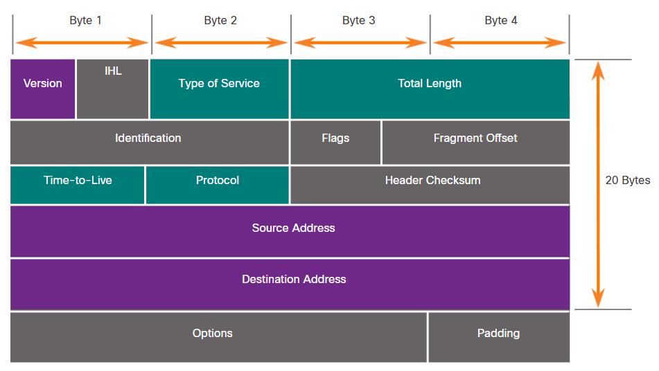

Significant fields in the IPv4 header include the following:

**Version** - Contains a 4-bit binary value set to 0100 that identifies this as an IPv4 packet.

**Differentiated Services or DiffServ (DS)** - Formerly called the **type of service (ToS)** field, the DS field is an 8-bit field used to determine the **priority of each packet**. The six most significant bits of the DiffServ field are the **differentiated services code point (DSCP)** bits and the last two bits are **the explicit congestion notification (ECN) bits.**

**Time to Live (TTL)** – TTL contains an 8-bit binary value that is used to **limit the lifetime of a packet.** The source device of the IPv4 packet sets the initial TTL value. It is decreased by one each time the packet is processed by a router. If the TTL field decrements to zero, the router discards the packet and sends an Internet Control Message Protocol (ICMP) Time Exceeded message to the source IP address. Because the router decrements the TTL of each packet, the router must also recalculate the Header Checksum.

**Protocol** – This field is used to identify the next level protocol. This 8-bit binary value indicates the data payload type that the packet is carrying, which enables the network layer to pass the data to the appropriate upper-layer protocol. Common values include **ICMP (1), TCP (6), and UDP (17).**

**Header Checksum** – This is used to detect corruption in the IPv4 header.

**Source IPv4 Address** – This contains a 32-bit binary value that represents the source IPv4 address of the packet. The source IPv4 address is always a unicast address.

**Destination IPv4 Address** – This contains a 32-bit binary value that represents the destination IPv4 address of the packet. The destination IPv4 address is a unicast, multicast, or broadcast address.

The two most commonly referenced fields are the source and destination IP addresses. These fields identify where the packet is coming from and where it is going. Typically, these addresses do not change while travelling from the source to the destination.

**The Internet Header Length (IHL), Total Length, and Header Checksum** fields are used to **identify** and **validate the packet.**

Other fields are used to reorder a fragmented packet. Specifically, the IPv4 packet uses Identification, Flags, and Fragment Offset fields to keep track of the fragments. A router may have to **fragment an IPv4 packet** when forwarding it from **one medium to another with a smaller MTU.**

# IPv4 vs. IPv6: Limitations and Advancements 🌐🚀

The transition from **IPv4** to **IPv6** addresses the growing challenges of network connectivity in the modern world. Here's a **detailed comparison** of their limitations and improvements.

**5.3.1 Limitations of IPv4 ⚠️**

Despite its long-standing success, **IPv4** faces several challenges due to its limited **address space** and increasing network demands.

**🔴 1. IPv4 Address Depletion**

* IPv4 uses **32-bit addresses**, allowing for **only ~4.3 billion unique addresses**.
* The rise of **IoT (Internet of Things), mobile devices, and global internet access** has rapidly **exhausted** IPv4 addresses.
* **Workarounds like NAT** (Network Address Translation) have helped, but they are not a long-term solution.

**🔴 2. Lack of End-to-End Connectivity**

* NAT allows **multiple devices to share a single public IP**, but it **hides** internal devices.
* This makes **peer-to-peer communication, VoIP, and real-time applications** more complex.
* IPv4’s reliance on NAT causes **security and performance challenges**.

**🔴 3. Increased Network Complexity**

* IPv4 networks require **workarounds** like:
  + **NAT (Network Address Translation)**
  + **Subnetting**
  + **DHCP (Dynamic Host Configuration Protocol)**
* These add **latency** and make **troubleshooting harder**.

**5.3.2 IPv6 Overview 🔄**

To overcome IPv4's issues, the **Internet Engineering Task Force (IETF)** developed **IPv6** in the **1990s**. IPv6 introduces **major improvements** to support modern and future networking needs.

**✅ 1. Increased Address Space**

* IPv6 uses **128-bit addresses** (compared to IPv4’s **32-bit**), providing:
  + **IPv4:** ~4.3 billion addresses
  + **IPv6:** **340 undecillion (3.4 × 10³⁸) addresses**
* IPv6 can assign a **unique address to every device**, eliminating the need for NAT.

**✅ 2. Improved Packet Handling**

* IPv6 has a **simplified header** with **fewer fields**, improving processing efficiency.
* IPv6 **removes unnecessary fields** from IPv4 (e.g., Checksum, Fragment Offset).

**✅ 3. Eliminates the Need for NAT**

* Since IPv6 offers **virtually unlimited addresses**, NAT is no longer required.
* This allows **true end-to-end communication**, benefiting applications like **VoIP, streaming, and gaming**.

**🌎 How Big is IPv6?**

IPv6 offers **340 undecillion** (340 * 10³⁶) addresses.  
That’s enough to assign an **IPv6 address to every grain of sand on Earth**! 🏖️

| **Number Name** | **Scientific Notation** | **Number of Zeros** |
| --- | --- | --- |
| Thousand | 10³ | 1,000 |
| Million | 10⁶ | 1,000,000 |
| Billion | 10⁹ | 1,000,000,000 |
| Trillion | 10¹² | 1,000,000,000,000 |
| Quadrillion | 10¹⁵ | 1,000,000,000,000,000 |
| Quintillion | 10¹⁸ | 1,000,000,000,000,000,000 |
| Sextillion | 10²¹ | 1,000,000,000,000,000,000,000 |
| Septillion | 10²⁴ | 1,000,000,000,000,000,000,000,000 |
| Octillion | 10²⁷ | 1,000,000,000,000,000,000,000,000,000 |
| Nonillion | 10³⁰ | 1,000,000,000,000,000,000,000,000,000,000 |
| Decillion | 10³³ | 1,000,000,000,000,000,000,000,000,000,000,000 |
| Undecillion | 10³⁶ | 1,000,000,000,000,000,000,000,000,000,000,000,000 |

**5.3.3 IPv4 vs. IPv6 Packet Headers 📦**

One of the key improvements in **IPv6** is its **simplified packet header**.

**🔄 Key Differences in IPv6 Header:**

| **IPv4 Field** | **IPv6 Equivalent** | **Changes** |
| --- | --- | --- |
| Version | Version | Remains the same |
| IHL (Header Length) | Removed | Fixed header size |
| Type of Service (ToS) | Traffic Class | Used for QoS |
| Total Length | Payload Length | Excludes header size |
| Identification | Removed | No fragmentation in IPv6 |
| Flags | Removed | Handled differently |
| Fragment Offset | Removed | Fragmentation is done at the source |
| Time to Live (TTL) | Hop Limit | Same function but renamed |
| Protocol | Next Header | Can indicate chained headers |
| Header Checksum | Removed | No longer needed |
| Source IP Address | Source Address | Remains the same (128-bit) |
| Destination IP Address | Destination Address | Remains the same (128-bit) |

**🚀 Advantages of IPv6 Header Over IPv4**

* **Fixed header size (40 bytes)** → Faster processing.
* **No checksum field** → Reduces processing overhead.
* **No fragmentation** → Source device handles fragmentation, improving efficiency.

**IPv4 vs. IPv6: Side-by-Side Comparison 📊**

| **Feature** | **IPv4** | **IPv6** |
| --- | --- | --- |
| Address Size | 32-bit | 128-bit |
| Total Addresses | ~4.3 billion | ~340 undecillion |
| NAT Required? | Yes | No |
| Header Size | 20-60 bytes | Fixed 40 bytes |
| Checksum | Yes | No |
| Security | Optional (IPsec) | Built-in |
| Broadcast Support | Yes | No (Uses multicast) |
| Routing Efficiency | Complex (Fragmentation, NAT) | Simplified |
| QoS Support | Limited | Improved |

**🌟 Key Takeaways**

✅ **IPv4 is running out of addresses**, and IPv6 provides **virtually unlimited addresses**.  
✅ IPv6 removes **NAT dependency**, ensuring **true end-to-end connectivity**.  
✅ IPv6 has a **simplified header**, leading to **faster processing** and **better performance**.  
✅ **IPv6 adoption is increasing**, but **IPv4 is still widely used**.

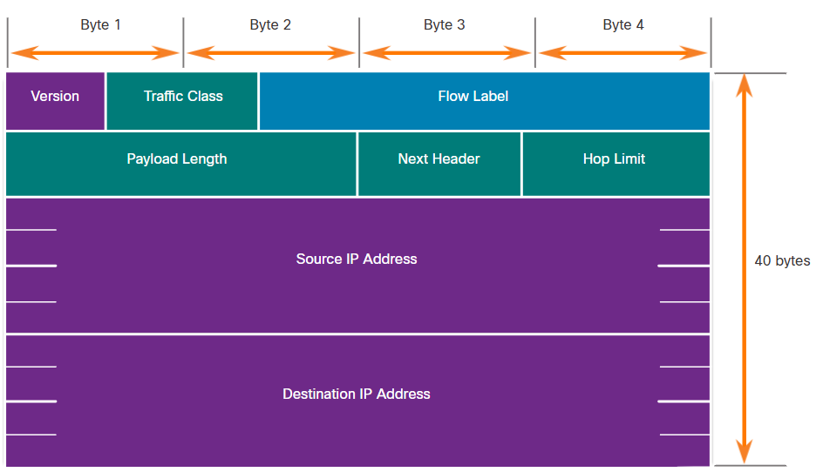

The fields in the IPv6 packet header include the following:

**Version** - This field contains a 4-bit binary value set to 0110 that identifies this as an IP version 6 packet.

**Traffic Class** - This 8-bit field is equivalent to the IPv4 Differentiated Services (DS) field.

**Flow Label** - This 20-bit field suggests that all packets with the same flow label receive the same type of handling by routers.

**Payload Length** - This 16-bit field indicates the length of the data portion or payload of the IPv6 packet. This does not include the length of the IPv6 header, which is a fixed 40-byte header.

**Next Header** - This 8-bit field is equivalent to the IPv4 Protocol field. It indicates the data payload type that the packet is carrying, enabling the network layer to pass the data to the appropriate upper-layer protocol.

**Hop Limit** - This 8-bit field replaces the IPv4 TTL field. This value is decremented by a value of 1 by each router that forwards the packet. When the counter reaches 0, the packet is discarded, and an ICMPv6 Time Exceeded message is forwarded to the sending host,. This indicates that the packet did not reach its destination because the hop limit was exceeded. Unlike IPv4, IPv6 does not include an IPv6 Header Checksum, because this function is performed at both the lower and upper layers. This means the checksum does not need to be recalculated by each router when it decrements the Hop Limit field, which also improves network performance.

**Source IPv6 Address** - This 128-bit field identifies the IPv6 address of the sending host.

**Destination IPv6 Address** - This 128-bit field identifies the IPv6 address of the receiving host.

An IPv6 packet may also contain extension headers (EH), which provide optional network layer information. Extension headers are optional and are placed between the IPv6 header and the payload. EHs are used for fragmentation, security, to support mobility and more.

Unlike IPv4, routers do not fragment routed IPv6 packets.

# Understanding IPv4 Addressing and Subnetting

**1. IPv4 Address: The Basics**

An **IPv4 address** is a unique number that identifies a device on a network. It consists of **32 bits** (binary digits) divided into four **8-bit sections** called **octets**. Each octet is separated by a dot (.) and written in decimal format, like this:

📌 **Example:** 192.168.10.10

If we convert this to binary, it looks like this:  
11000000 10101000 00001010 00001010

Each IPv4 address has **two parts**:

* **Network portion** (used to identify the network)
* **Host portion** (used to identify a specific device in that network)

**2. How to Know the Network and Host Portions?**

To separate the network and host portions, we use a **Subnet Mask**.

**Understanding the Subnet Mask**

A **Subnet Mask** is another 32-bit number that tells us which part of the IPv4 address belongs to the **network** and which part belongs to the **host**.

📌 **Example Subnet Mask:** 255.255.255.0  
In binary, this looks like:  
11111111 11111111 11111111 00000000

Here’s what happens:

* The **1s (ones)** in the subnet mask represent the **network portion**.
* The **0s (zeros)** represent the **host portion**.

Now, compare it with the IPv4 address:

| **IPv4 Address** | **11000000** | **10101000** | **00001010** | **00001010** |
| --- | --- | --- | --- | --- |
| Subnet Mask | 11111111 | 11111111 | 11111111 | 00000000 |
| Network/Host | Network | Network | Network | Host |

From the table above, we see that the first three octets (192.168.10) represent the **network**, and the last octet (10) represents the **host**.

Thus, the **network address** for this device is:  
📌 **192.168.10.0**

**Subnet Masks and Prefix Notation (/24, /16, etc.)**

Instead of writing the full subnet mask, we use a **prefix notation**.

📌 Example:

* 255.255.255.0 is written as /24 (because there are 24 **ones** in the subnet mask).
* 255.255.0.0 is written as /16 (16 ones in the subnet mask).

So, our IPv4 address 192.168.10.10 with the subnet mask 255.255.255.0 can be written as:  
📌 192.168.10.10/24

**Finding the Network Address Using ANDing**

To find out which network a device belongs to, we use a process called **ANDing**.

The **AND operation** works as follows:

* 1 AND 1 = 1
* 1 AND 0 = 0
* 0 AND 1 = 0
* 0 AND 0 = 0

Let’s apply this to our example:

**IPv4 Address: 192.168.10.10**

Binary: 11000000 10101000 00001010 00001010

**Subnet Mask: 255.255.255.0**

Binary: 11111111 11111111 11111111 00000000

**Performing AND operation**:

11000000 10101000 00001010 00001010 (IPv4 Address)

11111111 11111111 11111111 00000000 (Subnet Mask)

-------------------------------------------------

11000000 10101000 00001010 00000000 (Network Address)

So, the **network address** is **192.168.10.0/24**. This means all devices with addresses like **192.168.10.1, 192.168.10.2, ..., 192.168.10.254** belong to the same network.

**Conclusion**

* An **IPv4 address** has a **network portion** and a **host portion**.
* A **Subnet Mask** tells us where the network portion ends and the host portion begins.
* We can use **ANDing** to find the **network address**.
* The **prefix length** (/24, /16, etc.) makes it easier to write subnet masks.

# Understanding Address Resolution Protocol (ARP)

If you're using IPv4 to communicate on a network, your computer needs a way to figure out which device it should send data to. That’s where **Address Resolution Protocol (ARP)** comes in—it helps map IP addresses (logical addresses) to MAC addresses (physical addresses) so that devices can communicate effectively.

**Why is ARP Important?**

Every device on an Ethernet network has a **unique MAC address** (Media Access Control address) assigned to its network interface card (NIC). When a device sends data over a network, it includes:

* **Destination MAC address** – The MAC address of the device it wants to send data to. If the destination is on a different network, it uses the MAC address of the router (default gateway).
* **Source MAC address** – The MAC address of the sender’s network interface.

Imagine you are **H1** (a computer with IP **192.168.1.5**), and you want to send data to **H4** (IP **192.168.1.7**). You only have H4’s **IP address**, but you don’t know its **MAC address**. What do you do? This is where ARP comes in.

**How ARP Works**

When a device needs to communicate with another device on the same network, but only has its **IP address**, it follows these steps:

1. **Check ARP Table (Cache)**  
   The device first looks in its **ARP table**, which is a temporary memory storage that maps IP addresses to MAC addresses. If it finds an entry for the destination IP, it uses that MAC address.
2. **Send ARP Request (If No Entry Found)**  
   If the MAC address is **not in the ARP table**, the device sends out an **ARP request**. This request is a broadcast message (sent to all devices on the network) asking,  
   ➝ **"Who has IP 192.168.1.7? Tell me your MAC address!"**
3. **Receive ARP Reply**  
   The device that owns the IP address **192.168.1.7 (H4)** sees the request and responds directly to the sender with its MAC address.
4. **Update ARP Table and Send Data**  
   The sender stores the **newly learned MAC address** in its ARP table for future use and sends the data.

**What Happens in a Larger Network?**

* If the **destination IP is outside the local network**, the device sends the ARP request for the **default gateway’s MAC address** instead.
* Once it gets the gateway’s MAC address, it forwards the data to the router, which handles sending it to the correct destination.

**How ARP Requests and Replies Work**

**ARP Request**

* Sent when a device **doesn’t know the MAC address** for an IP.
* Uses a **broadcast address (FF-FF-FF-FF-FF-FF)** so that all devices on the network receive it.
* Only the **correct** device responds.

**ARP Reply**

* The device that has the requested **IP address** sends back its **MAC address** in a direct reply (unicast).
* The sender stores this information and **uses it for future communication**.

**How to View ARP Tables on Devices**

* **Cisco Routers:** Use the command

show ip arp

* **Windows PCs:** Use the command

arp -a

This will display a list of **known MAC addresses** mapped to their respective **IP addresses**.

**Clearing or Updating ARP Entries**

ARP entries don’t stay in memory forever.

* Most systems **automatically remove** old entries after a certain time (e.g., **Windows removes them after 15–45 seconds**).

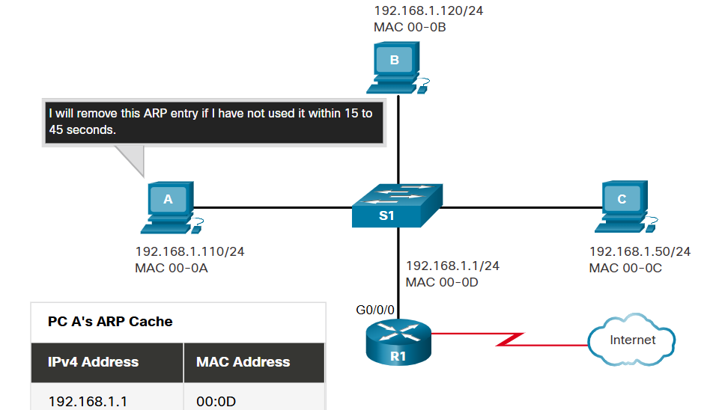

* You can also **manually clear ARP entries** using commands to refresh outdated mappings.

**Key Takeaways**

✔ **ARP is essential** for IPv4 communication—it helps find MAC addresses when only IP addresses are known.  
✔ **Devices first check their ARP cache** before sending an ARP request.  
✔ **ARP requests are broadcasted**, and only the target device responds with an ARP reply.  
✔ **Routers act as intermediaries** when communicating with devices on different networks.  
✔ **ARP tables store mappings** but expire over time to avoid outdated data.

ARP provides two basic functions:

* Resolving IPv4 addresses to MAC addresses
* Maintaining a table of IPv4 to MAC address mappings

When a packet is sent to the data link layer to be encapsulated into an Ethernet frame, the device refers to a table in its memory to find the MAC address that is mapped to the IPv4 address. This table is stored temporarily in RAM memory and called the ARP table or the ARP cache.

The sending device will search its ARP table for a destination IPv4 address and a corresponding MAC address.

If the packet’s destination IPv4 address is on the same network as the source IPv4 address, the device will search the ARP table for the destination IPv4 address.

If the destination IPv4 address is on a different network than the source IPv4 address, the device will search the ARP table for the IPv4 address of the default gateway.

In both cases, the search is for an IPv4 address and a corresponding MAC address for the device.

Each entry, or row, of the ARP table binds an IPv4 address with a MAC address. We call the relationship between the two values a map. This simply means that you can locate an IPv4 address in the table and discover the corresponding MAC address. The ARP table temporarily saves (caches) the mapping for the devices on the LAN.

If the device locates the IPv4 address, its corresponding MAC address is used as the destination MAC address in the frame. If there is no entry is found, then the device sends an ARP request.

Note: IPv6 uses a similar process to ARP for IPv4, known as ICMPv6 Neighbor Discovery (ND). IPv6 uses neighbor solicitation and neighbor advertisement messages, similar to IPv4 ARP requests and ARP replies.

Only the device that originally sent the ARP request will receive the unicast ARP reply. After the ARP reply is received, the device will add the IPv4 address and the corresponding MAC address to its ARP table. Packets destined for that IPv4 address can now be encapsulated in frames using its corresponding MAC address.

**If no device responds** to the ARP request, **the packet is dropped** because a **frame cannot be created.**

Entries in the ARP table are time stamped. If a device does not receive a frame from a particular device before the timestamp expires, the entry for this device is removed from the ARP table.

Additionally, static map entries can be entered in an ARP table, but this is rarely done. Static ARP table entries do not expire over time and must be manually removed.

In some cases, the use of ARP can lead to a potential security risk. A threat actor can use **ARP spoofing** to perform an **ARP poisoning attack**. **This is a technique used by a threat actor to reply to an ARP request for an IPv4 address that belongs to another device**, such as the default gateway, as shown in the figure. The threat actor sends an ARP reply with its own MAC address. The receiver of the ARP reply will add the wrong MAC address to its ARP table and send these packets to the threat actor.

Enterprise level switches include mitigation techniques known as **dynamic ARP inspection (DAI).** DAI is beyond the scope of this course.

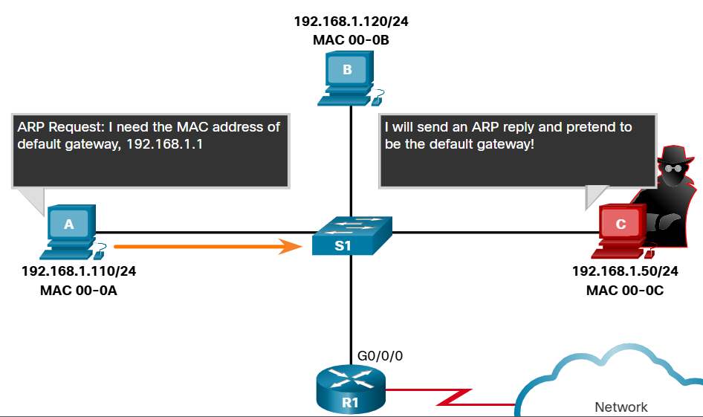

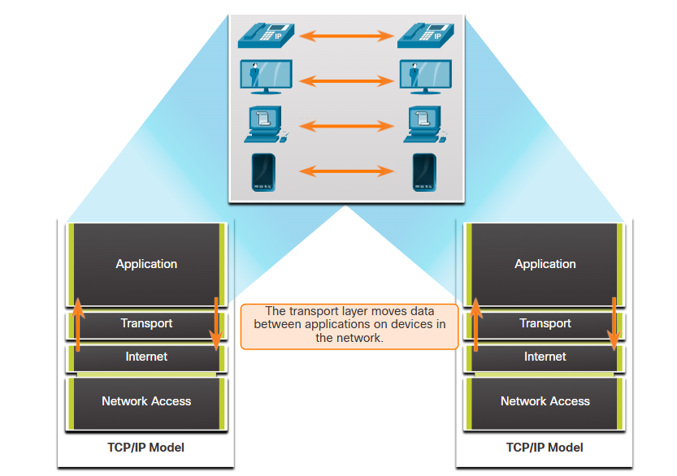

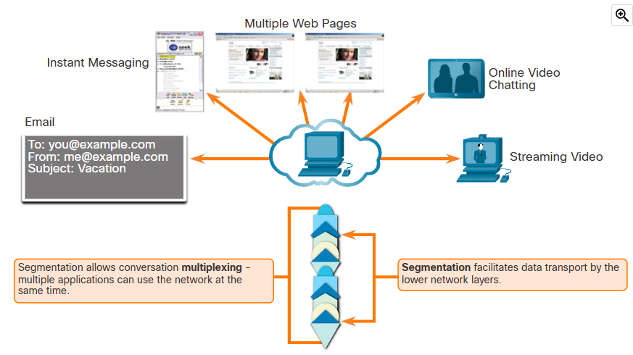

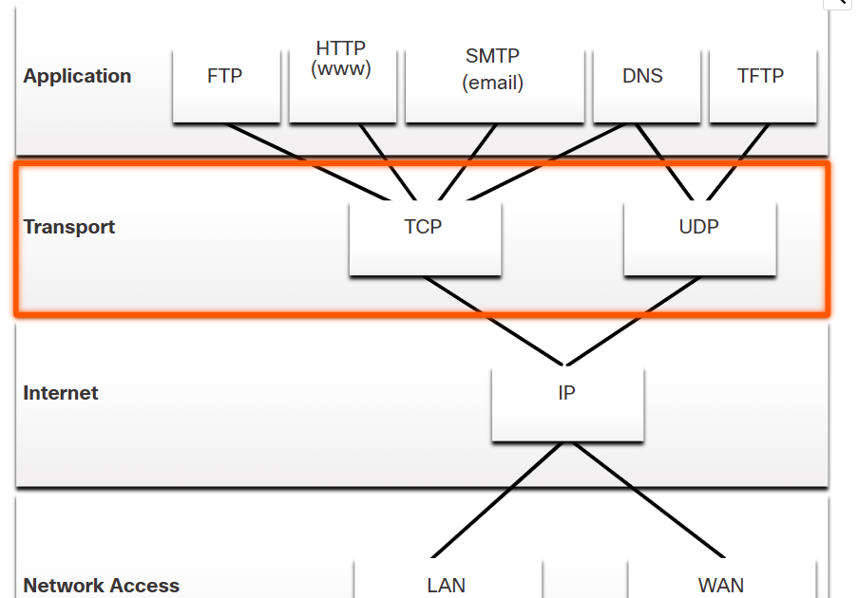

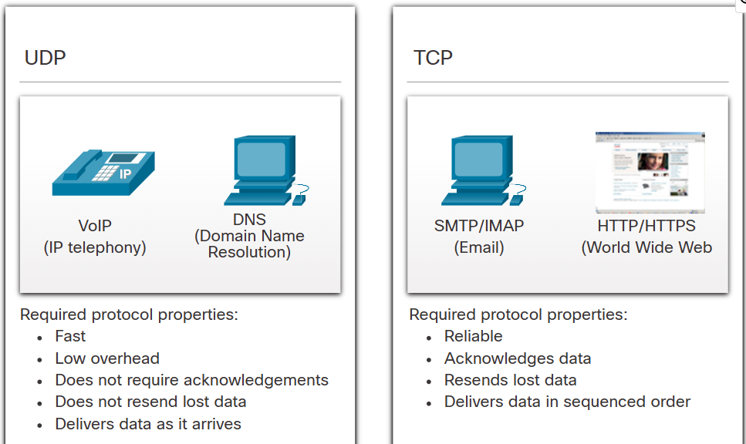

# Role of the Transport Layer

The **transport layer** is responsible for **logical communication between applications on different hosts** in a network. It ensures data is **delivered correctly and efficiently**, sitting between the application layer and the network layers in the **TCP/IP model**.

**Key Responsibilities:**

* Establish temporary **sessions** between hosts
* Ensure **reliable data transmission** (if needed)
* **Segment** and **reassemble** data
* Assign and use **port numbers** to identify specific application processes
* **Multiplex** and **track** multiple conversations on the same device

**Key Concepts**

**1. Segmenting and Reassembling**

* Application data is divided into **segments (TCP)** or **datagrams (UDP)**
* Enables easier management, error checking, and reassembly on the receiving side

**2. Headers**

* Each segment/datagram includes a **transport layer header** with necessary control info (e.g., port numbers, sequence numbers)

**3. Port Numbers**

* Identify destination application on the host
* Enables simultaneous communication by different apps on the same host

**4. Multiplexing**

* Allows multiple conversations to occur over the same network link
* Prevents one communication (like video streaming) from blocking others

**Transport Layer Protocols**

**1. Transmission Control Protocol (TCP)**

* **Reliable**, **connection-oriented** protocol
* Tracks conversations using **sequence numbers** and **acknowledgments**
* Ensures complete and ordered data delivery
* Used for: **web browsing, email, file transfers, banking apps**
* TCP features:
  + Establishes a connection (3-way handshake)
  + Retransmits lost data
  + Controls data flow (rate limiting)
  + Provides error checking

**Analogy**: Like a tracked parcel delivery with confirmation of every package received

**2. User Datagram Protocol (UDP)**

* **Unreliable**, **connectionless** protocol
* No acknowledgment, no guarantee of delivery or order
* Used for: **VoIP, live video, DNS queries, online gaming**
* Fast and lightweight – minimal delay and overhead

**Analogy**: Like sending a regular letter without tracking – faster, but with no delivery guarantee

**Choosing the Right Protocol**

| **Requirement** | **Preferred Protocol** | **Example Applications** |
| --- | --- | --- |
| Reliable, ordered delivery | TCP | Email, Web (HTTP), File Transfer (FTP) |
| Fast, low latency, tolerates some loss | UDP | VoIP, Live Streaming, DNS |

Some apps (like video conferencing) may use both TCP and UDP depending on network/firewall conditions.

# TCP Header Fields (20 bytes minimum)

Each TCP segment includes a header that carries vital control information. Here's what each field does:

| **Field** | **Size (bits)** | **Description** |
| --- | --- | --- |
| **Source Port** | 16 | Identifies the port number of the sending application. |
| **Destination Port** | 16 | Identifies the port number of the receiving application. |
| **Sequence Number** | 32 | Identifies the position of the first byte of data in this segment within the overall data stream. |
| **Acknowledgment Number** | 32 | If the ACK flag is set, this field contains the value of the next byte the receiver expects. |
| **Header Length (Data Offset)** | 4 | Indicates the size of the TCP header in 32-bit words. |
| **Reserved** | 6 | Reserved for future use (must be set to zero). |
| **Control Bits (Flags)** | 6 | Includes bits like SYN, ACK, FIN, RST, PSH, and URG to manage session control. |
| **Window Size** | 16 | Indicates the size of the receive window (how much data the receiver is ready to accept). |
| **Checksum** | 16 | Used for error-checking the header and data. |
| **Urgent Pointer** | 16 | Indicates if there is urgent data in the segment (used when URG flag is set). |
| **Options** | 0–320 (optional) | Used for special features like window scaling or timestamps. |
| **Application Data** | Varies | This is the actual data being transported from the application layer. |

**Summary of Key TCP Features**

| **Feature** | **Explanation** |
| --- | --- |
| **Session Establishment** | TCP uses a **three-way handshake** (SYN, SYN-ACK, ACK) to create a reliable connection. |
| **Reliable Delivery** | If a segment is lost or corrupted, TCP **retransmits** it using sequence and acknowledgment numbers. |
| **Same-Order Delivery** | TCP ensures segments are reassembled **in order** at the destination, even if they arrive out of sequence. |
| **Flow Control** | Using the **window size**, TCP can tell the sender to slow down if the receiver is overwhelmed. |
| **Stateful Protocol** | TCP **tracks each connection** (state) and maintains info about the session from start to finish. |

**9.2.4 – Applications that Use TCP**

TCP is ideal for applications where **reliable and ordered delivery** is essential. These include:

| **Application** | **Function** |
| --- | --- |
| **HTTP/HTTPS** | Used for web browsing (ensures complete and correct webpage loading). |
| **FTP** | Used for file transfers (ensures full file is transferred accurately). |
| **SMTP** | Used for sending emails (ensures message integrity). |
| **SSH** | Used for secure remote access (ensures secure and ordered session commands). |

These applications use TCP because it handles all reliability and session tasks, letting the application focus on what it does best.

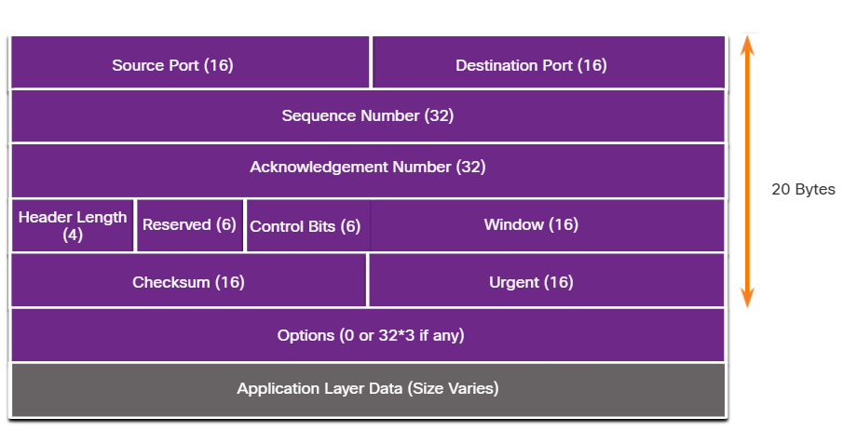

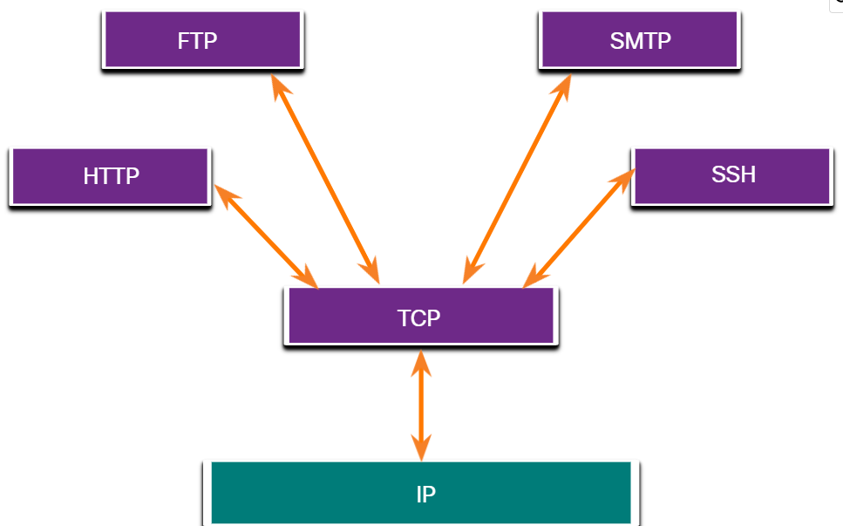

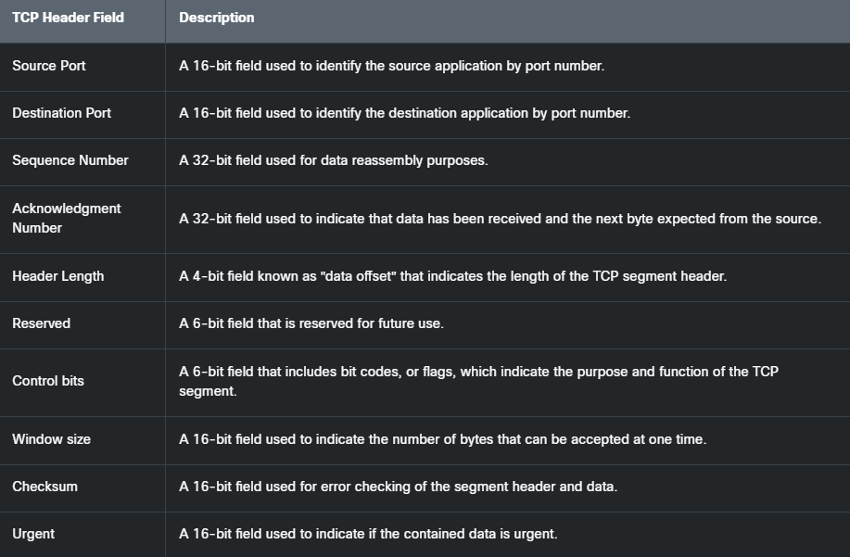

# UDP Features

UDP is a **lightweight, connectionless**, and **best-effort** transport layer protocol. It is often chosen for speed over reliability. Here’s what it offers and what it does **not** offer:

| **UDP Does** | **UDP Does Not** |
| --- | --- |
| Segments and reassembles data like TCP | Guarantee delivery of segments |
| Sends data as it arrives | Resend lost or corrupted segments |
| Adds minimal overhead | Establish a session before data transfer |
| Delivers data as received (no reordering) | Inform sender about resource issues |
| Suitable for fast communication | Perform flow or congestion control |

🔹 **Best used when speed is more critical than reliability**, like in live audio/video.

**9.3.2 & 9.3.3 – UDP Header and Fields**

The **UDP header** is only **8 bytes (64 bits)** long and has just four fields:

| **Field** | **Size (bits)** | **Description** |
| --- | --- | --- |
| **Source Port** | 16 | Port number of the sending application. |
| **Destination Port** | 16 | Port number of the receiving application. |
| **Length** | 16 | Length of the UDP header + data in bytes. |
| **Checksum** | 16 | Error-checking for the header and data (optional in IPv4, mandatory in IPv6). |

After the header, the **Application Layer Data** follows — the actual content being delivered.

📌 **Note**: Since UDP is **stateless**, it does not track communication sessions or ensure data reliability. Any required reliability must be implemented by the application layer.

**9.3.4 – Applications That Use UDP**

UDP is preferred when:

1. **Speed is critical**
2. **Some data loss is acceptable**
3. **The application can manage reliability itself**

**✅ Best-Suited Application Types**

| **Application Type** | **Examples** | **Why UDP?** |
| --- | --- | --- |
| **Live multimedia (real-time)** | VoIP, IPTV, video conferencing | Delay-sensitive; can tolerate small data losses. |
| **Simple request/response** | DNS, DHCP | Quick exchange; retransmissions handled by app if needed. |
| **Apps handling their own reliability** | SNMP, TFTP | These manage retries, acknowledgments themselves. |

🔄 **UDP-Based Apps → UDP → IP**  
Visualize as:

nginx

CopyEdit

VoIP → UDP → IP

DNS → UDP → IP

TFTP → UDP → IP

📌 **Note**:

* **DNS** can switch to **TCP** if the data exceeds 512 bytes (e.g., DNSSEC or large zone transfers).
* **SNMP** can be configured to use **TCP** in certain networks.

**✅ Quick Comparison: TCP vs UDP**

| **Feature** | **TCP** | **UDP** |
| --- | --- | --- |
| Connection | Connection-oriented | Connectionless |
| Reliability | Guaranteed with acknowledgments | No guarantees |
| Speed | Slower due to overhead | Faster, less overhead |
| Header Size | 20 bytes (minimum) | 8 bytes |
| Reordering/Data Flow | Ensures order and flow control | No reordering or flow control |
| Use Case | Web, file transfer, email | Live media, DNS, games |

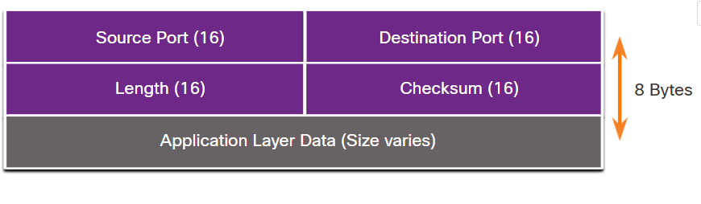

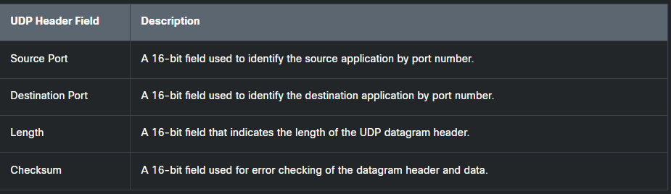

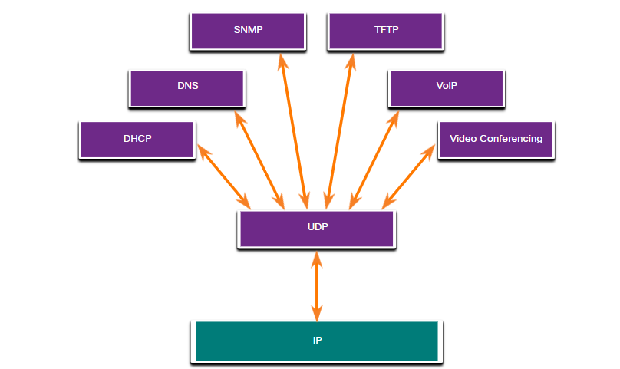

# 🔐 What Are Port Numbers?

Port numbers are **numeric identifiers** used by the **Transport Layer** protocols (TCP and UDP) to identify **specific processes or services** running on a host.

They allow a device to **handle multiple network connections at once**, by keeping track of which application is talking to which remote service. Port numbers are managed by IANA

**🧭 Why Are Port Numbers Important?**

When a device sends or receives data over a network:

* The **source port** identifies the application or service sending the data.
* The **destination port** identifies the application or service that should receive the data on the remote device.

**🧩 Structure of a Port Number**

* **16 bits long** → Range: 0 to 65535
* They are included in the TCP or UDP header.

**📊 Port Number Ranges**

Port numbers are divided into **three main ranges**:

| **Range** | **Name** | **Usage Example** |
| --- | --- | --- |
| **0 – 1023** | **Well-known Ports** | HTTP (80), FTP (21), DNS (53) |
| **1024 – 49151** | **Registered Ports** | Used by user processes/apps |
| **49152 – 65535** | **Dynamic/Private Ports** | Used temporarily by clients (ephemeral) |

**🎯 Examples of Well-known Port Numbers**

| **Service** | **Port** | **Protocol** |
| --- | --- | --- |
| HTTP | 80 | TCP |
| HTTPS | 443 | TCP |
| FTP (Command) | 21 | TCP |
| DNS | 53 | TCP/UDP |
| SMTP (Email Send) | 25 | TCP |
| DHCP | 67/68 | UDP |

**🔗 Socket and Socket Pairs**

A **socket** is the combination of:

* IP address + Port number (e.g., 192.168.1.10:80)

A **socket pair** is used for a full communication session:

* Source IP:Source Port, Destination IP:Destination Port

**📋 RESUME: Port Numbers**

* **Definition:** Numeric identifiers that specify services in network communications.
* **Used in:** TCP and UDP headers to enable multiple conversations simultaneously.
* **Ranges:**
  + 0–1023: Well-known (system services)
  + 1024–49151: Registered (user apps)
  + 49152–65535: Dynamic (temporary use by clients)
* **Help identify:** Which application should handle the incoming data.
* **Used in:** Web browsing, file transfers, emails, streaming, etc.
* **Example:** A web browser using source port 50000 to connect to server port 80.

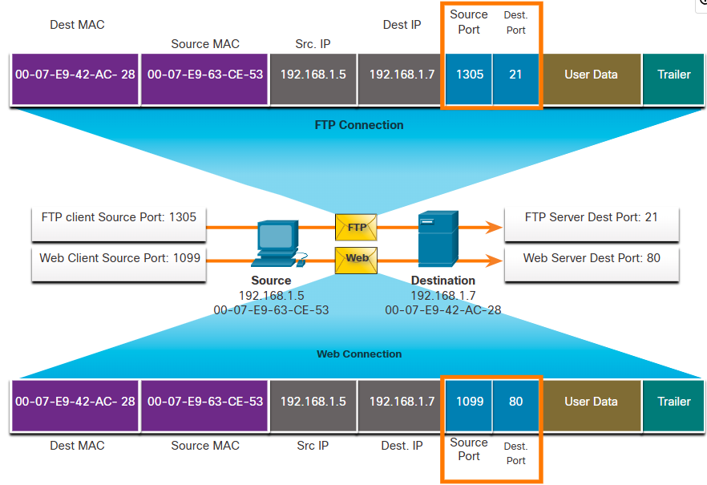

# DTP and VTP

DTP (Dynamic Trunking Protocol) and VTP (VLAN Trunking Protocol) are both Cisco proprietary protocols used in network configuration. DTP automates trunk port negotiation, while VTP manages VLAN database synchronization across a network. Though both are important for VLAN management and trunking, they serve different purposes and have distinct functionalities.

DTP (Dynamic Trunking Protocol):

* **Purpose:**

DTP automates the process of negotiating trunking on a link between two Cisco switches. It determines whether a link should operate as a trunk (carrying multiple VLANs) or an access port (carrying a single VLAN).

* **Functionality:**

It allows switches to dynamically exchange information about their trunking capabilities and negotiate the appropriate mode.

* **Key Modes:**

DTP has various modes, including access (explicitly an access port), trunk (explicitly a trunk port), desirable (attempts to negotiate trunking), auto (responds to trunk negotiation requests), and nonegotiate (disables DTP negotiation).

* **Security Considerations:**

While DTP can simplify trunk configuration, it can also be a security risk if not properly configured or if left enabled on unnecessary ports. An attacker could potentially exploit DTP to gain unauthorized access to VLANs.

VTP (VLAN Trunking Protocol):

* **Purpose:**

VTP synchronizes VLAN information across a network of Cisco switches within a VTP domain. It allows for centralized management of VLANs, reducing the administrative overhead of configuring VLANs on individual switches.

* **Functionality:**

VTP propagates VLAN information (creation, deletion, renaming) within a VTP domain. Switches can operate in different VTP modes (server, client, transparent) to control their role in the synchronization process.

* **Key Modes:**

VTP has server mode (creates, modifies, deletes VLANs), client mode (receives and applies VLAN information from the server), and transparent mode (forwards VTP messages but does not participate in synchronization).

* **Security Considerations:**

VTP can be a powerful tool for managing VLANs but also poses potential security risks if not configured correctly. Incorrect VTP configuration or exploitation by attackers can lead to VLAN inconsistencies and network disruptions.

Key Differences:

* **Focus:** DTP focuses on trunk negotiation, while VTP focuses on VLAN database synchronization.
* **Scope:** DTP operates on a per-link basis, while VTP operates within a VTP domain.
* **Security:** Both can be security risks if not configured properly, but DTP's potential risks are typically related to trunking while VTP's risks are more directly related to VLAN management and consistency.

In summary, DTP and VTP are both valuable Cisco technologies for managing VLANs and trunking in a network, but they serve different purposes and have distinct functionalities. DTP automates trunk negotiation, while VTP manages VLAN database synchronization. Understanding their differences and potential security implications is crucial for effective network administration.

**Difference Between VTP and DTP**

Last Updated : 23 Jul, 2025

The computer network is a system in which multiple computers are connected to each other to share information and resources. They share resources from one computer to another computer system. It creates files and stores them in one computer, accessing those files from the other computer(s) connected over the network.

Connect a printer, scanner, etc. to one computer within the network and let other computers of the network use the machines available over the network.

**VTP (VLAN Trunking Protocol)**

VTPis a protocol that is used to share VLAN information within a domain among connected switches. It is a Cisco proprietary protocol that propagates the system of Virtual Local Area Networks (VLAN) on the whole local area network. VTP carries VLAN information to all the switches in a VTP domain.

**For Example**  
Suppose you have multiple VLANs that you need to create in your network. But you don’t want to go to every single switch and create these VLANs. So you turn to VTP.  You just create the VLANs on one switch and you configure the right settings. VTP also propagates these VLANs to other switches that are set to client-mode.

So we can say, except for very little overlap, they are independent of each other. But if you have VTP domains configured on 2 switches, and the domains mismatch, then this affects DTPs ability to negotiate trunking between them. For purpose of your CCNA, this level of detail is not required.

**Advantages of VTP**

* **Centralized Management**: VTP also plays the roles of simplifying the management of VLANs since it is not easy to manage VLANs singularly on each switch.
* **Consistency**: VTP filter prevents changes on VLAN databases of switches which are inconsistent across the network.
* **Scalability**: VTP is specific in large networks, more so in cases where VLANs are consistently created or deleted as the VLAN information will be transmitted across all the switches.

**Disadvantages of VTP**

* **Risk of Misconfiguration**: There is one disadvantage of the VTP server configuration A single incorrect configuration on the VTP server can lead to the VTP domain sending wrong VLAN information to all the switches and this can cause some challenges on the network.
* **Limited to Cisco Devices**: VTP is a Cisco proprietary protocol which implies that it only works with the Cisco network elements and this might be a serious weakness when applied in multi-vendor network.

**DTP (Dynamic Trunking Protocol)**

DTP is a proprietary networking protocol developed by Cisco Systems for the purpose of negotiating trunking on a link between two VLAN-aware switches, and for negotiating the type of trunking [encapsulation](https://www.geeksforgeeks.org/java/encapsulation-in-java/) to be used. Trunk negotiations are managed by DTP only if the port is directly connected to each other.

**For Example:**  
Supposeif you want to automatically set up trunk interfaces on one switch, when the other side is requesting a trunk, you turn to DTP (Dynamic Trunking Protocol). By using the right settings, you’d be able to automatically set an interface to trunk mode, if it is connected to another switch.

DTP (Dynamic Trunking Protocol)

**Advantages of DTP**

* **Automation**: It can be deployed to automate the creation of a connection that is called trunk links that otherwise would require a manual configuration.
* **Flexibility**: DTP enables [switches](https://www.geeksforgeeks.org/computer-networks/types-of-switches-in-computer-network/) to periodically discuss how the trunk link should be, whether it should become a trunk or an access link.
* **Compatibility With VTP**: VTP this complements with DTP in that it is responsible for providing correct configuration of the trunk links that bear VLAN information.

**Disadvantages of DTP**

* **Security Concerns:** DTP is inherently unsafe since it allows an unauthorized device to connect to a trunk link that may result to VLAN hopping attacks.
* **Unnecessary Trunking**: It has been noted that, although rarely, when DTP is implemented, it is capable of configuring circuits that are not needed, thus may hinder the effectiveness of networks since it is creating unnecessary trunk links.

**Difference Between VTP and DTP**

| **VTP** | **DTP** |
| --- | --- |
| VTP stands for VLAN Trunking Protocol. | DTP stands for Dynamic Trunking Protocol. |
| VTP is a protocol used to share VLAN information within a domain among connected switches | DTP is a protocol used to negotiate trunking between switch ports on either end of a link. |
| VTP is responsible for synchronizing the VLAN database across multiple switches. | DTP tries to make sure that on a link that interconnects two switches, both ports operate in the same mode - either access or trunk. |
| VTP tries to make sure that all switches in a VTP domain have an identical VLAN [database](https://www.geeksforgeeks.org/dbms/what-is-database/) and propagates any changes to it. | DTP allows two interconnected switches to negotiate the operating mode of a link. |
| VTP requires a trunk, ISL or dot1Q in order to send VTP frames. | DTP is NOT required to form a trunk, you can manually establish a trunk with: switchport mode trunk and switchport nonegotiate is configured on the trunk interface. |

**Conclusion**

VTP and DTP are both Cisco proprietary [protocols](https://www.geeksforgeeks.org/computer-networks/types-of-network-protocols-and-their-uses/) which are important in [VLANs](https://www.geeksforgeeks.org/computer-networks/virtual-lan-vlan/) and trunk links though they serve differing features. VTP is directly related to the transmission of VLAN information throughout a network in an efficient manner when dealing with large networks. While, on the other hand, DTP is assigned the task of auto creation of trunk links that are required for VLANs traffic . To enable one to manage a Network properly and secure it effectively, it is important to get know the differences between these three protocols and their strengths and weaknesses.

# What is a VLAN?

A **VLAN (Virtual Local Area Network)** is a logical subdivision of a network at Layer 2 (Data Link Layer) of the OSI model.

* It allows you to group devices in the same broadcast domain **even if they are on different physical switches**.
* VLANs improve **security, performance, and network management**.

**Example:**  
You can have separate VLANs for Sales, HR, and IT departments on the same switch. Devices in VLAN 10 cannot directly communicate with devices in VLAN 20 without a router or Layer 3 switch.

**VLAN Ports: Access and Trunk**

**1. Access Ports**

* An **access port** connects **end devices (PCs, printers, IP phones)**.
* It **carries traffic for only one VLAN**.
* The switch **tags incoming frames** with the VLAN ID of that access port and **untags frames when sending** to the device.

**2. Trunk Ports**

* A **trunk port** connects **switch-to-switch links, switch-to-router links, or switch-to-server links** where multiple VLANs need to be carried.
* It **carries traffic for multiple VLANs** simultaneously.
* **802.1Q tagging** is used to differentiate VLANs on the same trunk link.

**Basic Cisco VLAN Commands**

Below are the common Cisco IOS commands for VLAN configuration:

**A. Creating a VLAN**

bash

CopyEdit

Switch> enable

Switch# configure terminal

Switch(config)# vlan 10

Switch(config-vlan)# name SALES

Switch(config-vlan)# exit

* vlan 10 → Creates VLAN 10.
* name SALES → Assigns a name to VLAN 10.

**B. Configuring an Access Port**

bash

CopyEdit

Switch(config)# interface fastethernet 0/1

Switch(config-if)# switchport mode access

Switch(config-if)# switchport access vlan 10

Switch(config-if)# no shutdown

* switchport mode access → Sets the port as access.
* switchport access vlan 10 → Assigns VLAN 10 to the port.

**C. Configuring a Trunk Port**

bash

CopyEdit

Switch(config)# interface fastethernet 0/24

Switch(config-if)# switchport mode trunk

Switch(config-if)# switchport trunk allowed vlan 10,20,30

Switch(config-if)# switchport trunk native vlan 99

Switch(config-if)# no shutdown

* switchport mode trunk → Configures the port as a trunk.
* switchport trunk allowed vlan 10,20,30 → Allows VLANs 10, 20, and 30 on the trunk.
* switchport trunk native vlan 99 → Sets VLAN 99 as the untagged (native) VLAN.

**D. Verifying VLANs and Ports**

bash

CopyEdit

Switch# show vlan brief

Switch# show interfaces trunk

* show vlan brief → Lists all VLANs and their assigned ports.
* show interfaces trunk → Shows trunk configuration and allowed VLANs.

**E. Deleting a VLAN**

bash

CopyEdit

Switch(config)# no vlan 10

* Removes VLAN 10 from the switch.

**Key Points to Remember**

* **Access ports = single VLAN traffic** (PCs, printers).
* **Trunk ports = multiple VLANs** (switches, routers, servers).
* **Native VLAN** on a trunk is untagged traffic (default is VLAN 1).
* VLAN communication between different VLANs requires a **router or Layer 3 switch** (Inter-VLAN routing).

**2.1 Cisco IOS Access**

**2.1.1 Operating Systems**

All end devices and network devices require an operating system (OS). As shown in the figure, the portion of the OS that interacts directly with computer hardware is known as the kernel. The portion that interfaces with applications and the user is known as the shell. The user can interact with the shell using a command-line interface (CLI) or a graphical user interface (GUI).

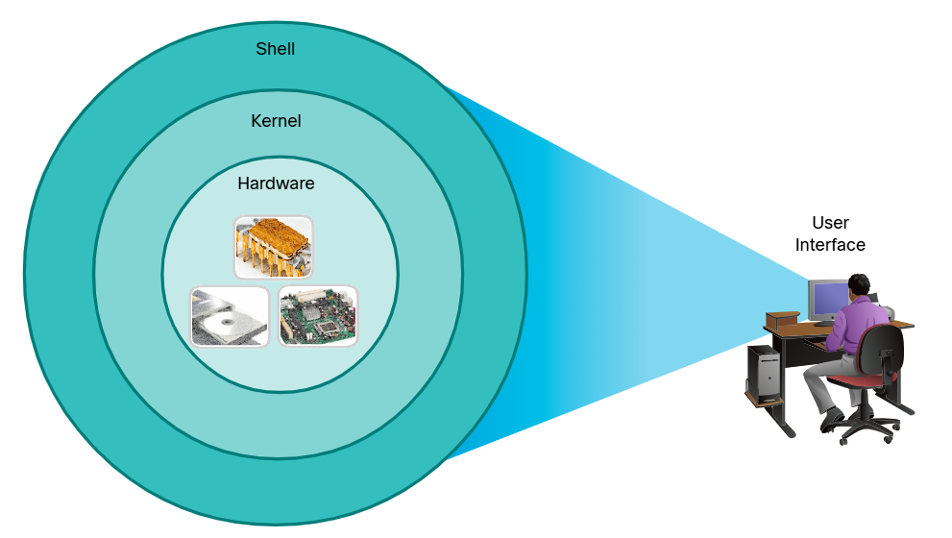

There are three concentric circles that appear to radiate from the monitor of a computer labeled user interface. They show the relationship between the different portions of an operating system. The inner circle labeled hardware shows examples of computer hardware, the middle circle is labeled kernel, and the outer circle is labeled shell. Text at the bottom reads: Shell - The user interface that allows users to request specific tasks from the computer. These requests can be made either through the CLI or GUI interfaces; Kernel - Communicates between the hardware and software of a computer and manages how hardware resources are used to meet software requirements; Hardware - The physical part of a computer including underlying electronics.

* ***Shell****- The user interface that allows users to request specific tasks from the computer. These requests can be made either through the CLI or GUI interfaces.*
* ***Kernel****- Communicates between the hardware and software of a computer and manages how hardware resources are used to meet software requirements.*
* ***Hardware****- The physical part of a computer including underlying electronics.*

When using a CLI, the user interacts directly with the system in a text-based environment by entering commands on the keyboard at a command prompt, as shown in the example. The system executes the command, often providing textual output. The CLI requires very little overhead to operate. However, it does require that the user have knowledge of the underlying command structure that controls the system.

analyst@secOps ~]$ **ls**

Desktop  Downloads  lab.support.files  second_drive

[analyst@secOps ~] $

**2.1.2 GUI**

A GUI such as Windows, macOS, Linux KDE, Apple iOS, or Android allows the user to interact with the system using an environment of graphical icons, menus, and windows. The GUI example in the figure is more user-friendly and requires less knowledge of the underlying command structure that controls the system. For this reason, most users rely on GUI environments.

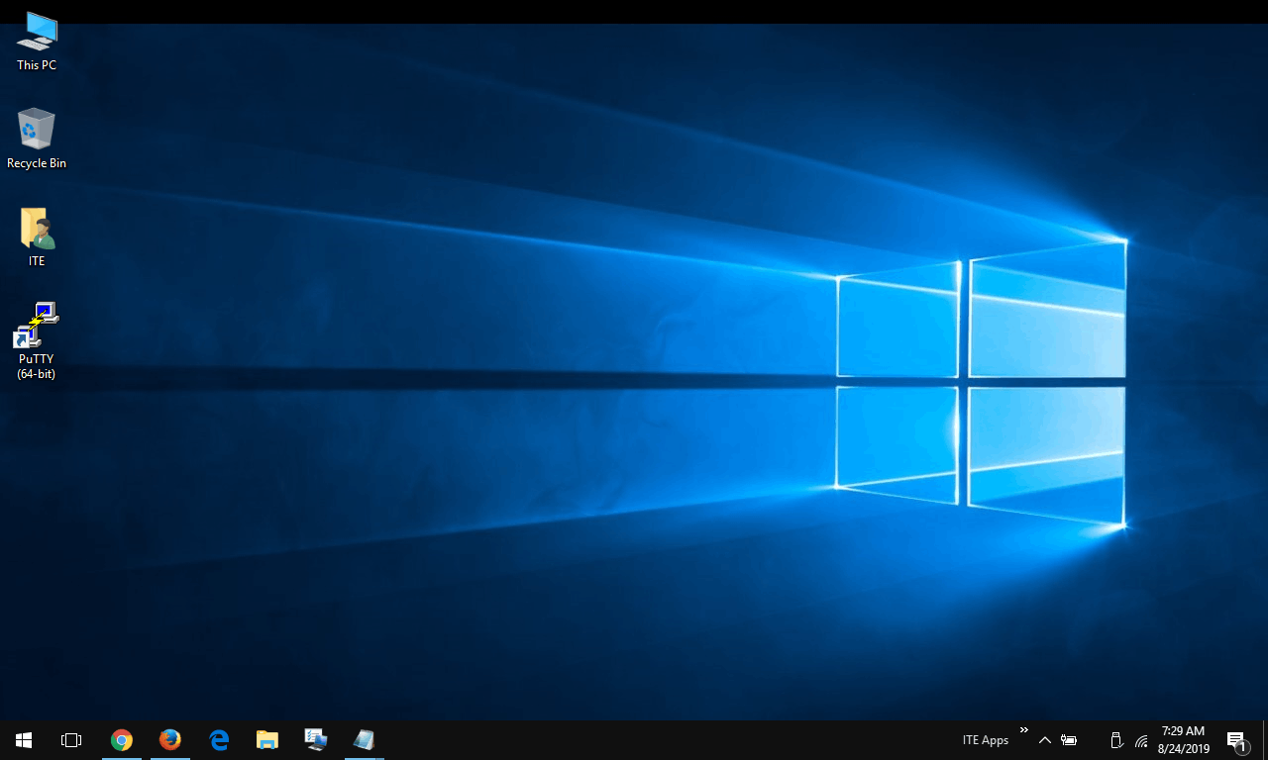

However, GUIs may not always be able to provide all the features available with the CLI. GUIs can also fail, crash, or simply not operate as specified. For these reasons, network devices are typically accessed through a CLI. The CLI is less resource intensive and very stable when compared to a GUI.

The family of network operating systems used on many Cisco devices is called the Cisco Internetwork Operating System (IOS). Cisco IOS is used on many Cisco routers and switches regardless of the type or size of the device. Each device router or switch type uses a different version of Cisco IOS. Other Cisco operating systems include IOS XE, IOS XR, and NX-OS.

**Note:** The operating system on home routers is usually called *firmware*. The most common method for configuring a home router is by using a web browser-based GUI.

**2.1.3 Purpose of an OS**

Network operating systems are similar to a PC operating system. Through a GUI, a PC operating system enables a user to do the following:

* Use a mouse to make selections and run programs
* Enter text and text-based commands
* View output on a monitor

A CLI-based network operating system (e.g., the Cisco IOS on a switch or router) enables a network technician to do the following:

* Use a keyboard to run CLI-based network programs
* Use a keyboard to enter text and text-based commands
* View output on a monitor

Cisco networking devices run particular versions of the Cisco IOS. The IOS version is dependent on the type of device being used and the required features. While all devices come with a default IOS and feature set, it is possible to upgrade the IOS version or feature set to obtain additional capabilities.

The figure displays a list of IOS software releases for a Cisco Catalyst 2960 Switch.

**Cisco Software Download Example**

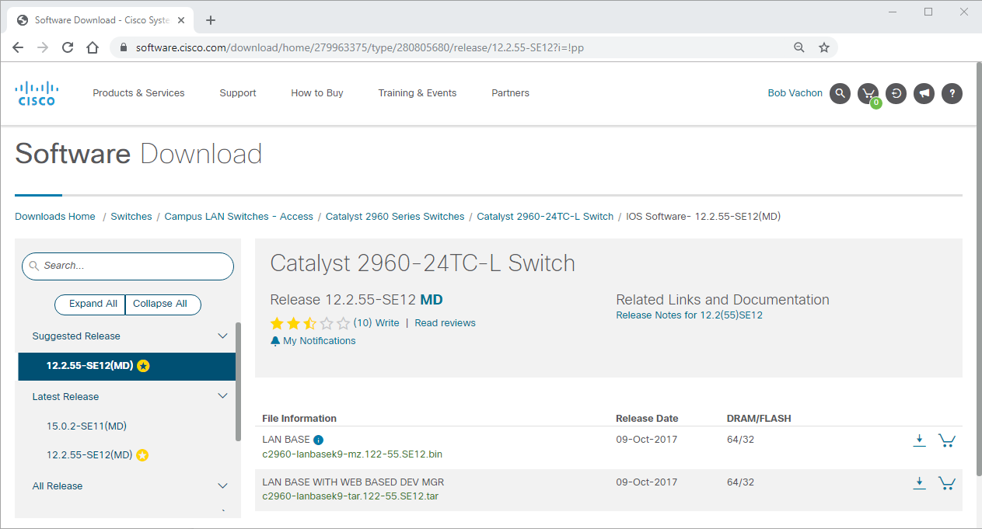

**2.1.4 Access Methods**

A switch will forward traffic by default and does not need to be explicitly configured to operate. For example, two configured hosts connected to the same new switch would be able to communicate.

Regardless of the default behavior of a new switch, all switches should be configured and secured.

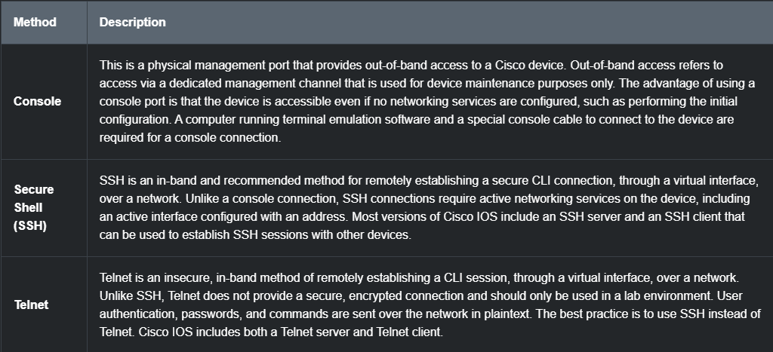

**Note:** Some devices, such as routers, may also support a legacy auxiliary port that was used to establish a CLI session remotely over a telephone connection using a modem. Similar to a console connection, the AUX port is out-of-band and does not require networking services to be configured or available.

**2.1.5 Terminal Emulation Programs**

There are several terminal emulation programs you can use to connect to a networking device either by a serial connection over a console port, or by an SSH/Telnet connection. These programs allow you to enhance your productivity by adjusting window sizes, changing font sizes, and changing color schemes.

Click each program name to see a screen capture of the interface.

PuTTY

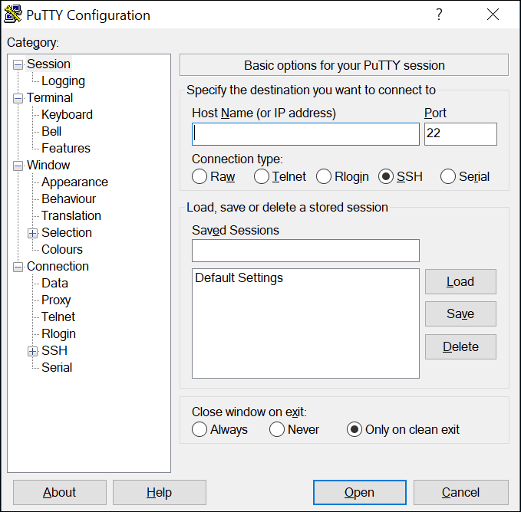

Tera Term

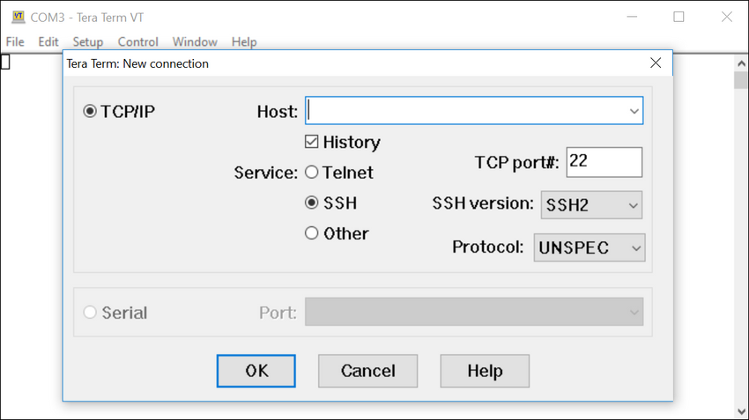

SecureCRT

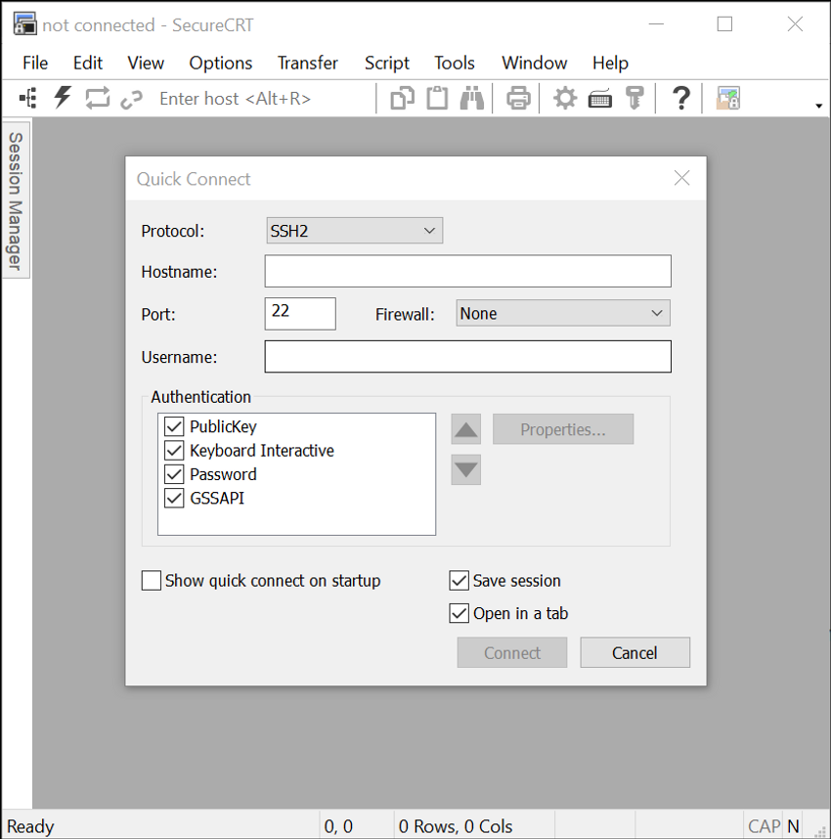

**2.1.6 Check Your Understanding - Cisco IOS Access**

Check your understanding of Cisco IOS Access by choosing the BEST answer to the following questions.

**Question 1**

Which access method would be most appropriate if you were in the equipment room with a new switch that needs to be configured?

**Console**

Telnet/SSH

Aux

**Question 2**

Which access method would be most appropriate if your manager gave you a special cable and told you to use it to configure the switch?

**Console**

Telnet/SSH

Aux

**Question 3**

Which access method would be the most appropriate in-band access to the IOS over a network connection?

Console

**Telnet/SSH**

Aux

**Question 4**

Which access method would be the most appropriate if you call your manager to tell him you cannot access your router in another city over the internet and he provides you with the information to access the router through a telephone connection?

Console

Telnet/SSH

**Aux**

**2.2 IOS Navigation**

Scroll to begin

**2.2.1 Primary Command Modes**

In the previous topic, you learned that all network devices require an OS and that they can be configured using the CLI or a GUI. Using the CLI may provide the network administrator with more precise control and flexibility than using the GUI. This topic discusses using CLI to navigate the Cisco IOS.

As a security feature, the Cisco IOS software separates management access into the following two command modes:

* **User EXEC Mode** - This mode has limited capabilities but is useful for basic operations. It allows only a limited number of basic monitoring commands but does not allow the execution of any commands that might change the configuration of the device. The user EXEC mode is identified by the CLI prompt that ends with the > symbol.
* **Privileged EXEC Mode** - To execute configuration commands, a network administrator must access privileged EXEC mode. Higher configuration modes, like global configuration mode, can only be reached from privileged EXEC mode. The privileged EXEC mode can be identified by the prompt ending with the # symbol.

The table summarizes the two modes and displays the default CLI prompts of a Cisco switch and router.

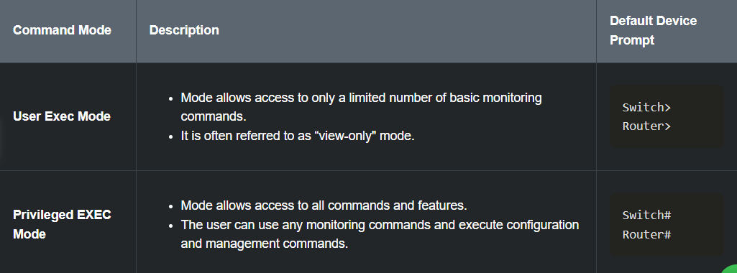

**2.2.2 Configuration Mode and Subconfiguration Modes**

To configure the device, the user must enter global configuration mode, which is commonly called global config mode.

From global config mode, CLI configuration changes are made that affect the operation of the device as a whole. Global configuration mode is identified by a prompt that ends with (config)# after the device name, such as **Switch(config)#**.

Global configuration mode is accessed before other specific configuration modes. From global config mode, the user can enter different subconfiguration modes. Each of these modes allows the configuration of a particular part or function of the IOS device. Two common subconfiguration modes include:

* **Line Configuration Mode** - Used to configure console, SSH, Telnet, or AUX access.
* **Interface Configuration Mode** - Used to configure a switch port or router network interface.

When the CLI is used, the mode is identified by the command-line prompt that is unique to that mode. By default, every prompt begins with the device name. Following the name, the remainder of the prompt indicates the mode. For example, the default prompt for line configuration mode is **Switch(config-line)#** and the default prompt for interface configuration mode is **Switch(config-if)#**.

**2.2.3 Video - IOS CLI Primary Command Modes**

Click Play in the figure to view a video demonstration of navigating between IOS modes.

**2.2.4 Navigate Between IOS Modes**

Various commands are used to move in and out of command prompts. To move from user EXEC mode to privileged EXEC mode, use the **enable** command. Use the **disable** privileged EXEC mode command to return to user EXEC mode.

**Note:** Privileged EXEC mode is sometimes called *enable mode*.

To move in and out of global configuration mode, use the **configure terminal** privileged EXEC mode command. To return to the privileged EXEC mode, enter the **exit** global config mode command.

There are many different subconfiguration modes. For example, to enter line subconfiguration mode, you use the **line** command followed by the management line type and number you wish to access. Use the **exit** command to exit a subconfiguration mode and return to global configuration mode.

Switch(config)# **line console 0**

Switch(config-line)# **exit**

Switch(config)#

To move from any subconfiguration mode of the global configuration mode to the mode one step above it in the hierarchy of modes, enter the **exit** command.

To move from any subconfiguration mode to the privileged EXEC mode, enter the **end** command or enter the key combination **Ctrl+Z**.

Switch(config-line)# **end**

Switch#

You can also move directly from one subconfiguration mode to another. Notice how after selecting an interface, the command prompt changes from **(config-line)#** to **(config-if)#**.

Switch(config-line)# **interface FastEthernet 0/1**

Switch(config-if)#

**2.2.5 Video - Navigate Between IOS Modes**

Click Play in the figure to view a video demonstration of how to move between various IOS CLI modes.

**2.2.6 A Note About Syntax Checker Activities**

When you are learning how to modify device configurations, you might want to start in a safe, non-production environment before trying it on real equipment. NetAcad gives you different simulation tools to help build your configuration and troubleshooting skills. Because these are simulation tools, they typically do not have all the functionality of real equipment. One such tool is the Syntax Checker. In each Syntax Checker, you are given a set of instructions to enter a specific set of commands. You cannot progress in Syntax Checker unless the exact and full command is entered as specified. More advanced simulation tools, such as Packet Tracer, let you enter abbreviated commands, much as you would do on real equipment.

**2.2.7 Syntax Checker - Navigate Between IOS Modes**

Use the Syntax Checker activity to navigate between IOS command lines on a switch.

Enter privileged EXEC mode using the **enable** command.

Top of Form

Switch>

Bottom of Form

Show meShow allReset

**2.2.8 Check Your Understanding - IOS Navigation**

Check your understanding of IOS navigation by choosing the correct answer to the following questions.

**Question 1**

Which IOS mode allows access to all commands and features?

Global configuration mode

Interface subconfiguration mode

Line console subconfiguration mode

done

Privileged EXEC mode

User EXEC mode

**Question 2**

Which IOS mode are you in if the Switch(config)# prompt is displayed?

done

Global configuration mode

Interface subconfiguration mode

Line console subconfiguration mode

Privileged EXEC mode

User EXEC mode

**Question 3**

Which IOS mode are you in if the Switch> prompt is displayed?

Global configuration mode

Interface subconfiguration mode

Line console subconfiguration mode

Privileged EXEC mode

done

User EXEC mode

**Question 4**

Which two commands would return you to the privileged EXEC prompt regardless of the configuration mode you are in? (Choose two.)

done

**CTRL+Z**

**disable**

**enable**

done

**end**

**exit**